25/03/20 Week 1: Being at home
Each week, the Year 8 team and I have come up with a list of activities for you to do. This is to help develop you as a person. You can do 1 or all of these activities, it’s really just to make sure you know we still want to support you!
It won’t be long until we are all back together again! We will come back even hungrier to succeed. You are all amazing. #FactsOnly #StrongerTogether

Recommended list: What to watch with your families
Netflix:
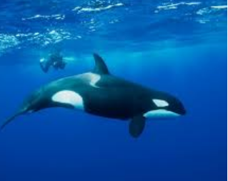
Blackfish: It’s a 2013 American documentary film, nominated for the BAFTA Award for Best Documentary. It concerns Tilikum, an orca held by SeaWorld and the debate over whether we should keep animals captive.
Moral Question to discuss as a family: Should animals be used for human entertainment? Why? Why not?
The Boy in the Striped Pyjamas (rated PG-13): This fictional film deals with issues surrounding the Jewish Holocaust and how two young boys—one German and one Jewish—may have perceived what was happening around them.
Moral Question to discuss as a family: Why should we acknowledge the Holocaust? How did it make you feel?
CHEF’S TABLE, Volume 2 Episode 4: Dominique Crenn. Curveball episode but it’s about a chef that was adopted at 18 months in France and grew up to be a 2 Michelin star chef. Inspiring!
Moral Question to discuss as a family: Does your childhood influence/change who you are? What is your passion?

Recommended books to read
FREE! Oh sorry for shouting, just wanted to let you know that this link will allow you to read a book a day for free.
https://www.worldofdavidwalliams.com/elevenses/

Or this one, has loads for free! https://stories.audible.com/start-listen
Remember that Shakespeare wrote King Lear whilst in quarantine from the plague! Read more, learn more and keep imagining the impossible my squad!
TikTok Challenge- this week!
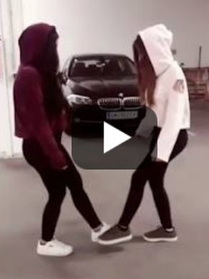
Email me at gmalhi@nusa.org.uk for your version of #OohNaNaNa
You don’t have to copy exactly, make your own version! Do it with the family and keep active at home! You don’t have to show your face but get involved!! (Hide your username though! Save it as a video then send!)
Cannot wait!
Year 8 bake-off!
Will your brownies be as good as Bruce’s? Email me a picture, I’ll put on Green Flags for you!
Homemade Eggless Brownies (eggless because your family needs them!)
Ingredients | Instructions
1 1/3 cups All-Purpose Flour gluten-free flour will work  1 cup Sugar  1/3 cup Unsweetened Cocoa Powder  1/2 teaspoon Baking Powder  1/2 teaspoon Salt  1/2 cup Water  1/2 cup Vegetable Oil  1/2 teaspoon Vanilla Extract | Mix together all the ingredients. Dry ingredients first and then the wet.  You should have a nice thick mixture. Make sure all the flour and baking powder are mixed in otherwise you will have sour clumps in the brownies and that's not fun.  Pat the brownie batter into a lightly greased 8x8 (or similar size) pan. My Le Creuset has treated me well for many years and always bakes these egg free brownies to perfection! Bake at 350F degrees for about 20 minutes or until a toothpick comes out clean.

Year 8 Meme challenge!
This will stay each week because memes are life! Send me your memes! Your tutor team came up with these:
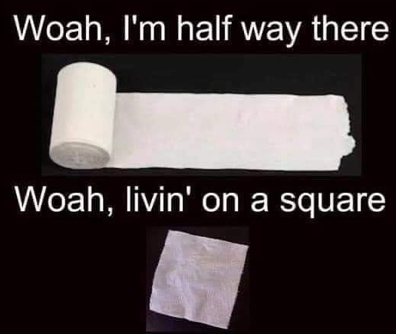
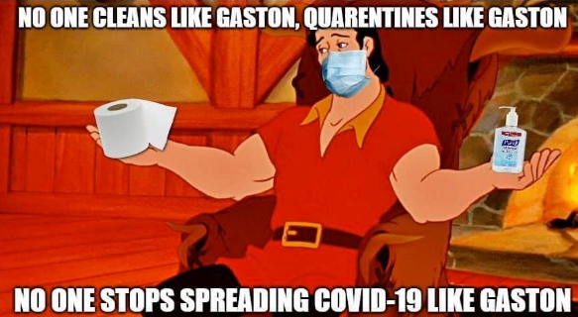
Think you can do better? Email gmalhi@nusa.org.uk Green flags for you! Until next week!

