Q1.
A student investigated the effect of different concentrations of sugar solution on pieces of potato. This is the method used.
1. Cut three pieces of potato to the same length.
2. Dry each piece on a paper towel.
3. Weigh each piece.
4. Place each piece in a different concentration of sugar solution.
5. Leave all three pieces for 2 hours.
6. Remove the three pieces of potato from the solutions.
7. Dry each piece on a paper towel.
8. Measure the length and mass of each piece of potato.
Figure 1 shows how the investigation was set up.
Figure 1: 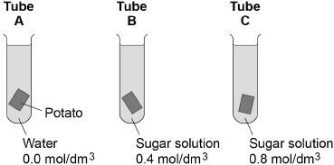
(a) Why did the student dry each piece of potato before weighing it?
___________________________________________________________________
___________________________________________________________________ (1)
(b) What two changes would you expect in the potato in tube A after 2 hours?
Tick two boxes.

Breaks into pieces
Decrease in hardness
Decrease in size
Increase in mass
Increase in length
(2)
(c) Complete the sentences.
Water moves into and out of cells by a process called ____________________ .
Water would move ____________________ the potato cells in tube A.
The solution outside the potato in tube A is at a ____________________
concentration than the solution inside the potato cells. (3)
(d) The potato in tube B did not change.
Give one conclusion that can be made from this observation.
___________________________________________________________________
___________________________________________________________________ (1)
(e) Figure 2 shows the root of a germinating seed.
Figure 2: 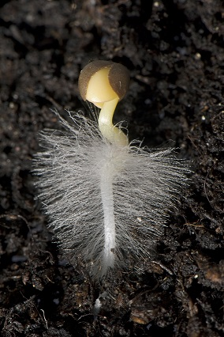
Describe two ways the root is adapted to absorb water efficiently.
1. _________________________________________________________________
___________________________________________________________________
2. _________________________________________________________________
___________________________________________________________________ (2)
(Total 9 marks)
Q2.
Diffusion is an important process in animals and plants.
The movement of many substances into and out of cells occurs by diffusion.
Describe why diffusion is important to animals and plants.
In your answer you should refer to:
• animals
• plants
• examples of the diffusion of named substances.
_______________________________________________________________________
_______________________________________________________________________
_______________________________________________________________________
_______________________________________________________________________
_______________________________________________________________________
_______________________________________________________________________
_______________________________________________________________________
_______________________________________________________________________
_______________________________________________________________________
_______________________________________________________________________
_______________________________________________________________________
_______________________________________________________________________
_______________________________________________________________________
_______________________________________________________________________
_______________________________________________________________________
_______________________________________________________________________
_______________________________________________________________________
_______________________________________________________________________
(Total 6 marks)
Q3.
(a) The diagram shows four ways in which molecules may move into and out of a cell. The dots show the concentration of molecules.
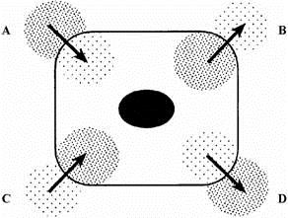
The cell is respiring aerobically.
Which arrow, A, B, C or D, represents:
(i) movement of oxygen molecules; __________
(ii) movement of carbon dioxide molecules? __________
(2)
(b) Name the process by which these gases move into and out of the cell.
___________________________________________________________________
(1)
(c) Which arrow, A, B, C or D, represents the active uptake of sugar molecules by the cell?
___________________________________________________________________
Explain the reason for your answer.
___________________________________________________________________
___________________________________________________________________
___________________________________________________________________
(2)
(Total 5 marks)

