Q1.
Figure 1 shows an animal cell and a bacterial cell.
Figure 1: 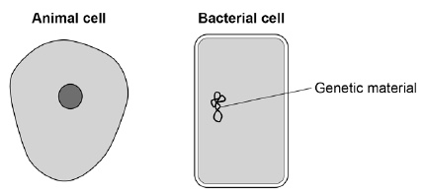
(a) Compare the structure of the cells in Figure 1.
Complete the sentences. Choose the answers from the box.

cell membrane | cell wall | chloroplast
cytoplasm |  | nucleus
Only the animal cell contains a _________________________________________ .
Only the bacterial cell contains a _______________________________________ . (2)
Figure 2 shows a section through a leaf.
Figure 2
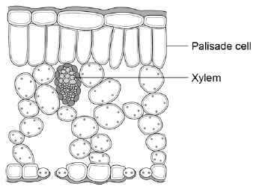
(b) The function of palisade cells is to photosynthesise.
Describe one way palisade cells are adapted to carry out their function.
___________________________________________________________________
___________________________________________________________________ (1)

(c) Complete Table 1 to show whether each structure is a tissue, an organ or an organ system.
Tick one box for each structure.

Table 1
Structure | Tissue | Organ | Organ system
Leaf
Xylem
Roots, stem and leaves
(2)
A student observed palisade cells using a microscope.
The microscope had four objective lenses, each with a different magnification.
(d) Which objective lens should the student use first?
Tick one box.
Give a reason for your answer.

×4 magnification
×10 magnification
×40 magnification
×100 magnification
Reason ____________________________________________________________
___________________________________________________________________
(2)
The student measured the width of 5 different palisade cells at a total magnification of ×400
(e) Eyepiece lenses are usually ×5 or ×10 magnification.
What combination of eyepiece and objective lenses would give a total magnification of ×400?
Eyepiece lens ____________________
Objective lens ____________________
(1)
(f) Table 2 shows the student’s results.

Table 2
Cell | Width of cell image in mm
1 | 12
2 | 13
3 | 16
4 | 10
5 | 11
(f) Calculate the mean width of the palisade cell images.
___________________________________________________________________
___________________________________________________________________
Mean width = ____________________ mm
(1)
(g) Calculate the real width of a palisade cell.
Use the mean width you calculated in part (f).
Use the equation:
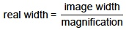
___________________________________________________________________
___________________________________________________________________
Real width = ____________________ mm
(2)
(Total 11 marks)
Q2.
This question is about cell structures.
(a) Draw one line from each cell structure to the type of cell where the structure is found.

Cell Structure |  | Type of cell where the structure is found
Nucleus |  | Prokaryotic cells
Permanent vacuole |  | Plant cells only
Plasmid |  | Eukaryotic cells
(2)
(b) Figure 1 shows a plant cell.
Figure 1
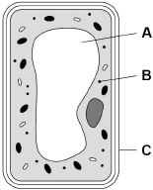
What are the names of structures A, B and C?
Tick one box.

Structure A | Structure B | Structure C
Chloroplast | Vacuole | Cell wall
Nucleus | Chloroplast | Cell membrane
Vacuole | Mitochondrion | Cell membrane
Vacuole | Ribosome | Cell wall
(1)
A student observed slides of onion cells using a microscope. Figure 2 shows two of the slides the student observed.
Figure 2: 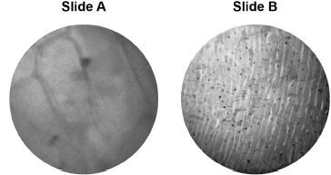
The cells on the slides are not clear to see.
(c) Describe how the student should adjust the microscope to see the cells on Slide A more clearly.
___________________________________________________________________ (1)
(d) Describe how the student should adjust the microscope to see the cells on Slide B more clearly. ___________________________________________________________________
___________________________________________________________________ (2)
(e) The student made the necessary adjustments to get a clear image.
Figure 3 shows the student’s drawing of one of the cells.
Figure 3
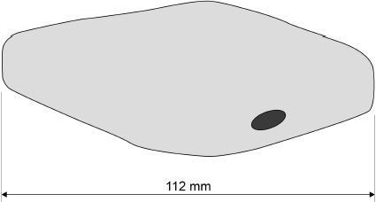
The real length of the cell was 280 micrometres (µm). Calculate the magnification of the drawing.
___________________________________________________________________
___________________________________________________________________
___________________________________________________________________
Magnification = × _________________________ (3)
(Total 9 marks)

