Q1.
The diagrams show four types of cell, A, B, C and D.
Two of the cells are plant cells and two are animal cells.
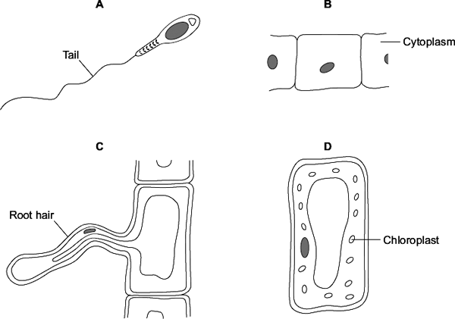
(a) (i) Which two of the cells are plant cells?
Tick () one box.

A and B

A and D

C and D
(1)
(ii) Which part is found only in plant cells?
Draw a ring around one answer.

cell membrane | cell wall | nucleus
(1)

(b) | (i) | Which cell, A, B, C or D, is adapted for swimming?
(1)

(ii) | Which cell, A, B, C or D, can produce glucose by photosynthesis?
(1)
(c) Cells A, B, C and D all use oxygen.
For what process do cells use oxygen?
Draw a ring around one answer.

osmosis | photosynthesis | respiration
(1)
(Total 5 marks)
Q2.
The diagram shows an animal cell.
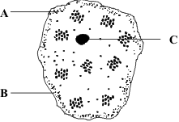
(a) Name each labelled part and give its function.
A Name _________________________________________________________
Function _______________________________________________________
______________________________________________________________
B Name _________________________________________________________
Function _______________________________________________________
______________________________________________________________
C Name _________________________________________________________
Function _______________________________________________________
______________________________________________________________
(6)
(b) (i) This plant cell also contains chloroplasts, a cell wall and a vacuole. Label each of these parts on the diagram.
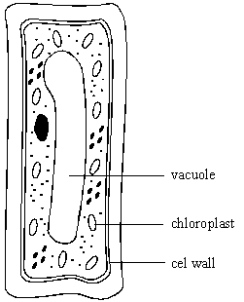
(3)
(ii) Give the function of these parts of a plant cell.
Chloroplast function _____________________________________________
______________________________________________________________
Cell wall function ________________________________________________
______________________________________________________________
Vacuole function ________________________________________________
______________________________________________________________
(3)
(Total 12 marks)

