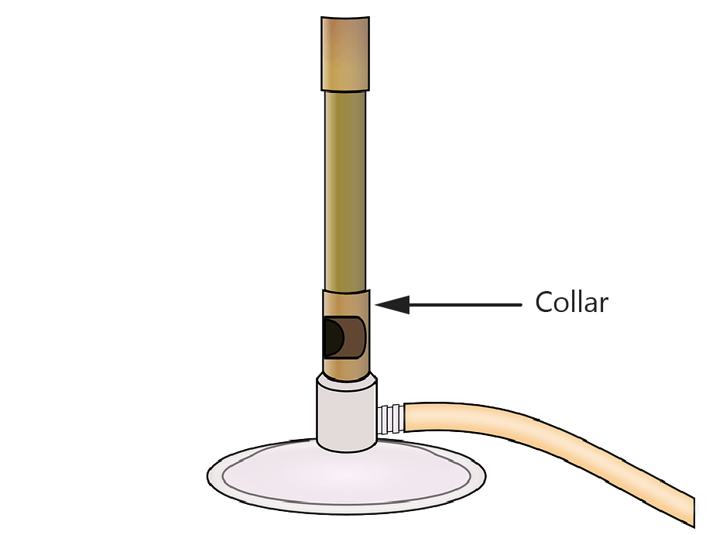**Science IST Week 6 – Bunsen Burners**

A

1. Identify which part of the Bunsen burner is the barrel.
2. What is the job of the barrel?
3. Changes the flame b) Lets gas into Bunsen burner

C

B

c) Allows air in d) Where the flame comes out

D

1. Which is the safest part of the Bunsen burner to touch if you need to move/carry it?
2. Identify which part of the Bunsen burner is the air hole.
3. What is the job of the rubber hose?
4. Changes the flame b) Lets gas into Bunsen burner

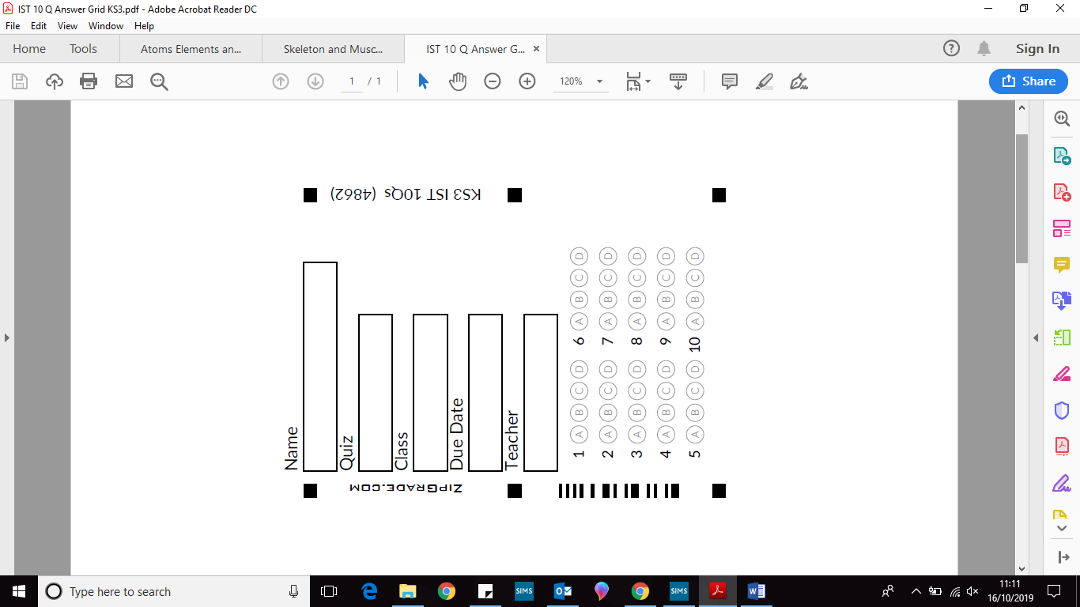 c) Allows air in d) Where the flame comes out

1. The collar controls how much ________ can enter the Bunsen burner and mix with the gas.
2. Carbon dioxide b) Nitrogen

c) Oxygen d) Methane

1. The ________ flame is the yellow flame

a) roaring b) safety c) open d) closed

1. The Bunsen burner will burn yellow when the air hole is:

a) roaring b) safety c) open d) closed

1. The hottest flame is the ________ flame.

a) roaring b) safety c) open d) closed

1. Heating with a ________ flame will cause glassware and other equipment to get covered in black soot.
2. Roaring b) Safety

**Task**

Write a step by step method for how you would set up a Bunsen burner and ***safely*** light it, include the names of equipment that you will need.

____________________________________________________________________________________________________________________________________________________________________________________________________________________________________________________________________________________________________________________________________________________________________________________________________________________________________________________________________________________________________________________________________________________________________________________________________________________________________________________________________________________________________________________________________________________________________________________________________________________________________________________________________________________________________________________________________________________________________________________________________________________________________________________________________________________________________________________________________________________________________________________________________________________________________________