Q1.
(a) Many chemicals are dangerous if not used carefully.
Read the two hazard descriptions. Look at the hazard labels.
Draw a line from each description to the correct label.
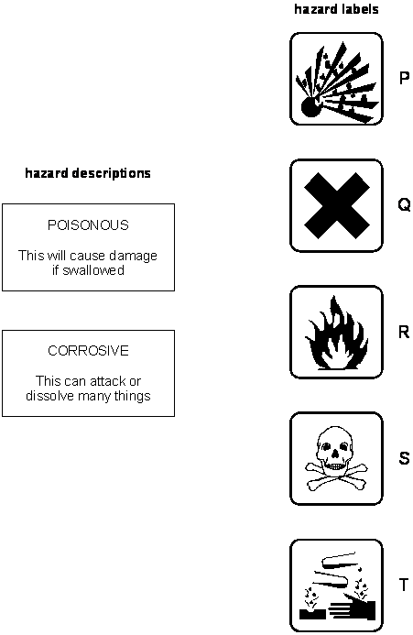
2 marks
(b) The label on a bottle of kitchen cleaner says:
It leaves kitchen and bathroom surfaces bright and shiny.
Another part of the label says:
Contains sulphamic acid
Irritating to eyes and skin
Keep out of reach of children
(i) Which hazard label do you expect to see on the bottle?
Write the correct letter from the list above.
............................................…
1 mark
Maximum 3 marks
Q2.
Joanne burnt four different crisps.
She predicted that the bigger the crisp, the longer it will burn.
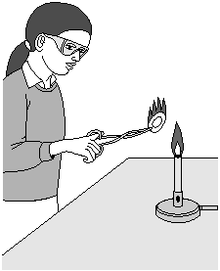
(a) Look at the picture above. What did Joanne wear to protect herself?
............................................................. 1 mark
(b) Joanne measured the time taken for each crisp to burn completely.
The bar chart shows Joanne’s results.
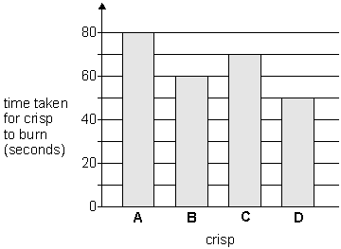
Look at the bar chart.
How much time did crisp D take to burn?
..................... seconds
1 mark
(c) The crisps Joanne used in her investigation are shown below.
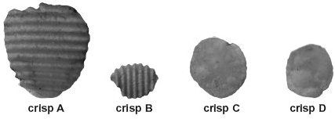
(i) Joanne predicted that the bigger the crisp, the longer it will burn.
Do the results support Joanne’s prediction?
Tick one box.
yes no
Use Joanne’s results to explain your answer.
.............................................................................................................
.............................................................................................................
1 mark
(ii) How can you tell that Joanne did not carry out a fair test?
.............................................................................................................
1 mark
(d) Joanne wrote some conclusions for her investigation.
Decide whether each conclusion is true, false, or you cannot tell.
Tick the correct box for each conclusion.

conclusion | true | false | cannot  tell
Two crisps took the same amount of time to burn.
The smallest crisp burnt for the shortest time.
Two of the crisps burnt with flames of the same size.
3 marks
maximum 7 marks
Q3.
(a) (i) What do the hazard warning symbols, A and B, on this tube of glue mean?
Choose from the box below and write your answers on the lines.

corrosive explosive flammable toxic radioactive

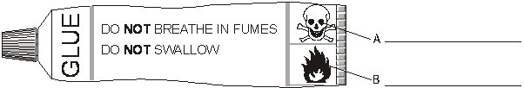
2 marks
(ii) The glue contains a solvent.
Why is it dangerous to breathe in the fumes from the glue?
...............................................................................................................
...............................................................................................................
1 mark
maximum 3 marks
Q4.
(a) George used the apparatus below to find out what substances are produced
when methanol burns.
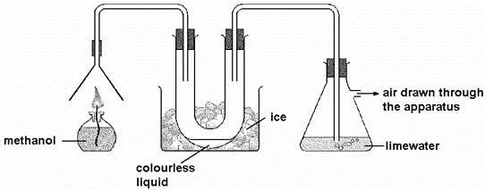
As the methanol burned, two different gases were produced.
(i) One of these gases condensed in the U-tube to give a colourless liquid. Give the name of this liquid.
........................................................ 1 mark
(ii) The other gas turned the lime water cloudy.
Give the name of this gas.
........................................................ 1 mark
(b) Methanol is sometimes used in antifreeze. It can be added to water in car
windscreen wash-bottles to prevent the water from freezing in cold conditions.
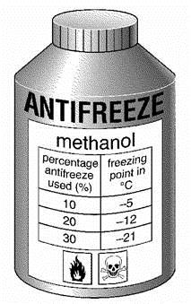
(i) The label on the bottle of antifreeze has two hazard warning symbols. What two precautions would you need to take when using this antifreeze?
1. .........................................................................................................
…………………………………………………………………………………………………………………………………………………………………………………………………………………………………………………………………………………………………………………………………………………………………………………………………………………………………………………………….
2. .........................................................................................................
............................................................................................................. 1 mark
Maximum 3 marks
Q5.
Marie mixed 5 g of carbon with 5 g of lead oxide.
She heated the mixture strongly for 15 minutes in a fume cupboard.
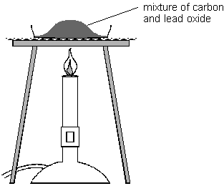
(a) Marie also expected carbon dioxide to be formed in this experiment.
(i) In carbon dioxide, what element is combined with carbon?
……………..…………….……
1 mark
(ii) Where, apart from the air, did this element come from in this experiment?
……………..…………….……
1 mark
(b) Give one safety precaution Marie should take during this experiment.
……………..……………………………….…………………..……………………
……………..……………………………….…………………..……………………
1 mark
Maximum 3 marks

