Q1.
The diagram below shows a plant cell.
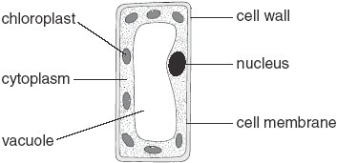
(a) In which part of a plant would you find this type of cell?
........................................................ 1 mark
(b) (i) Give the function of the nucleus.
...............................................................................................................
............................................................................................................... 1 mark
(ii) Give the function of the chloroplasts.
...............................................................................................................
............................................................................................................... 1 mark
(iii) Give the function of the cell wall.
...............................................................................................................
............................................................................................................... 1 mark
(c) Give the names of two labelled parts that are not present in animal cells.
1. .............................................................
2. ............................................................. 2 marks
(d) Tick one box in each row to show whether the statement is true for
photosynthesis or for respiration.

statement | photosynthesis | respiration
carbon dioxide is produced
light is needed
it occurs in plants and animals
oxygen is produced
2 marks
maximum 8 marks

Q2.
The drawing shows an experiment to investigate photosynthesis in weed from a pond.
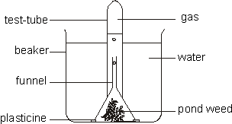
Bubbles of gas produced during photosynthesis were given off from the pond weed and collected in the test tube.
(a) Name the gas given off in photosynthesis
......................................................................................................................
1 mark
(b) What two substances are taken in by the plant and used for photosynthesis?
1. ..................................................................................................................
2. ..................................................................................................................
2 marks
Light of different intensities was shone onto the pond weed. The number of gas bubbles given off in one minute at each light intensity was counted. The results are shown in the graph.
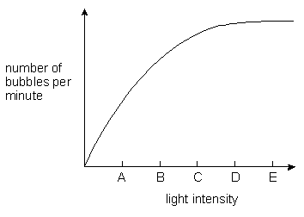
(c) Which letter on the horizontal axis shows the light intensity at which the rate of photosynthesis first reaches its maximum?
............................................................
1 mark

Blue, green and red light were then shone, in turn, onto the pond weed. The number of bubbles of the gas given off in one minute was counted. The results are shown in the table.
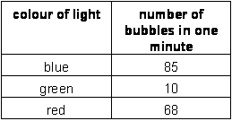
The leaves of the pond weed contain a green pigment which absorbs light for photosynthesis
(d) (i) Name this pigment.
.............................................................................................................
1 mark
(ii) Using the information in the table, tick a box by one colour of light which is strongly absorbed by the pigment.
blue
green
red
1 mark
(e) Sugar is also produced during photosynthesis.
Give two ways in which the plant uses sugar.
1. ..................................................................................................................
..................................................................................................................
2. ..................................................................................................................
..................................................................................................................
2 marks
Maximum 8 marks

