Q1.
(a) Complete the sentences.
Choose the answers from the box.

ionising | light | sound | transmitted | waves
X-rays travel at the speed of ____________________ .
X-rays can cause cancer because they are ____________________ . (2)
(b) How do X-rays compare with gamma rays?
Tick one box.

X-rays have a longer wavelength and a higher frequency
X-rays have a longer wavelength and a lower frequency
X-rays have a shorter wavelength and a higher frequency
X-rays have a shorter wavelength and a lower frequency
(1)
A scientist measured the radiation dose that a person received at different distances from an X-ray machine.
The table shows the results.

Distance from machine in m | Dose in millisieverts/ |  |  | Mean dose in millisieverts
 | Test 1 | Test 2 | Test 3
0.5 | 0.152 | 0.146 | 0.155 | 0.151
1.0 | 0.039 | 0.035 | 0.040 | X
1.5 | 0.017 | 0.018 | 0.017 | 0.017
2.0 | 0.012 | 0.007 | 0.007 | 0.009
2.5 | 0.007 | 0.006 | 0.005 | 0.006
(c) Calculate value X in the table.
___________________________________________________________________
___________________________________________________________________
___________________________________________________________________
Mean dose = ____________________ millisieverts (2)
(d) What conclusion can be made from the results in the table?
Tick one box.

The dose decreases if you stand further from the machine.
The dose is directly proportional to the distance.
The dose is the same at all distances from the machine.
There is a linear relationship between dose and distance.
(1)
(e) An X-ray gives a radiation dose of 0.180 millisieverts.
Natural sources give a dose of 0.012 millisieverts per day.
Calculate the time it would take for natural sources to give a dose of 0.180 millisieverts.
___________________________________________________________________
___________________________________________________________________
___________________________________________________________________
Time = ____________________ days
(2)
(f) Suggest why doctors use X-rays even though this increases the risk of cancer to the patient.
___________________________________________________________________
___________________________________________________________________
(1)
(g) X-rays can also be used to treat cancer.
A patient receives a dose of 20 millisieverts from an X-ray.
Proton beam therapy delivers 40% of this dose.
Calculate the dose delivered by proton beam therapy.
___________________________________________________________________
___________________________________________________________________
___________________________________________________________________
Dose = ____________________ millisieverts
(2)
(Total 11 marks)

Q2.
(a) The diagram shows the electromagnetic spectrum.
The pictures show four devices that use electromagnetic waves. Each device uses a different type of electromagnetic wave.
Draw a line from each device to the type of electromagnetic wave that it uses. One has been done for you.
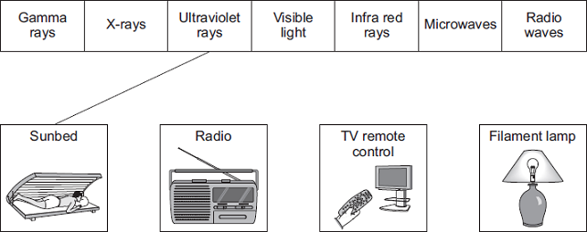
(3)
(b) A headline from a recent newspaper article is shown below.
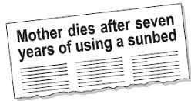
(i) What serious health problem may be caused by using a sunbed too much?
______________________________________________________________
(1)

(ii) The pie chart compares the number of deaths in Britain each year which may have been caused by using sunbeds too much, with those which may have been caused by too much exposure to the Sun.
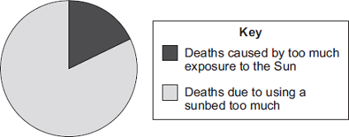
It is difficult for a doctor to be certain that a person has died because of using a sunbed too much.
Suggest why.
______________________________________________________________
______________________________________________________________
(1)
(iii) A spokesperson for a leading cancer charity said:

‘We want people, especially young people, to know the possible dangers of using a sunbed.’
Why is it important that you know the possible dangers of using a sunbed?
______________________________________________________________
______________________________________________________________
(1)
(Total 6 marks)

