Q1.
Figure 1 is a wave front diagram showing light travelling through the air and into a glass block.
Figure 1
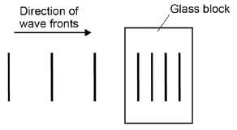
(a) Complete Figure 1 by drawing wave fronts after they have left the glass block.
(1)
(b) Figure 2 shows a ray of light incident on a semi-circular glass block.
Figure 2
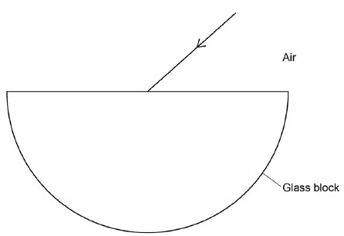
Complete the ray diagram in Figure 2.
• Draw the ray of light passing through and leaving the glass block.
• Label the angle of refraction.
(4)
(c) Explain why the light is refracted.
___________________________________________________________________
___________________________________________________________________
___________________________________________________________________ (2)
(d) A student investigated how different coloured light was refracted by glass.
The student aimed rays of different coloured light at a glass block.
She measured the angle of refraction for each colour.
Give two variables that the student should control.
1. _________________________________________________________________
2. _________________________________________________________________
(2)
The table shows the student's results.

Colour of light | Angle of refraction in degrees
Red | 27.94
Orange | 27.90
Yellow | 27.82
Green | 27.78
Blue | 27.70
(e) Explain why these results could not have been obtained with a normal protractor.
___________________________________________________________________
___________________________________________________________________
___________________________________________________________________
___________________________________________________________________
(2)
(f) What conclusion can be made about the relationship between the wavelength of light and the angle of refraction?
___________________________________________________________________
___________________________________________________________________
(1)
(g) Glass does not transmit ultraviolet radiation.
Suggest what happens to ultraviolet radiation when it is incident on glass.
___________________________________________________________________
___________________________________________________________________
(1)
(Total 13 marks)

