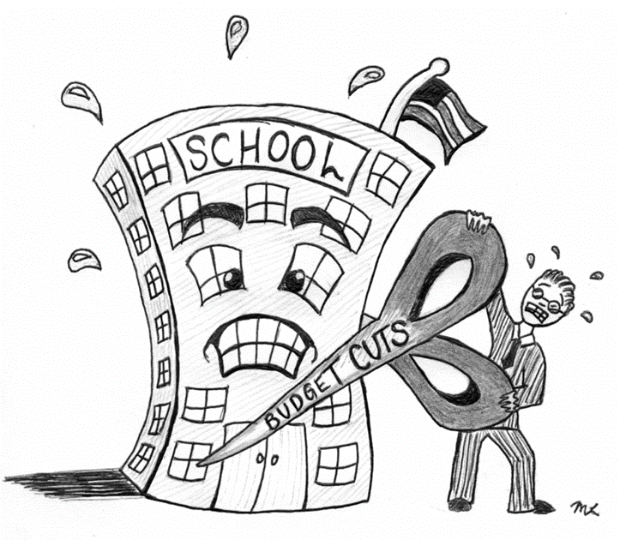

**Vocabulary:**

Ostentatious

Soporific

Tenacious

Vindictive

Zealous



**ENGLISH**

**Year 7 – Autumn 2 – Homework 7**

**Date:**

**Details:** Write the opening of a story that begins with this sentence: Last Friday began like any other day.

Name:

English Group:

Teacher:

Technical Accuracy Effort Grade:

/ 4

**Peer Assessment Feedback:**

1. Highlight and label the ingredients that were given in the challenge
2. Circle any errors
3. Give a positive comment (WWW) in terms of content and structure
4. Give a target for improvement (EBI)
5. Sign and date your peer assessment

Use GREEN pen

……………………………………………………………………………………………………………………………………………………………………………………………………………………………………………………………………………………………………………………………………………………………………………………………………………………………………………………………………………………………………………………………………………………………………………………………………………………………………………………………………………………………………………………………………………………………………………………………………………………………………………………………………………………………………………………………………………………………………………………………………………………………………………………………………………………………………………………………..………………………………………………………………………………………………………………………………………………………………………………………………………………………………………………………………………………………………………………………………………………………………………………………………………………………………………………………………………………………………………………………………………………………………………………………………………………………………………………………………………………………………………………………………………………………………………………………………………………………………………………………………………………………………………………………………………………………………………………………………………………………………………………………………………………………………………

……………………………………………………………………………………………………………………………………………………………………………………………………………………………………………………………………………………………………………………………………………………………………………………………………………………………………………………………………………………………………………………………………………………………………………………………………………………………………………………………………………………………………………………………………………………………………………………………………………………………………………………………………………………………………………………………………………………………………………………………………………………………………………………………………………………………………………………………………………………………………………………………………………………………………………………………………………………………………………………………………………………………………………………………………………………………………………………………………………………………………………………………………………………………………………………………………………………………………………………………………………………………………………………

**Ingredients to Include:**

* **Anthropomorphism (giving animals human qualities)**
* **A sentence that begins unbeknownst to me…**
* **An exclamation !**
* **An ellipsis…**
* **A one sentence paragraph**