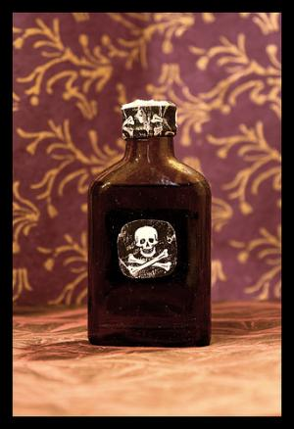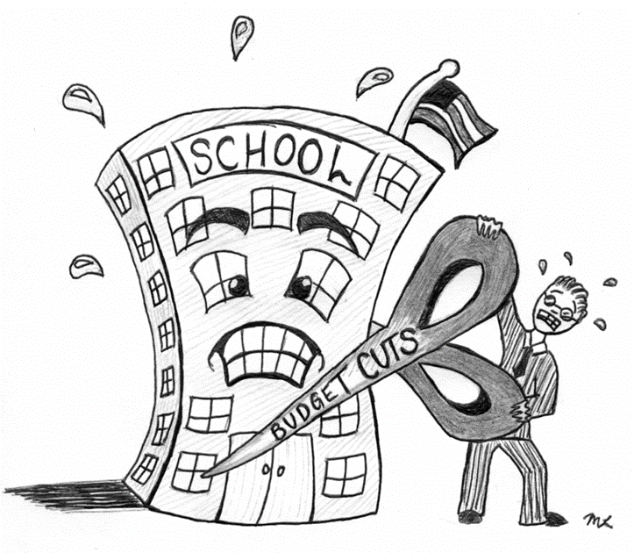

**Vocabulary:**

Alacrity

Animosity

Antithesis

Avarice

Benevolence

Conjecture

Crescendo

Dichotomy

Discord

Discrepancy

**Ingredients to Include:**

* **It was evident that..**
* **A metaphor**
* **Sensory detail : smell**
* **Personify the books as witnesses to the crime**
* **A semi colon ;**

Name:

English Group:

Teacher:



**ENGLISH**

**Year 10 – Autumn 2 Homework 3**

**Date:**

**Details:** Miss Scarlet murdered Mr Black in the library with poisoned ink. Write the final scene of a detective story where this crime is explained.

Technical Accuracy Effort Grade:

/ 4

**Peer Assessment Feedback:**

1. Highlight and label the ingredients that were given in the challenge
2. Circle any errors
3. Give a positive comment (WWW) in terms of content and structure
4. Give a target for improvement (EBI)
5. Sign and date your peer assessment

Use GREEN pen

……………………………………………………………………………………………………………………………………………………………………………………………………………………………………………………………………………………………………………………………………………………………………………………………………………………………………………………………………………………………………………………………………………………………………………………………………………………………………………………………………………………………………………………………………………………………………………………………………………………………………………………………………………………………………………………………………………………………………………………………………………………………………………………………………………………………………………………………..………………………………………………………………………………………………………………………………………………………………………………………………………………………………………………………………………………………………………………………………………………………………………………………………………………………………………………………………………………………………………………………………………………………………………………………………………………………………………………………………………………………………………………………………………………………………………………………………………………………………………………………………………………………………………………………………………………………………………………………………………………………………………………………………………………………………………

……………………………………………………………………………………………………………………………………………………………………………………………………………………………………………………………………………………………………………………………………………………………………………………………………………………………………………………………………………………………………………………………………………………………………………………………………………………………………………………………………………………………………………………………………………………………………………………………………………………………………………………………………………………………………………………………………………………………………………………………………………………………………………………………………………………………………………………………………………………………………………………………………………………………………………………………………………………………………………………………………………………………………………………………………………………………………………………………………………………………………………………………………………………………………………………………………………………………………………………………………………………………………………………