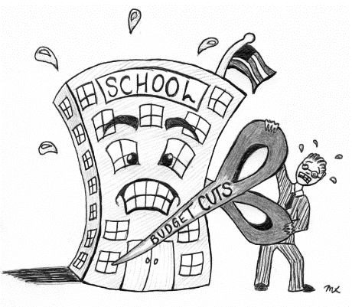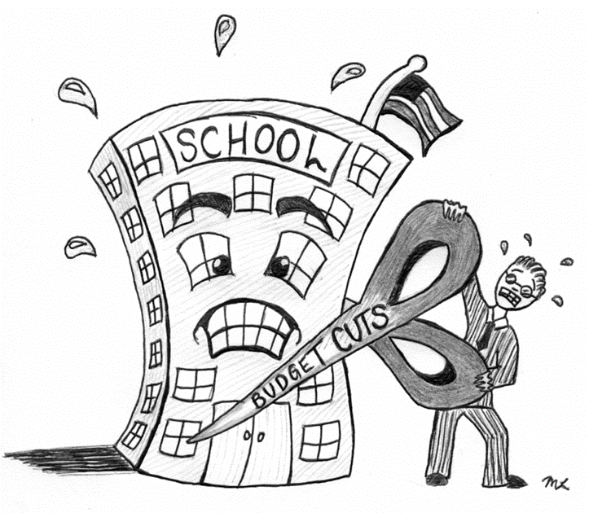



**ENGLISH**

**Year 9 – Autumn 2 – Homework 2**

**Date:**

**Details:** Budget cuts mean one subject must be cut from the curriculum: pick a subject and write a letter to the minister for education arguing why it should or shouldn’t be cut.

Name:

English Group:

Teacher:

Technical Accuracy Effort Grade:

/ 4

**Peer Assessment Feedback:**

1. Highlight and label the ingredients that were given in the challenge
2. Circle any errors
3. Give a positive comment (WWW) in terms of content and structure
4. Give a target for improvement (EBI)
5. Sign and date your peer assessment

Use GREEN pen

……………………………………………………………………………………………………………………………………………………………………………………………………………………………………………………………………………………………………………………………………………………………………………………………………………………………………………………………………………………………………………………………………………………………………………………………………………………………………………………………………………………………………………………………………………………………………………………………………………………………………………………………………………………………………………………………………………………………………………………………………………………………………………………………………………………………………………………………..………………………………………………………………………………………………………………………………………………………………………………………………………………………………………………………………………………………………………………………………………………………………………………………………………………………………………………………………………………………………………………………………………………………………………………………………………………………………………………………………………………………………………………………………………………………………………………………………………………………………………………………………………………………………………………………………………………………………………………………………………………………………………………………………………………………………………

……………………………………………………………………………………………………………………………………………………………………………………………………………………………………………………………………………………………………………………………………………………………………………………………………………………………………………………………………………………………………………………………………………………………………………………………………………………………………………………………………………………………………………………………………………………………………………………………………………………………………………………………………………………………………………………………………………………………………………………………………………………………………………………………………………………………………………………………………………………………………………………………………………………………………………………………………………………………………………………………………………………………………………………………………………………………………………………………………………………………………………………………………………………………………………………………………………………………………………………………………………………………………………………

**Vocabulary:**

**Advanced verbs**

Amass

Arbitrate

Cajole

Debase

Discombobulate

**Ingredients to Include:**

* **Epistrophe (repetition of words at the end of successive clauses or sentences)**
* **An anecdote**
* **A one sentence paragraph**
* **A shocking statistic**
* **A colon to introduce a list :**