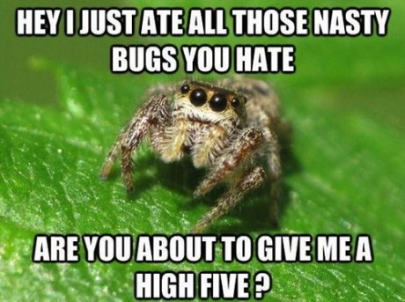

**Vocabulary:**



**ENGLISH**

**Year 8 Homework 10**

**Date:**

**Details:** ‘Spiders are our friends - if left alone, they will consume most of the insects in our homes.’ Write a newspaper article arguing for or against this statement.

Technical Accuracy Effort Grade:

/ 4

**Peer Assessment Feedback:**

1. Highlight and label the ingredients that were given in the challenge
2. Circle any errors
3. Give a positive comment (WWW) in terms of content and structure
4. Give a target for improvement (EBI)
5. Sign and date your peer assessment

Use GREEN pen

……………………………………………………………………………………………………………………………………………………………………………………………………………………………………………………………………………………………………………………………………………………………………………………………………………………………………………………………………………………………………………………………………………………………………………………………………………………………………………………………………………………………………………………………………………………………………………………………………………………………………………………………………………………………………………………………………………………………………………………………………………………………………………………………………………………………………………………………..………………………………………………………………………………………………………………………………………………………………………………………………………………………………………………………………………………………………………………………………………………………………………………………………………………………………………………………………………………………………………………………………………………………………………………………………………………………………………………………………………………………………………………………………………………………………………………………………………………………………………………………………………………………………………………………………………………………………………………………………………………………………………………………………………………………………………

……………………………………………………………………………………………………………………………………………………………………………………………………………………………………………………………………………………………………………………………………………………………………………………………………………………………………………………………………………………………………………………………………………………………………………………………………………………………………………………………………………………………………………………………………………………………………………………………………………………………………………………………………………………………………………………………………………………………………………………………………………………………………………………………………………………………………………………………………………………………………………………………………………………………………………………………………………………………………………………………………………………………………………………………………………………………………………………………………………………………………………………………………………………………………………………………………………………………………………………………………………………………………………………

**Ingredients you need to include:**

* **Anthropomorphism**
* **Anaphora (repetition of words at the start of successive clauses or sentences**
* **An expert opinion**
* **An anecdote**
* **Colon to introduce a list :**

Name:

English Group:

Teacher: