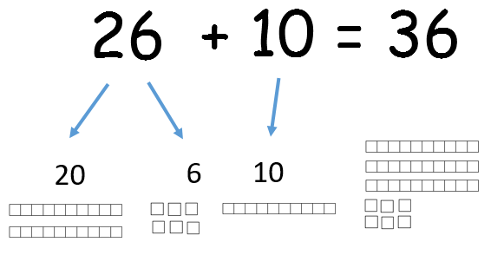

subtract

10 - 1 = 9

10 - 2 = 8

10 - 3 = 7

10 - 4 = 6

10 - 5 = 5

add

+

1 + 9 = 10

2 + 8 = 10

3 + 7 = 10

4 + 6 = 10

5 + 5 = 10

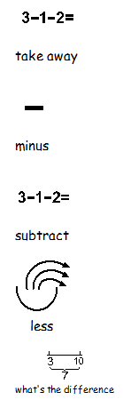

15 - 5

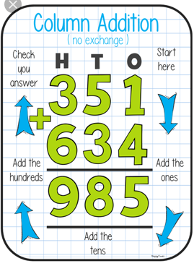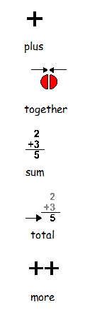

bigger

number

first

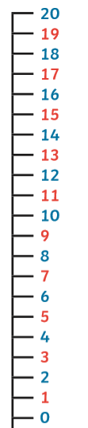

|  |  |
| --- | --- |
| 10 | |
| 8 | 2 |

20 – 7 =

7 – 20 =

[](https://www.google.co.uk/url?sa=i&rct=j&q=&esrc=s&source=images&cd=&ved=2ahUKEwiZqMDqkd_lAhUOyxoKHXnuATsQjRx6BAgBEAQ&url=https%3A%2F%2Fwww.123rf.com%2Fclipart-vector%2Ftick_cross.html&psig=AOvVaw2NIywIoIB-U_7DnjLa911F&ust=1573457961680901)

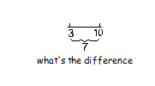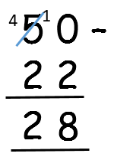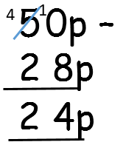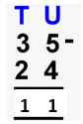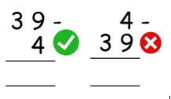[](https://www.google.co.uk/url?sa=i&rct=j&q=&esrc=s&source=images&cd=&ved=2ahUKEwiZqMDqkd_lAhUOyxoKHXnuATsQjRx6BAgBEAQ&url=https%3A%2F%2Fwww.123rf.com%2Fclipart-vector%2Ftick_cross.html&psig=AOvVaw2NIywIoIB-U_7DnjLa911F&ust=1573457961680901)[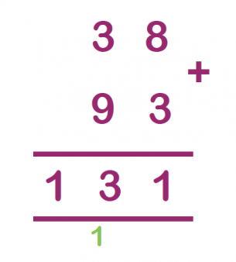](https://www.google.co.uk/url?sa=i&rct=j&q=&esrc=s&source=images&cd=&ved=2ahUKEwiWzpPcjN_lAhWNx4UKHesMDSAQjRx6BAgBEAQ&url=https%3A%2F%2Fwww.theschoolrun.com%2Fwhat-is-the-column-method&psig=AOvVaw2xt8H2uR25nz4D9dTDcOMf&ust=1573456584818136)

bigger

number

on top

11 + 9 = 20

12 + 8 = 20

13 + 7 = 20

14 + 6 = 20

15 + 5 = 20

10 + 10 = 20

10 + 7

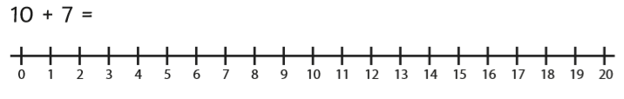

|  |  |
| --- | --- |
| 01 | January |
| 02 | February |
| 03 | March |
| 04 | April |
| 05 | May |
| 06 | June |
| 07 | July |
| 08 | August |
| 09 | September |
| 10 | October |
| 11 | November |
| 12 | December |

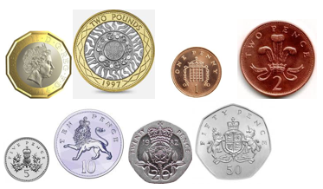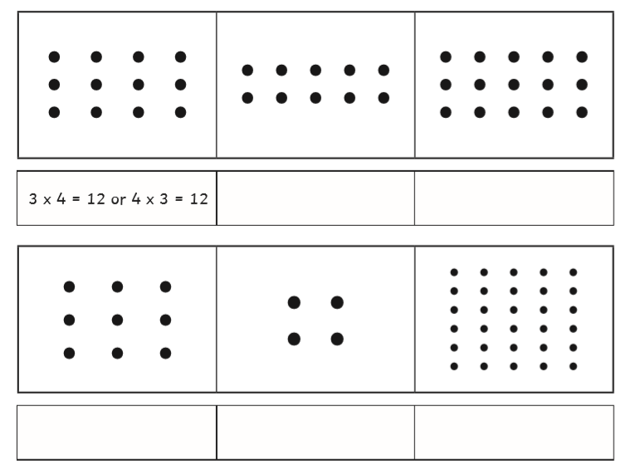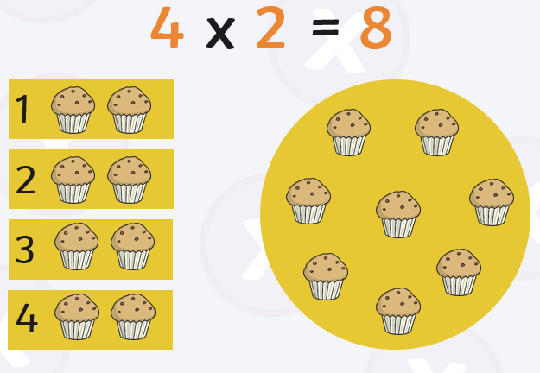

multiply

x



5

10

15

20

25

30

35

40

45

50

3

6

9

12

15

18

21

24

27

30

1 x 2 = 2

2 x 2 = 4

3 x 2 = 6

4 x 2 = 8

5 x 2 = 10

6 x 2 = 12

7 x 2 = 14

8 x 2 = 16

9 x 2 = 18

10 x 2 = 20

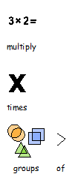



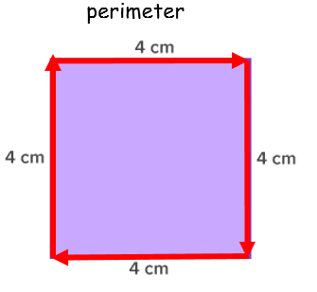

|  |  |  |  |  |
| --- | --- | --- | --- | --- |
| 6 7 13 | | | | |
| 6 | + | 7 | = | 13 |
| 7 | + | 6 | = | 13 |
| 13 | - | 6 | = | 7 |
| 13 | - | 7 | = | 6 |

|  |  |  |  |  |
| --- | --- | --- | --- | --- |
| 20 5 4 | | | | |
| 5 | X | 4 | = | 20 |
| 4 | + | 5 | = | 20 |
| 20 | ÷ | 4 | = | 5 |
| 20 | ÷ | 5 | = | 4 |

