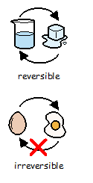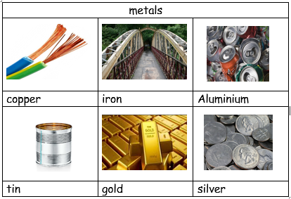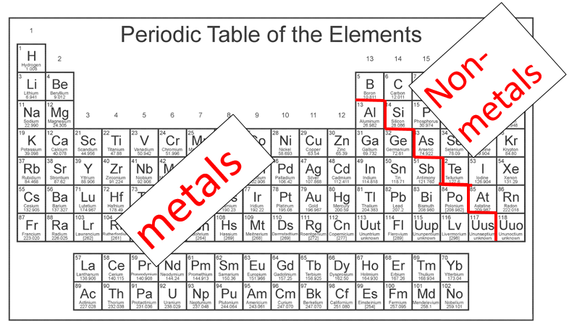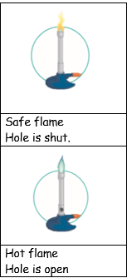[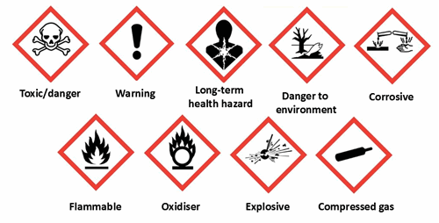](https://www.google.co.uk/url?sa=i&rct=j&q=&esrc=s&source=images&cd=&cad=rja&uact=8&ved=2ahUKEwiOgsCZ79zlAhUCNRoKHWnCD2MQjRx6BAgBEAQ&url=%2Furl%3Fsa%3Di%26rct%3Dj%26q%3D%26esrc%3Ds%26source%3Dimages%26cd%3D%26ved%3D%26url%3Dhttps%253A%252F%252Fwww.britsafe.org%252Ftraining-and-learning%252Ffind-the-right-course-for-you%252Fwhat-is-coshh%252F%26psig%3DAOvVaw3Gfdo-Jz_jigbQ03FILxE9%26ust%3D1573379936065464&psig=AOvVaw3Gfdo-Jz_jigbQ03FILxE9&ust=1573379936065464)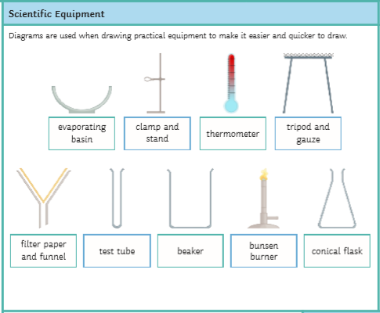

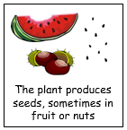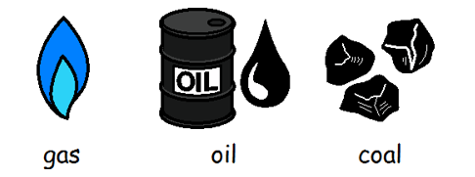

Gas and oil and coal are **fossil fuels.**

They come from under the ground.

They are made of carbon.

They will run out.



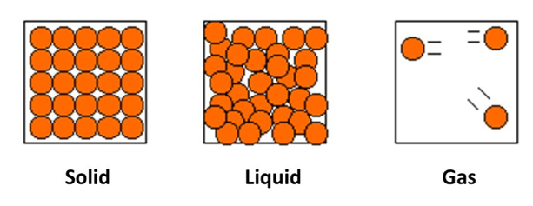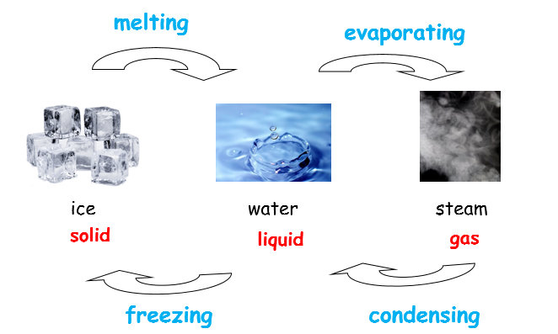

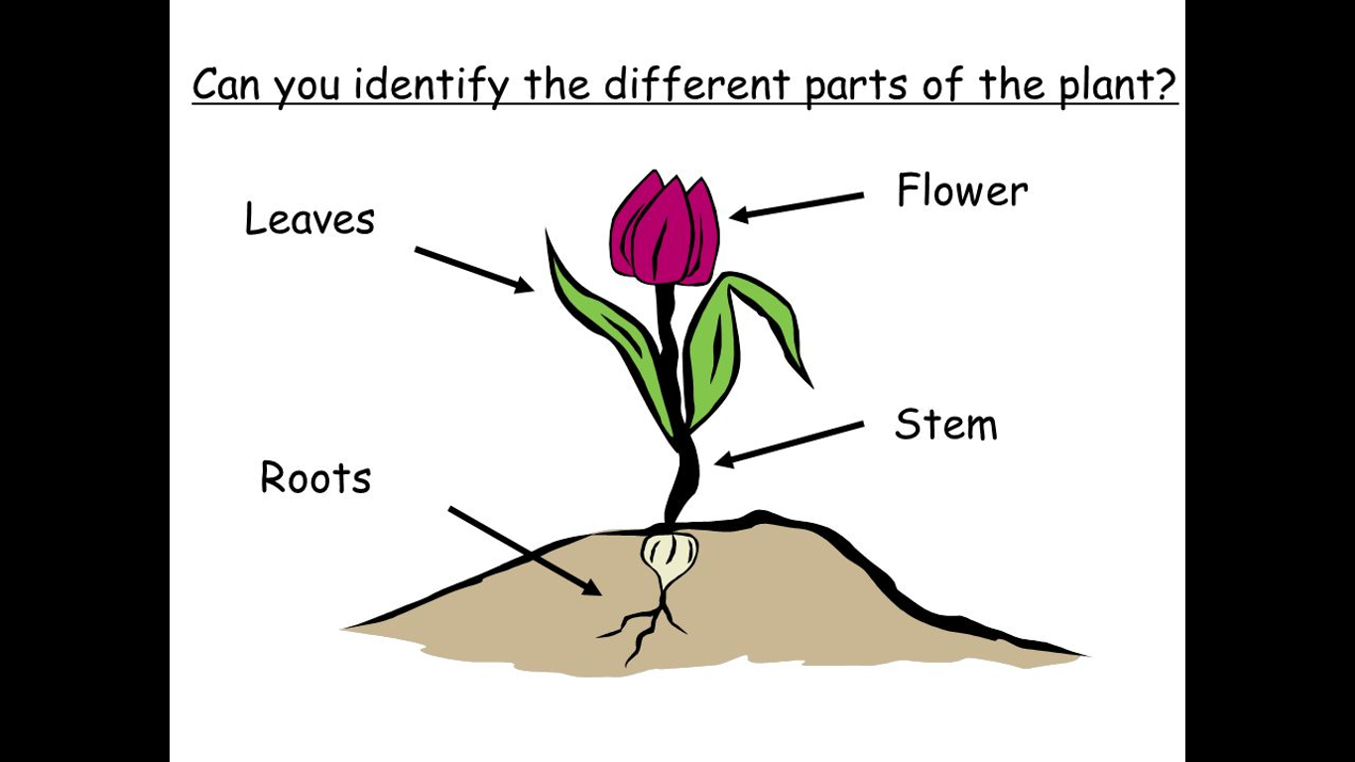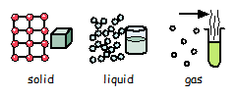

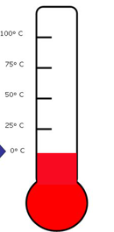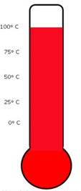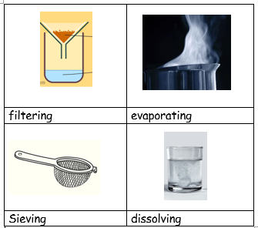

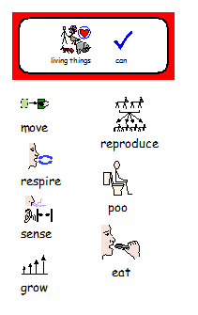



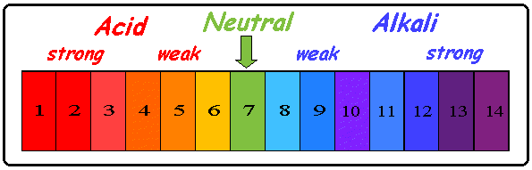

[](https://www.google.co.uk/url?sa=i&rct=j&q=&esrc=s&source=images&cd=&ved=2ahUKEwiLh4re-NzlAhUkx4UKHad4BVQQjRx6BAgBEAQ&url=https%3A%2F%2Fwww.toppr.com%2Fguides%2Fscience%2Fsorting-materials-into-groups%2Fproperties-of-materials%2F&psig=AOvVaw1mDg1An20vqJ7Z4kDWamJT&ust=1573382500835176)