Being at home can be hard! Roll the dice & answer the questions to win a point. |  | 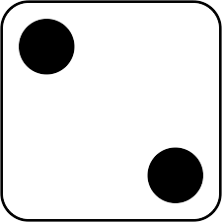 | 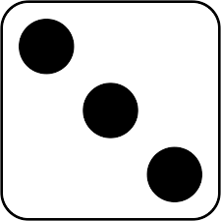 | 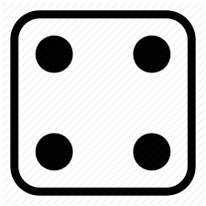 | 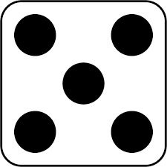 | 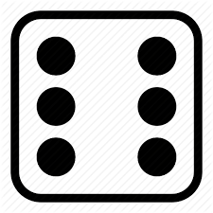
 | Name three expected life events.  3 | How can low self-esteem be an obstacle to following a health plan?  2 | Give an example of a time constraint obstacle.  1 | Give an example of informal support.  1 | What does “acceptance of current state” mean?  2 | Name three long term effects of stress.  3
 | Name the four types of lifestyle data.  4 | Name two effects of noise pollution  2 | What does SMART stand for?  5 | What is the negative definition of health and wellbeing?  2 | How long is a short-term target?  1 | What is the difference between a goal and an action?  2
 | Name three negative effects of smoking.  3 | Name three effects of eating too much.  3 | Name three short term effects of stress.  3 | How long is a long-term target?  1 | Name two chronic illnesses.  2 | Name two conditions caused by bacteria from poor personal hygiene.  2
 | When an illness is acute, is it short or long term?  1 | What type of peak flow is bad – high or low?  1 | Name two effects of low BMI?  2 | Name three causes of high blood pressure?  3 | Name three unexpected life events.  3 | Give an example of formal support.  1
 | What is considered a “healthy” BMI range?  1 | Describe the effects of living in a small home in the city.  4 | What is the positive definition of health and wellbeing?  2 | What is considered a “normal” resting pulse rate?  1 | What does a person centred approach mean?  2 | Name three effects of eating too little.  3
 | Name two genetically inherited conditions.  2 | What does physiological mean?  1 | Name two benefits of exercising.  2 | Name two effects of high blood pressure?  2 | What does “predisposition” mean in genetics?  1 | What is a geographical barrier?  1

