#LearningAtHome2020 L.O: To be able to describe physical events
Do Now: What is an expected life event? What is an unexpected life event? Can you give an example?

You’ve heard of life events, what are these?

Now, we will look at physical events. Starting with accident and injury.

How physical events may impact growth and development.
- Affects diet, causing a delay in growth
- Isolation and difficulty in building relationships
- Impacts on intellectual development
- Impacts on life chance
- Impacts on income
- Temporary or permanent loss of independence
- Causes negative self-image/self-esteem
- Restricts mobility and fine motor control
Think: ISL
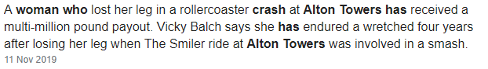
What is the impact on the person?
What about the family? Think PIES
Coronavirus: How does it affect people physically? How has it affected you? Explain the physical changes and choose one other developmental change from PIES.
