NUSA
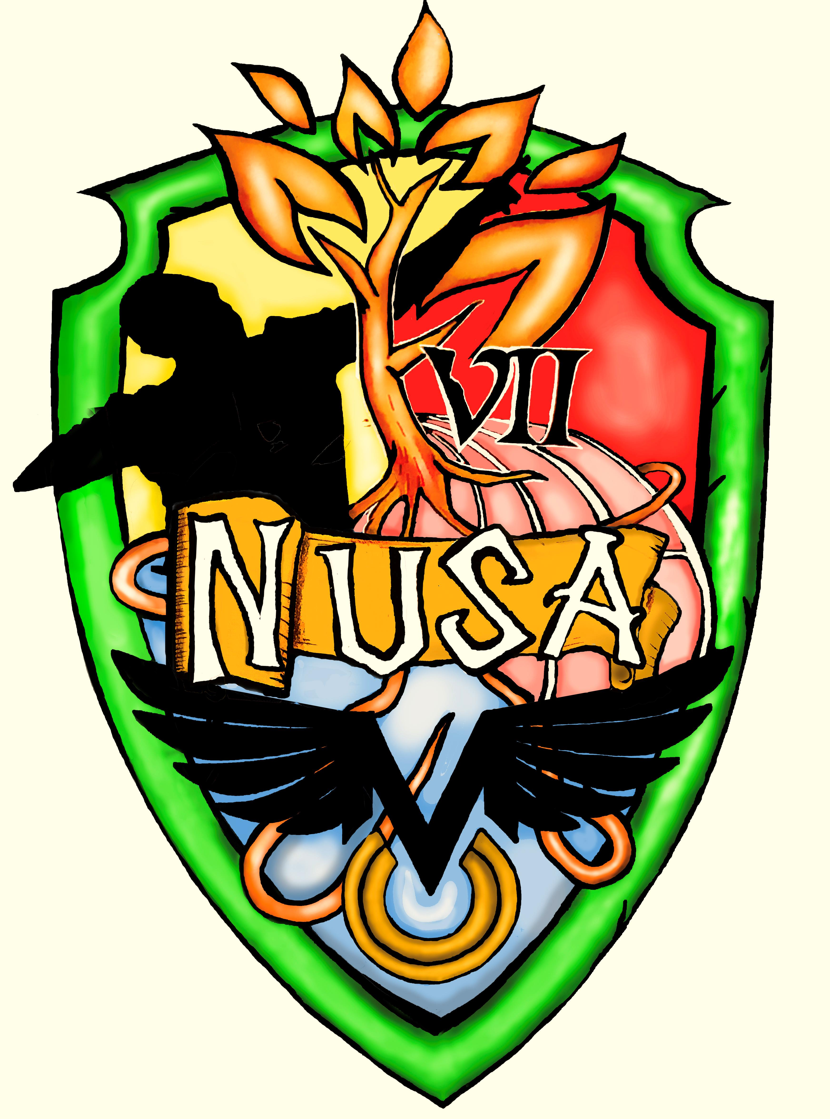
GCSE PE scheme of work
OCR 2016 Specification

Component 01: The Physical Factors Affecting Performance
&
Component 02: Socio- Cultural Issues and Sports Psychology

Table 1: The table outlines the scheme of work for designed for the OCR 2018 1-9 GCSE Physical Education specification beginning in year 9.
Week number | 1.1 Applied Anatomy and Physiology | Homework | Whole School Calendar
1 | Course introduction and expectations of each student  - Literacy project: Identify, Describe and Explain
2 | Course introduction and expectations of each student  - Literacy project: Identify, Describe and Explain
3 | Topic 1.1.a: The Structure and Function of the Skeletal System.  - Location of major bones
4 | Location of major bones | Complete relevant exam questions in ‘GCSE PE Bible’.
5 | Function of the skeleton |  | Keep Up  PD: Kids Having Kids
6 | Function of the skeleton | Complete relevant exam questions in ‘GCSE PE Bible’.
7 | Types of synovial joint
8 | Types of synovial joint | October half term: Complete relevant exam questions in ‘GCSE PE Bible’.
October half term

1 | Other components of joints
2 | Other components of joints | Complete relevant exam questions in ‘GCSE PE Bible’. | 9PC1
3 | Topic 1.1.b: The Structure and Function of the Muscular System.  - Location of major muscle groups
4 | Location of major muscle groups | Complete relevant exam questions in ‘GCSE PE Bible’.
5 | The roles of muscle in movement |  | Parents Evening
6 | The roles of muscle in movement
Christmas holidays

1 | The roles of muscle in movement | Christmas half term: Complete relevant exam questions in ‘GCSE PE Bible’.
2 | Topic 1.1.c: Movement analysis.  - Lever systems
3 | Lever systems |  | PD SRE drop down day
4 | Lever systems | Complete relevant exam questions in ‘GCSE PE Bible’.
5 | Planes of movement and axes of rotation | Revision
6 | Planes of movement and axes of rotation | February half term: Complete relevant exam questions in ‘GCSE PE Bible’.
February half term

1 | Planes of movement and axes of rotation | Revision
2 | Revision: Strategies and how to revise.  **End of unit assessment | Revision
3 | Exam feedback and follow up tasks | Follow up tasks
4 | Topic 1.1.d: The Cardiovascular and Respiratory System.  - Structure and Function of the Cardiovascular System  - GCSE PE Bible doc. |  | Exams
5 | Structure and Function of the Cardiovascular System | Complete relevant exam questions in ‘GCSE PE Bible’. | Exams
6 | Structure and Function of the Cardiovascular System | Complete relevant exam questions in ‘GCSE PE Bible on areas of weaknesses based upon mock paper.  - HA- Complete x4 P.E.A paragraphs  - MA- Complete x2 P.E.A paragraphs  - LA- Complete x1 P.E.A paragraph.
Easter half term

1 | Structure and Function of the Cardiovascular System  How to structure a P.E.A paragraph |  | PC.2
2 | Structure and Function of the Respiratory System
3 | Structure and Function of the Respiratory System
4 | Structure and Function of the Respiratory System | Complete relevant exam questions in ‘GCSE PE Bible’.
5 | Aerobic and anaerobic exercise
Half term

1 | Aerobic and anaerobic exercise  - How to structure a P.E.A paragraph | Complete relevant exam questions in ‘GCSE PE Bible on areas of weaknesses based upon mock paper.  - HA- Complete x4 P.E.A paragraphs  - MA- Complete x2 P.E.A paragraphs  - LA- Complete x1 P.E.A paragraph.
2 | Revision: Strategies and how to revise.  **End of unit assessment | Revision
3 | Exam feedback and follow up tasks | Follow up tasks
4 | Topic 1.1.e: Effects of exercise on body systems.  Short term effects of exercise |  | PD Prison Me No Way!
5 | Short term effects of exercise | Complete relevant exam questions in ‘GCSE PE Bible’.
6 | Long term effects of exercise |  | Disco
7 | Activities Week
8 | Monday- Assemblies  Tuesday- INSET DAY
End of school year!!!

