N USA
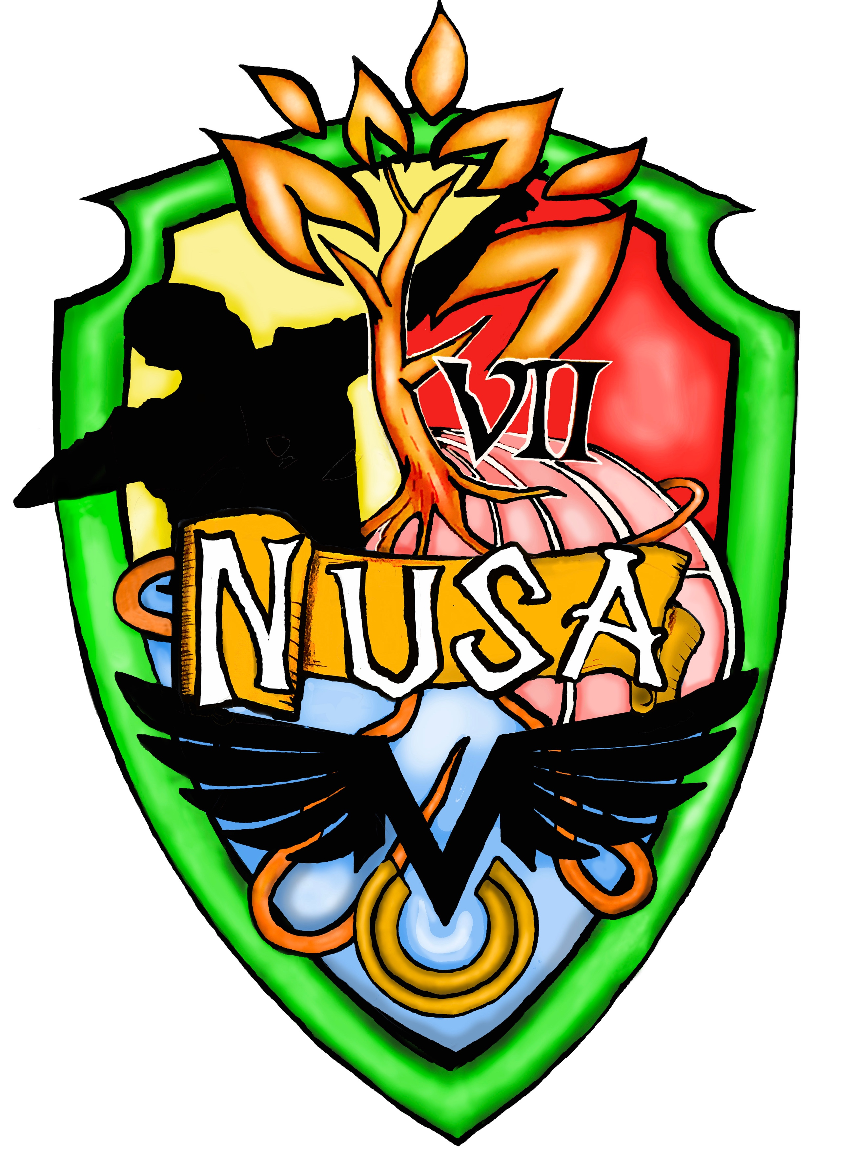
GCSE PE scheme of work
OCR 2016 Specification

Component 01: The Physical Factors Affecting Performance
&
Component 02: Socio- Cultural Issues and Sports Psychology

Table 1: The table outlines the scheme of work for designed for the OCR 2018 1-9 GCSE Physical Education specification beginning in year 10.
Week number | 1.1 Applied Anatomy and Physiology &  2.1 Socio- cultural influences | Interleaving  Topic | Homework | Whole School Calendar
1 | Welcome back and expectations of each student.  Catch up on previous topics
2 | Catch up on previous topics
3 | Topic 1.2. Physical training.  Topic 1.2.a: Components of fitness.  - Components of fitness | Location of major bones
4 | Components of fitness | Location of major bones
5 | Components of fitness | Function of the skeleton | Complete relevant exam questions in ‘GCSE PE Bible’ and x1 P.E.A paragraph.
6 | Components of fitness | Function of the skeleton
7 | Components of fitness | Types of synovial joint | Complete relevant exam questions in ‘GCSE PE Bible’ and x1 P.E.A paragraph.
8 | Components of fitness  - How to structure a P.E.A paragraph | Types of synovial joint
October half term

1 | Topic 1.2.b: Applying the principles of training.  - Principles of training | Other components of joints |  | 10 PC.1
2 | Principles of training | Other components of joints | Complete relevant exam questions in ‘GCSE PE Bible’ and x1 P.E.A paragraph.
3 | Optimising training | Location of major muscle groups
4 | Optimising training | Location of major muscle groups | Complete relevant exam questions in ‘GCSE PE Bible’ and x1 P.E.A paragraph. | Parents evening
5 | Optimising training | The roles of muscle in movement
6 | Optimising training  - How to structure a P.E.A paragraph | The roles of muscle in movement | Christmas half term: Complete relevant exam questions in ‘GCSE PE Bible’.  - HA- Complete x4 P.E.A paragraphs  - MA- Complete x2 P.E.A paragraphs  - LA- Complete x1 P.E.A paragraph. | A Christmas Carol English Performance PM
Christmas holidays

1 | Topic 1.3.c: Preventing injury in physical activity and training.  - Prevention of injury | The roles of muscle in movement
2 | Prevention of injury | Lever systems | Revision | Finance Education Exam
3 | Revision | Lever systems | Revision | Big Bang event
4 | Revision  **End of unit assessment FULL PAPER 01 |  | Follow up tasks | Exams
5 | Section 02: Content of Socio- cultural issues and sports psychology  2.1 Socio- cultural influences  Topic 2.2.a: Engagement patterns of different social groups in physical activities and sports.  - Physical activity and sport in the UK | Planes of movement and axes of rotation
6 | Physical activity and sport in the UK | Planes of movement and axes of rotation | Complete relevant exam questions in ‘GCSE PE Bible’ and x2 P.E.A paragraphs. | 10 PC.2
February half term

1 | Participation in physical activity and sport | Planes of movement and axes of rotation
2 | Participation in physical activity and sport | Structure and Function of the Cardiovascular System
3 | Topic 2.1.b: Commercialisation of physical activity and sport.  - Commercialisation of sport | Structure and Function of the Cardiovascular System
4 | Commercialisation of sport | Structure and Function of the Cardiovascular System | Complete relevant exam questions in ‘GCSE PE Bible on areas of weaknesses based upon mock paper.  - HA- Complete x4 P.E.A paragraphs  - MA- Complete x2 P.E.A paragraphs  - LA- Complete x1 P.E.A paragraph.
5 | Topic 2.1.c: Ethical and socio- cultural issues in physical activity and sport.  - Ethics in sport | Structure and Function of the Respiratory System |  | Maths Feast- UoN PM  Media Trip to UoN
6 | Ethics in sport | Structure and Function of the Respiratory System | Complete relevant exam questions in ‘GCSE PE Bible’ and x2 P.E.A paragraphs.
Easter half term

1 | Drugs in sport | Structure and Function of the Respiratory System
1 | Drugs in sport | Aerobic and anaerobic exercise
2 | Violence in sport | Aerobic and anaerobic exercise
3 | Violence in sport | Short term effects of exercise | Revision
4 | Revision  **End of unit assessment
5 | Exam feedback and follow up tasks | Short term effects of exercise | Follow up tasks
Half term

1 | 2.2 Sports psychology  - Characteristics of skilful movement | Short term effects of exercise
2 | Characteristics of skilful movement | Long term effects of exercise |  | Work Experience
3 | Characteristics of skilful movement | Long term effects of exercise | Complete relevant exam questions in ‘GCSE PE Bible’ and x2 P.E.A paragraphs.
4 | Classification of skills | Long term effects of exercise
5 | Classification of skills | Area of specific weakness | Complete relevant exam questions in ‘GCSE PE Bible’ and x2 P.E.A paragraphs. | Exams
6 | Classification of skills | Area of specific weakness |  | Exams
7 | Activities Week
8 | Monday- Assemblies  Tuesday- INSET DAY
End of school year!!!

