Read the text and put a cross next to the three correct statements:
X
Hoy es Domingo de Ramos y las celebraciones de Semana Santa acaban de empezar en mi pueblo. Aquí, las fiestas de Semana Santa no son tan famosas como las de Sevilla y no atraen a tantos turistas pero son importantes y a toda la población le gusta participar en esta tradición católica que existe desde hace siglos.
Esta mañana, vi desde el balcón de mi habitación una gran procesión. Había un montón de gente en la calle y todo el mundo tenía una rama de olivo para conmemorar la llegada de Jesucristo en Jerusalén. El paso que llevaba una estatua gigante de Cristo era cubierto de telas bordadas, flores y velas y los costaleros que llevaban el paso andaban muy despacio por la calle, era un espectáculo impresionante.
Mi abuela estaba encantada ya que es una persona muy religiosa y siempre va a misa todos los domingos. Mi padre estaba disfrazado de nazareño y acompañaba el paso con otros miembros de la iglesia. ¡Mi abuela estaba muy orgullosa de su hijo!
Como a muchos jóvenes de mi edad, a mí no me interesan tanto las fiestas religiosas y no voy nunca a la iglesia pero entiendo que las Pascuas son una parte de nuestra cultura y por eso es importante celebrarlas. Para mí, lo mejor de las fiestas son las vacaciones y la comida. Hoy vamos a comer paella, ¡qué rico!
Rosa

Domingo de Ramos – Palm Sunday: first official day of the Holy week.
una rama de oliva – an olive branch
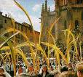

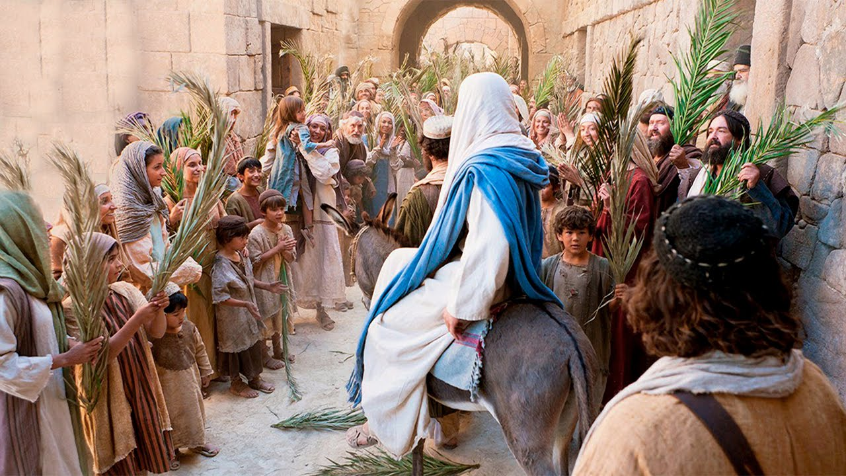

el paso – the float
los costaleros – people carrying the float

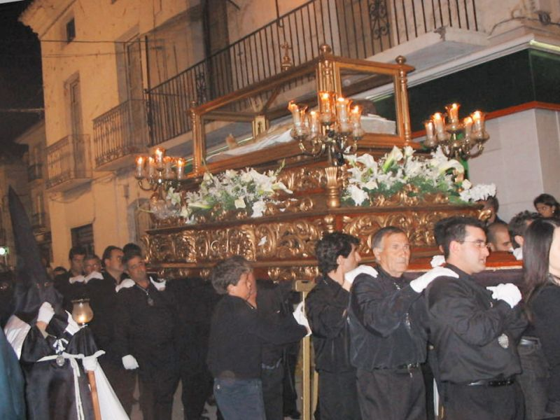

los nazareños – people taking part in the processions as members of a brotherhood representing one same church.

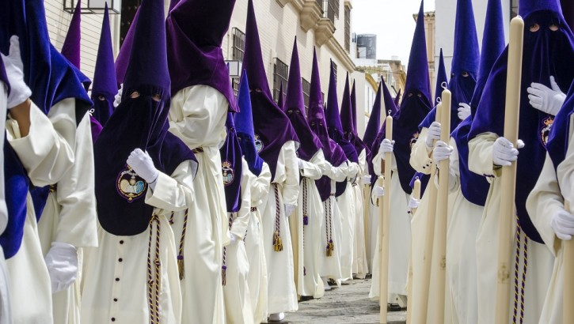

las Pascuas – Easter
la paella – typical Spanish dish in which rice is the main ingredient.
Put a cross next to the three correct statements:
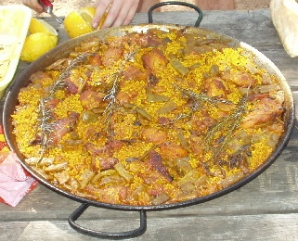
Example: | The Holy week starts on Palm Sunday. | X
 | Rosa was in the street watching the procession.
 | The celebrations are century old.
 | Rosa is a devoted catholic.
 | Rosa’s grand-mother enjoyed seeing the procession.
 | Rosa’s grand-mother goes to church every week.
 | Rosa’s father was helping carrying the float.
Total: ____ / 3

Answer the following questions in English:
What can we say about Seville’s Holy week celebrations from what Rosa writes in the first paragraph? (2 details)
1 point
________________________________________________________________________
________________________________________________________________________
1 point

What biblical event does el domingo de ramos commemorate?
_________________________________________________________________________
2 points
_________________________________________________________________________

Name three things that can be seen on a float.
_________________________________________________________________________
_________________________________________________________________________
3 points
_________________________________________________________________________

What is Rosa’s attitude towards religion and her country’s catholic traditions?
_________________________________________________________________________
_________________________________________________________________________
3 points
_________________________________________________________________________
Total: ____ / 10

Translate the first paragraph into English.
_____________________________________________________________________________________________________________________________________________________________________________________________________________________________________________________________________________________________________________________________________________________________________________________________________________________________________________________________________________________________________________________________________________________________________________________________________________________________________________________________________________________________________________________________________________________________________________________________________________________________________________________________________________________________________________________________________________________________________________________________________________________________________________________________________________________________________________________________________________________________________________________________________________________________________________________________________________________________________________________________________________________________________________________________________________________

Total: ____ / 7

