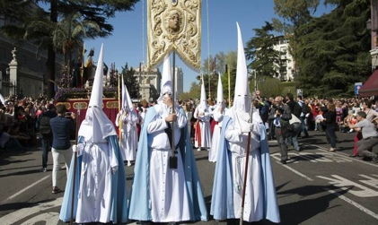
La semana santa

Read the slides about Easter in Spain and answer to questions below:

What are the following words in Spanish:

Candles ________________________
Easter ________________________
Processions ________________________
Church ________________________
Costumes ________________________
Palm Sunday ________________________
Brotherhood ________________________
Sins ________________________
Hoods ________________________
Cross ________________________

Name two cities where the most elaborate processions are seen:
__________________________________________________

What do the ‘nazareños’ carry?
__________________________________________________

Name a typical food eaten at Easter in Spain?
__________________________________________________

Explain two differences between how Spain and England celebrate Easter:
__________________________________________________
__________________________________________________
__________________________________________________
__________________________________________________
__________________________________________________

