Volcano Vocabulary
TASK 1: Match up the term with the correct definition.
Term | Definition
- Mantle | - The layer between the crust and the outer core of the earth.
- Magma | - Molten rock flowing from the vent of a volcano during an eruption.
- Volcano | - The rocky outer layer of the earth.
- Active | - A vent in the earth’s surface from which lava pours out during an eruption.
- Lava | - A volcano that hasn’t erupted recently and is not expected to erupt again.
- Eruption | - Molten (liquid) rock beneath the earth’s surface.
- Extinct | - The name of the process in which solids, liquids or gases are expelled through a vent in the earth’s surface.
- Crust | - The centre of the earth which is made of nickel and iron.
11. Core | i. Tiny pieces of rock or lava blasted into the air during a volcanic eruption.
12. Ash | j. A volcano that has erupted recently or is erupting now.

TASK 2: Write a sentence using as many of the terms as you can.

TASK 3: Label the diagram using the missing words.

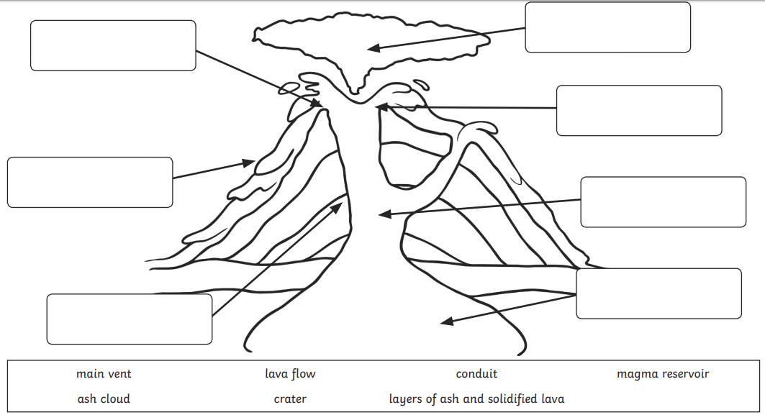
2.
3.
4.
5.
6.
7.
1.
TASK 3: Put the following sentences in the correct order to describe the formation of a volcano.

- Pressure builds up inside the Earth
- The lava from the eruption cools to form new rock
- Magma rises through cracks in the Earth’s crust
- The pressure is released through an eruption of lava
- After several eruptions the rock builds up and a volcano forms

