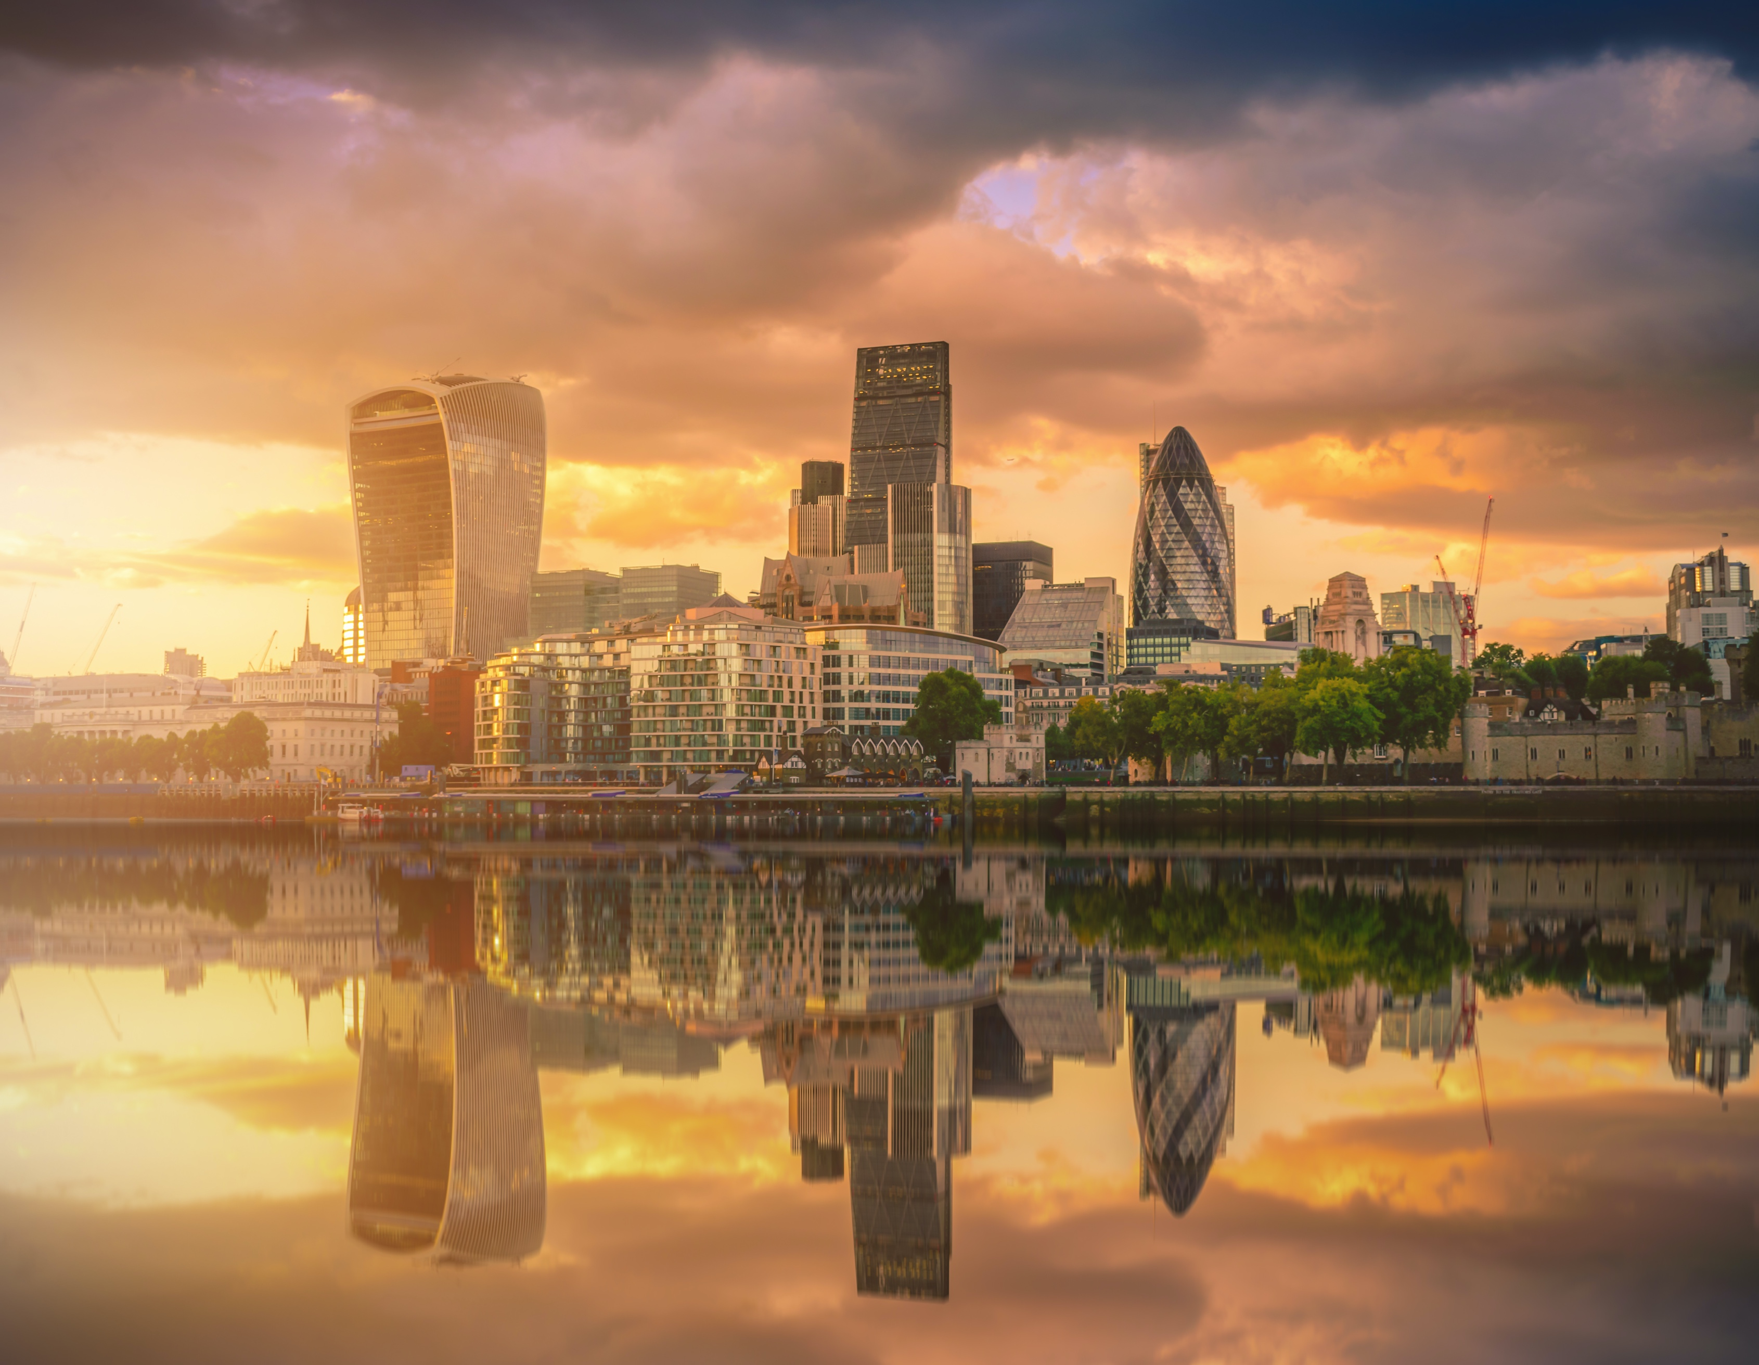
Urban Issues and Challenges
Multiple choice knowledge checker
1. | Urbanisation is increasing around the world. What proportion of the world’s population is predicted to live in urban areas by 2050?
 | A. | 46%
 | B. | 55%
 | C. | 66%
 | D. | 76%
Global Pattern of Urban Change

2. | Which type of country is likely to be more urbanised?
 | A. | LIC
 | B. | NIC
 | C. | HIC

3. | Identify the most urbanised region in the world.
 | A. | South America
 | B. | Europe
 | C. | Asia
 | D. | North America

4. | Urbanisation in HICs tends to be over…
 | A. | 70%
 | B. | 75%
 | C. | 80%
 | D. | 85%

5. | What is happening to the rate of urbanisation in HICs?
 | A. | It is increasing rapidly.
 | B. | It is slowing.
 | C. | It is slowing and reversing in some areas.

6. | What term describes an increase in the number of people moving from urban to rural areas?
 | A. | Urbanisation
 | B. | Counter-urbanisation
 | C. | Immigration
 | D. | International migration

7. | Which countries are experiencing rapid urbanisation?
 | A. | HICs
 | B. | NEEs
 | C. | LICs
 | D. | NEEs and LICs

8. | True or false?  Africa’s population is predominantly rural.
 | A. | True
 | B. | False

9. | Which three countries are expected to account for 37% of the growth in the world’s population between 2014 and 2050?
 | A. | USA, UK and China
 | B. | China, India and the USA
 | C. | China, India and Nigeria
 | D. | Nigeria, China and the USA

10. | True or false?  Urbanisation is one of the most important and challenging trends for the future, creating many issues in both cities and the countryside.
 | A. | True
 | B. | False

11. | Which of the following cause urbanisation?
 | A. | Natural increase
 | B. | Rural to urban migration
 | C. | Urban to rural migration
 | D. | Counter-urbanisation

12. | What causes natural increase?
 | A. | When birth rates are higher than death rates.
 | B. | When death rates are higher than birth rates.
 | C. | When in-migration is higher than out-migration.
 | D. | When out-migration is higher than in-migration.

13. | Migration from the countryside to cities usually results from push and pull factors. Which of the following are push factors?
 | A. | Poor harvest causing a shortage of food.
 | B. | Few-well paid employment opportunities.
 | C. | The prospect of better paid employment.
 | D. | Poor transport infrastructure.

14. | Migration from the countryside to cities usually results from push and pull factors. Which of the following are pull factors?
 | A. | Better schools and healthcare provision.
 | B. | Better public transport facilities and access to services such as water and electricity.
 | C. | Friends and families already living in urban areas encourage others to join them.
 | D. | Limited services such as electricity and fresh water.

15. | What is a megacity?
 | A. | A city with a population of more than 100,000
 | B. | A city with a population of more than 1,000,000
 | C. | A city with a population of more than 10,000,000
 | D. | A city with a population of more than 100,000,000

16. | How many megacities were there in 2015?
 | A. | 8
 | B. | 18
 | C. | 28
 | D. | 38

17. | What is the world’s largest megacity?
 | A. | Delhi
 | B. | Mumbai
 | C. | Mexico City
 | D. | Tokyo

18. | True or false?  The growth of megacities in HICs is slowing down.
 | A. | True
 | B. | False

19. | There are more mega cities in LICs and NEEs than HICs.
 | A. | True
 | B. | False

20. | How many world megacities are there expected to be by 2030?
 | A. | 40
 | B. | 50
 | C. | 60
 | D. | 70

Case Study – Urban Growth in Lagos

21. | True or false?  Lagos is the most populated city in Nigeria.
 | A. | True
 | B. | False

22. | Where is Lagos located within Nigeria?
 | A. | North east
 | B. | North west
 | C. | South west
 | D. | South east

23. | What is the approximate population of Lagos?
 | A. | 5 million
 | B. | 15 million
 | C. | 25 million
 | D. | 35 million

24. | True or false?  Lagos is the capital city of Nigeria.
 | A. | True
 | B. | False

25. | In the past, which colonial country ruled Nigeria?
 | A. | France
 | B. | Spain
 | C. | Germany
 | D. | Britain

26. | Which of the following describe the regional importance of Lagos?
 | A. | It is important in its provision of schools, universities and hospitals.
 | B. | There is a thriving arts and cultural scene.
 | C. | Most large transnational corporations (TNCs) are located here.
 | D. | The city is a transport hub.

27. | Which of the following describe the national importance of Lagos?
 | A. | 80% of Nigeria’s industry is located in Lagos, generating 25% of Nigeria’s GDP.
 | B. | Lagos in Nigeria’s media centre.
 | C. | Lagos is home to most banks, financial institutions and the stock exchange.
 | D. | Lagos has one of the highest standards of living in Nigeria and Africa.

28. | Which of the following describe the international importance of Lagos?
 | A. | There is a thriving arts scene in Lagos.
 | B. | Lagos’ Apapa port is the fifth busiest in West Africa.
 | C. | Lagos has been the location for major sporting events, such as the African Cup of Nations tournament.
 | D. | Lagos is the ICT centre of West Africa, with the largest market on the continent.

29. | True or false?  Lagos is a megacity.
 | A. | True
 | B. | False

30. | Since the 1970s what has drawn many thousands of people to the city?
 | A. | The gold boom
 | B. | The oil boom
 | C. | The gas boom
 | D. | The silver boom

31. | Which of the following are push factors responsible for the growth of the population of Lagos?
 | A. | Poor rural services
 | B. | Low wages
 | C. | Land shortage
 | D. | Better health care

32. | True or false?  The high rate of migration has resulted in a youthful population in Lagos, which in turn has resulted in a high rate of natural increase.
 | A. | True
 | B. | False

33. | Which of the following are examples of social opportunities created by the growth and development of Lagos?
 | A. | Improved healthcare compared to the countryside.
 | B. | The growth of commercial and industrial zones has led to considerable development.
 | C. | State schools, operated by Lagos State Government, offers all children a basic education on the first 9 years.
 | D. | A reasonably reliable water supply is available to the residents of Lagos.

34. | Which of the following are examples of improved economic development created by the growth and development of Lagos?
 | A. | The Lagos Water Corporation claims to supply 12 million people with fresh water.
 | B. | The improved transport infrastructure has attracted many businesses to Lagos.
 | C. | The manufacturing sector in Lagos is dominated by food and beverages, pharmaceuticals and vehicles. The growth in population has increased the market stimulating economic growth.
 | D. | Investment into energy has improved the reliability of electric supplies.

35. | Which of the following are challenges associated with the growth of Lagos?
 | A. | The population is expected to double by 2050.
 | B. | High levels of poverty.
 | C. | The physical growth of the city.
 | D. | A decrease in population.

36. | The lack of affordable housing has led to many people in Lagos living in squatter settlements. Which of the following are characteristics of squatter settlements?
 | A. | Most homes are constructed from waste materials.
 | B. | Over 75% of households live in a single room.
 | C. | Over 50% of households lack a kitchen, bath or toilet.
 | D. | Most homes are provided by the local council.

37. | Identify the slum that is constructed on the Lagos Lagoon.
 | A. | Maliko
 | B. | Maloco
 | C. | Makoko
 | D. | Mukwato

38. | Which sector do the majority of the residents of the slum above work in?
 | A. | Formal sector
 | B. | Informal sector
 | C. | Primary sector
 | D. | Quaternary sector

39. | Why did authorities start to demolish parts of the squatter settlement in 2012?
 | A. | They want to construct an area for wealthy people to moor their boats.
 | B. | They want to drain the lagoon to provide land for economic development.
 | C. | They want to create a ‘Venice of Africa’.

40. | What proportion of people in Makoko have access to safe, piped water?
 | A. | 5 per cent
 | B. | 11 per cent
 | C. | 17 per cent
 | D. | 23 per cent

41. | In Lagos, providing which of the following is a major issue?
 | A. | Food
 | B. | Water supply
 | C. | Sanitation
 | D. | Energy

42. | What steps were taken by the Lagos State Water Regulatory Commission in 2012 to improve access to clean water?
 | A. | It provided clean water directly to all houses.
 | B. | It introduced the regulation of street water vendors.
 | C. | Boreholes were licensed.
 | D. | It began extracting water from Lagos Lagoon and pumped it directly to houses in the local area.

43. | What proportion of the population of Lagos has direct access to safe piped water supplies?
 | A. | 5%
 | B. | 10%
 | C. | 15%
 | D. | 20%

44. | Energy supplies in Lagos are unreliable. What do most large organisations rely on to ensure a consistent supply of energy?
 | A. | Electricity imported from abroad.
 | B. | Back-up generators.
 | C. | Batteries designed by Tesla.

45. | What plans are in place to increase energy production in Lagos?
 | A. | New power stations are planned to include one powered by methane from the Olusosun landfill site.
 | B. | Importing electricity from countries that border Nigeria.
 | C. | The development of the world’s largest solar energy farm.

46. | Which of the following statements is true?
 | A. | Pollution in Lagos Lagoon is reducing due to all houses in the local area having sanitation systems fitted.
 | B. | The Lagos State Water Regulatory Commission is using natural bacteria to reduce the impact of human waste being deposited in the Lagos Lagoon.
 | C. | Lagos Lagoon is heavily polluted with raw sewage.

47. | Which of the following statements are true about healthcare in Lagos?
 | A. | All healthcare must be paid for.
 | B. | Healthcare is available but not always free. There are long queues to see doctors.
 | C. | Investment in healthcare does not match the growth in population.
 | D. | Many wealthier people seek medical help abroad.

48. | Which of the following statements are true about education in Lagos?
 | A. | Although the government offers free education many of the poorest children have to work to earn money for their family.
 | B. | Secondary schools are limited and are usually private.
 | C. | Industries are being encouraged to work with universities to develop relevant courses.
 | D. | University places are free in Lagos.

49. | Which of the following statements are true about unemployment in Lagos?
 | A. | Unemployment is high at 60%.
 | B. | Unemployment is relatively low at 10%.
 | C. | Due to there being no unemployment benefit many people work in the informal sector and do not pay taxes.
 | D. | Since 2016 the Employment Trust has provided loans to help people become self-employed.

50. | Which of the following statements are true about crime in Lagos?
 | A. | Crime rates are very high, particularly those involving drugs, vandalism and theft.
 | B. | Crime rates are rapidly falling in Lagos.
 | C. | Kidnapping and cyber fraud is common.
 | D. | Outbreaks of violence occur between gangs known as ‘Area Boys’.

51. | In Lagos, what proportion of waste is collected by the city authorities?
 | A. | 10%
 | B. | 20%
 | C. | 30%
 | D. | 40%

52. | 13% of the waste taken to landfill is recycled. Who is responsible for this?
 | A. | The city authorities
 | B. | People working informally at landfill sites.
 | C. | International organisations such as Oxfam.
 | D. | TNCs

53. | How much higher is air pollution in Lagos compared to the international recommended limit?
 | A. | Two times higher
 | B. | Five times higher
 | C. | Eight times higher
 | D. | 11 times higher

54. | What is the main source for air pollution in Lagos?
 | A. | Vehicles
 | B. | Industry
 | C. | Poor sanitation

55. | How long does the average commuter in Lagos spend in traffic every day due to congestion?
 | A. | 1 hour
 | B. | 2 hours
 | C. | 3 hours
 | D. | 4 hours

56. | What was opened in 2016 in an attempt to reduce traffic congestion and air pollution?
 | A. | Water taxis
 | B. | A light railway system
 | C. | An electric bus network
 | D. | A city-wide cycle network

57. | Which of the following are features of the 2016 Lagos integrated transport system?
 | A. | An integrated system linking road, rail and waterway.
 | B. | Dedicated bus lanes
 | C. | Improved opportunities for walking and cycling
 | D. | A new underground system

58. | Which of the following are problems faced by the urban poor living in Lagos’ squatter settlements?
 | A. | Poor housing
 | B. | High crime rates
 | C. | Lack of parking spaces for cars
 | D. | Lack of services (water, electricity and sanitation)

59. | Which of the following are examples of government policies to through urban planning, to improve the lives of people living in squatter settlements?
 | A. | All people living in squatter settlements were given rights to the land they settled on.
 | B. | Upgrading schools and health centres as well as well as the provision of bathroom and toilets and sinking boreholes to access fresh water.
 | C. | Increased police and military patrols and more street lighting to make people feel safer.
 | D. | Many local people have been involved in the improvements and developed new skills.

60. | True or false?  More recently the government has been working with local communities to identify their needs and consider strategies for improving people’s lives.
 | A. | True
 | B. | False

Urban Growth in the UK

61. | Approximately what proportion of people in the UK live in urban areas?
 | A. | 74%
 | B. | 78%
 | C. | 82%
 | D. | 86%

62. | Which of the following statements about population distribution in the UK are true?
 | A. | Population density in the UK is the highest in London.
 | B. | The lowest population densities are in the north and west of the UK.
 | C. | Population density is high across England, particularly in major cities.
 | D. | Major cities such as Manchester and Glasgow have a low population density.

63. | Which of the following statements are true about the location of the UK’s major towns and cities?
 | A. | Most major towns and cities are located in England, with relatively few in the west and the north of the UK.
 | B. | Cities are relatively evenly spread across the south of England, but clustered across the north.
 | C. | Cities in the north are located close to sources of raw materials such as coal.
 | D. | Cities in the south west have grown in response to the growing service sector.
Case study of a major city in the UK
For the major city in the UK you have studied create multiple choice questions covering:
- The location of the city
- The importance of the city
- The impacts of national and international migration on the growth and characteristics of the city
- Opportunities resulting from urban change (social and economic)
- Challenges associated with urban growth (social and economic)
- The impact of urban sprawl on the rural-urban fringe

64.
A.
B.
C.
D.

65.
A.
B.
C.
D.

66.
A.
B.
C.
D.

67.
A.
B.
C.
D.

68.
A.
B.
C.
D.

69.
A.
B.
C.
D.

70.
A.
B.
C.
D.

71.
A.
B.
C.
D.

Urban Regeneration in the UK

Olympic Park - London

72. | Where is the Olympic Park located?
 | A. | North London
 | B. | East London
 | C. | South London
 | D. | West London

73. | How was the area characterised before regeneration?
 | A. | Low income housing
 | B. | Poor service provision
 | C. | Large areas of derelict or underused land
 | D. | Affluent neighbourhoods

74. | Why was the area chosen for regeneration?
 | A. | Much of the area was either derelict, abandoned or occupied by low-value land uses.
 | B. | The high level of deprivation meant that it was hoped the area would benefit from the legacy of the Olympic Games in 2012.
 | C. | The area is very accessible from central London.
 | D. | The high quality housing could be regenerated at a relatively low cost.

75. | Identify the main features of the regeneration project.
 | A. | All former residents were promised new accommodation in the area.
 | B. | The purchase of land by the ODA.
 | C. | The decontamination of land formerly used by industry.
 | D. | Electric cables were buried below the ground to improve the look of the area.
 | E. | Natural habitats were created to improve the area’s attractiveness.

76. | Which of the following are features of the area since its transformation?
 | A. | Modern sports facilities.
 | B. | A landscaped park.
 | C. | The athlete’s village has been converted into housing units for local people.
 | D. | A multimillion-pound shopping centre employs hundreds of people from the local area.

Temple Quarter, Bristol
72. | Where is the Temple Quarter located?
 | A. | North Bristol
 | B. | South Bristol
 | C. | Central Bristol
 | D. | East Bristol

73. | How was the area characterised before regeneration?
 | A. | Low income housing
 | B. | Industrial decline
 | C. | Large areas of derelict or underused land
 | D. | Affluent neighbourhoods

74. | Why was the area chosen for regeneration?
 | A. | Much of the area was either derelict, abandoned or occupied by low-value land uses.
 | B. | There were high levels of pollution.
 | C. | The area is very accessible from central Bristol.
 | D. | The high-quality housing could be regenerated at a relatively low cost.

75. | Identify the main features of the regeneration project.
 | A. | All former residents were promised new accommodation in the area.
 | B. | The area has been landscaped, with green areas, footpaths and cycleways.
 | C. | The decontamination of land formerly used by industry.
 | D. | £21 million was spent on improving vehicle, cycling and pedestrian access.
 | E. | New offices, houses and retail areas were constructed.

76. | Which of the following are features of the area since its transformation?
 | A. | Superfast broadband is provided to many companies.
 | B. | Over 2000 new jobs have been created.
 | C. | Land has been cleared and decontaminated.
 | D. | A multimillion-pound science park has been opened.

Urban Sustainability

77. | Which of the following are examples of sustainable urban living?
 | A. | Conserving water and energy
 | B. | Recycling waste
 | C. | Creating green space
 | D. | Urban transport strategies
 | E. | The use of fossil fuel energy solutions.

78. | What is sustainable urban living?
 | A. | Sustainable urban living involves using only renewable energy.
 | B. | Sustainable urban living involves the cultivation of all food in the local area and ensures the opportunities of future generations is not affected.
 | C. | Sustainable urban living offers a good quality of life to current residents but doesn't reduce the opportunities for future residents to enjoy.

79. | Which of the following are examples of conserving water and energy through sustainable urban living?
 | A. | Energy and water conservation involve using less energy by using it more efficiently and reducing waste.
 | B. | Collecting and harvesting grey water in the house, at work and in the community.
 | C. | Using green roofs to harvest rainwater and grow food.
 | D. | Increasing the efficiency of electronic devices such as washing machines.
 | E. | Reducing car parking spaces or charging cars to enter the city centre.

80. | What is grey water?
 | A. | Dirty water from sinks and toilets that is disposed of via sewers.
 | B. | Harvested rainwater used in homes and businesses for flushing toilets and watering gardens rather than using treated water.
 | C. | Water that is distributed from treatment works to homes and businesses.

81. | Which of the following are examples of recycling waste through sustainable urban living?
 | A. | Reducing packaging and recycling materials, so fewer of these end up as waste.
 | B. | Afforestation in urban areas.
 | C. | Using waste to create energy e.g. biogas digesters convert organic food and garden waste into gas.
 | D. | Encouraging communities to grow food and compost organic waste.

82. | Which of the following are benefits of creating green space through sustainable urban living?
 | A. | Flood risk is reduced.
 | B. | Carbon dioxide is absorbed.
 | C. | Valuable ecosystems are created increasing biodiversity.
 | D. | Financial rewards can be given to people who compost green waste.

83. | Which of the following are examples of urban transport strategies through sustainable urban living?
 | A. | Reducing car parking spaces and/or charging to enter a city centre.
 | B. | Making public transport more attractive.
 | C. | Enabling more cyclists on the road by developing cycle networks.
 | D. | Making greater use of insulation.

84. | True or false?  Urban greening absorbs and purifies water.
 | A. | True
 | B. | False

85. | Green roofs on buildings increases the rate that water runs-off into rivers increasing the risk of flooding.
 | A. | True
 | B. | False

86. | True or false?  Traffic congestion is a major issue facing cities, leading to increased levels of air pollution, affecting people’s health.
 | A. | True
 | B. | False

87. | Which German city is a good example of sustainable urban living?
 | A. | Munich
 | B. | Friedberg
 | C. | Freiburg
 | D. | Frankfurt

88. | Which city has reduced traffic by 44 per cent by having automatic road pricing, high vehicle registration fees and high petrol prices?
 | A. | London
 | B. | Bristol
 | C. | Singapore
 | D. | Beijing

89. | True or false?  Water can be naturally recycled by being filtered and cleaned by reed beds then used for flushing toilets and irrigating trees.
 | A. | True
 | B. | False

90. | Permeable pavements allow surface water to seep into the ground, reducing surface run-off and flooding.
 | A. | True
 | B. | False

Answers
1 – C
2 – C
3 – D
4 – A
5 – C
6 – B
7 – D
8 – A
9 – C
10 – A
11 – A and B
12 – A
13 – A, B and D
14 – A, B and C
15 – C
16 – C
17 – D
18 – A
19 – A
20 – A
21 – A
22 – C
23 – B
24 – B
25 – D
26 – A, B and D
27 – A, B and C
28 – B, C and D
29 – A
30 – B
31 – A, B and C
32 – A
33 – A, C and D
34 – B, C and D
35 – D
36 – A, B and C
37 – C
38 – B
39 – C
40 – B
41 – B, C and D
42 - B and C
43 – B
44 – B
45 – A
46 – B
47 – B, C and D
48 – A, B and C
49 – B, C and D
50 – A, C and D

51 – D
52 – B
53 – B
54 – A
55 – C
56 – B
57 – A, B and C
58 – A, B and D
59 – B, C and D
60 – A
61 – C
62 – A, B and C
63 – D
64 –
65 –
66 –
67 –
68 –
69 –
70 –
71 –
Olympic Park - London
72 – B
73 – A, B and C
74 – A, B and C
75 – B, C, D and E
76 – A, B and C

Temple Quarter, Bristol
72 – C
73 – D
74 – D
75 – B, C, D and E
76 – A, B and C

77 – A, B, C and D
78 – C
79 – A, B, C and D
80 – B
81 – A, C and D
82 – A, B and C
83 – A, B and C
84 – A
85 – B
86 – A
87 – C
88 – C
89 – A
90 – A

