Time Periods we need to know:
Key names you should know
SALT Strategic Arms Limitation Talks (SALT) were negotiations between the Soviet Union and the United States to limit the number of newly created nuclear weapons. The first negotiations extended from 1969 to 1972 and resulted in SALT I (the first Strategic Arms Limitation Treaty) in which each side agreed to keep their strategic ballistic missile launchers at their current numbers and provided for the increase in submarine-launched ballistic missiles (SLBM) in proportion to the decrease in number of intercontinental ballistic missiles (ICBM). The second round of negotiations extended from 1972 to 1979 and resulted in SALT II (the second Strategic Arms Limitation Treaty) which provided a broad range of limitations on offensive nuclear weapons.

Mutually assured destruction MAD was the guarantee that if one superpower launched a massive nuclear attack, the other would reciprocate by also launching a massive nuclear attack, and both countries would be destroyed. This ultimately became the prime deterrent against a nuclear war between the two superpowers.

Limited Test Ban Treaty Signed August 5, 1963, this treaty is a worldwide agreement to prohibit nuclear weapons testing in the atmosphere, outer space, or underwater.

deterrence theory A theory that proposed a massive build-up of military and weaponry in order to threaten a destructive counter-attack to any potential attack. The threat was intended to prevent, or deter, anyone from attacking.

DEFCON An acronym for "defense readiness condition." The term is followed by a number (one to five) which informs the U.S. military to the severity of the threat, with DEFCON 5 representing normal, peacetime readiness to DEFCON 1 warning the need for maximum force readiness, i.e. war.

Broken arrow A nuclear bomb that is either lost, stolen, or accidentally launched that causes a nuclear accident. Though broken arrows made great movie plots throughout the Cold War, the most serious real-life broken arrow occurred on January 17, 1966, when a U.S. B-52 crashed off the coast of Spain. Though all four of the nuclear bombs aboard the B-52 were eventually recovered, radioactive material contaminated large areas around the crash site.

brinkmanship Purposely escalating a dangerous situation to the limit (​brink), while giving the impression that you are willing to go to war, in the hope of pressuring your opponents to back down.

Checkpoint Charlie A crossing point between West Berlin and East Berlin when the Berlin Wall divided the city.

Star Wars Nickname (based on the Star Wars movie trilogy) of U.S. President Ronald Reagan's plan to research, develop, and build a space-based system that could destroy incoming nuclear missiles. Introduced March 23, 1983, and officially called the Strategic Defense Initiative (SDI).
1945-1949
- Ideological differences between the USSR and the USA
Yalta and Potsdam
The Iron Curtain
The Truman Doctrine
The Marshall Plan
Cominform and Comecon
The Berlin Blockade and Airlift

1945-55
- NATO
- The Arms Race
- The Koran War
- The Warsaw Pact
- Death of Stalin
- Kruschchev and the thaw
1955-70
- Kruschchev’s policies (destalinisation)
- Hungary 1956
- The Arms race
- The Space Race
- The U2 crisis
- The Berlin Wall
1060’s
- The Cuban Missile Crisis 1962
- Czechoslovakia 1968
- The Brezhnev Doctrine
1970’s and 1980’s
- Detenete
- Soviet invasion of Afghanisatan
- Ronald Regan
- Solidarity
Collapse of Communism
Soviet invasion of Afghanisatan
Ronald Regan
Solidarity
Policies of Gorbachev
The revolutions in Eastern Europe and the fall of the Berlin Wall
The fall of Gorbachev and the breakup of the USSR.

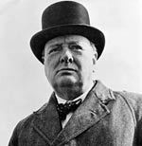 | Winston Churchill  After leading Great Britain in the Second World War, he was one of the first leaders to raise the spectre of an ‘Iron Curtain’ descending across Europe. | 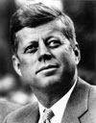 | John F. Kennedy (1917 – 1963) US President (1961-63) As President he helped to defuse the Cuban Missile Crisis which came perilously close to escalation. He delivered a famous speech in West Berlin arguing the Berlin Wall showed the failure of Communism. In 1961, he ordered the expanse of the Space Race programme.
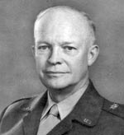 | Dwight Eisenhower  When President of the US 1953-61, he articulated a domino theory – arguing Communism should be stopped before allowing it to spread. He ended the Korean War in 1953, but sent the first US troops to Vietnam and prepared to intervene in Cuba. He made some attempts to limit nuclear weapon proliferation, but this was generally unsuccessful, and nuclear stockpiles increased on both sides. | 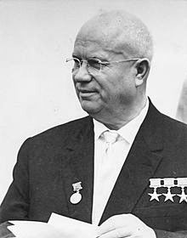 | Nikita Khrushchev (1894 – 1971) Successor to Stalin. He led the Soviet Union from 1953 to 1964 during the tense years of the Cold War. He cut conventional forces, but built up the number of nuclear missiles and was involved in the stand-off when in 1962 missiles were sent to Cuba – an ally of the Soviet Union.
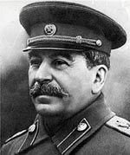 | Joseph Stalin (1879 – 1953) Leader and dictator of the Soviet Union. | 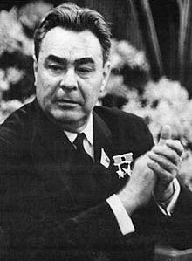 | Leonid Brezhnev (1906-1982) Brezhnev took over from Khrushchev in 1964. He followed a policy of détente with the West – signing treaties to limit the proliferation of nuclear arms. He also ordered the invasion of Czechoslovakia in the Prague Spring of 1968. Brezhnev also ordered Soviet troops into Afghanistan in 1979, rekindling Cold War tensions.
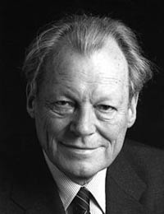 | Willy Brandt (1913-1992) German politician and statesman. After WWII he became the Mayor of Berlin – playing a key role during the Cold War tensions, centred around Berlin. Brandt became Chancellor of Germany in 1979. He sought rapprochement with the East and creating a stronger, united Europe. | 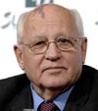 | Mikhail Gorbachev (1931 – ) Russian President from 1984-1991. Gorbachev initiated a policy of Glasnost and Perestroika. These policies of reform and openness led to a decline in Cold War tensions, the fall of the Berlin wall and the ending of Communist party rule in the Soviet Union. He negotiated with Reagan to reduce nuclear weapons, and unlike his predecessors, allowed Eastern European countries to leave the Warsaw Pact and become independent democracies.
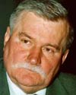 | Lech Walesa. (1943-) Leader of the Polish Solidarity Movement – he helped to bring about the end of one-party Communist rule. Became first non-Communist President in 1991. Awarded the Nobel Peace Prize in 1983. | 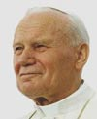 | Pope John Paul II (1920 – 2005) Pope John Paul met with the main protagonists of the Cold War and led to improved relations between the Soviet Union and the Vatican. Considered a moral force for reducing Cold War tensions.
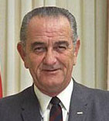 | Lyndon Johnson (1908 – 1973) – US President 1963-69. Johnson took over from the assassinated JFK. He expanded America’s role in Vietnam and took a hard line against Communism. | 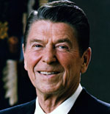 | Ronald Reagan (1911 – 2004) – US President (1980 – 1988) Reagan pursued an aggressive anti-Communist foreign policy. But, in his second term was involved in negotiations which led to arms reductions.

Key Event | Information about it | Impact on the Cold War
Ideological differences between the USSR and the USA | During World War Two the USSR and USA were allies. Only allies because they had a common enemy-Nazi Germany.  Became suspicious of each other’s ideologies after the war.  USA was capitalist and the USSR were communist. | USA believed the USSR wanted a communist world  USSR believed USA wants to destroy communism  Both became suspicious of each other.  The soviets argued they just wanted to protect their borders with a number of friendly states
The Yalta Conference February 1945 | Churchill, Roosevelt and Stalin met to discuss what to do with Germany and Europe after WW2.  Agreed to divide Germany into four zones; USSR, USA, Britain and France.  Allow free elections for countries of Europe.  United Nations to be set up.  USSR to enter war against Japan once Germany is defeated. | Stalin wanted to protect the USSR from further invasion.  Western powers feared the USSR wants to dominate Europe with Communism  Western Powers fear a communist Poland.
Potsdam Conference July 1945 | By this point Germany was defeated.  Stalin set up communist government in Poland  Roosevelt had died and replaced by Truman  America had tested the Atomic bomb.  Agreed to; divide Germany and Berlin, demilitarise Germany, Return democracy to Germany, De-Nazify Germany,  Make all decisions on Germany together. | Revealed differences over Germany between the USSR and the West  Truman causes further tension with free elections.  Truman convinced he needs to stop soviet expansion.  USA had not told Stalin about the atomic bomb.
Dropping of the Atomic Bomb on Japan | On August 6, 1945, the American bomber Enola Gay dropped a five-ton bomb over the Japanese city of Hiroshima. A blast equivalent to the power of 15,000 tons of TNT reduced four square miles of the city to ruins and immediately killed 80,000 people. | Infuriates Stalin, the USA had broken the agreement between them and the USSR.  Now Stalin wanted his own weapons as he felt threatened by the power of America.
The Arms Race | When the USA dropped the atomic bomb it started an arms race.  1949-USSR exploded its first atomic bomb  1952-the USA developed the hydrogen bomb  1953-the USSR developed their own H-bomb | Increased a climate of fear between both sides.  Created the chance of nuclear war.  Each side afraid of nuclear attacks  Some historians feel the arms race helped to make war less likely.
Iron Curtain | Soviet buffer zone essential to the USSR security  End of WW2-Europe divided between the democratic east and west.  Churchill called it an Iron Curtain during his speech.  Between 1945-48 the USSR had taken over; Poland, Romania, Hungary and Czechoslovakia. The USSR had fixed the elections in these countries. They became known as satellite states. | Major differences in opinion develop  Soviet expansion of Eastern Europe seen as only the beginning.  Led to the development of Iron Curtain  It led to the US policy of containment which would be expressed in the Truman Doctrine
Truman Doctrine, March 1947 | Policy of Containment  Truman announced the US would protect countries needing protection from threats to their border (Communism)  Britain unable to support the Greek Government from communist threats.  The US wanted to spread communism. | Marked the turning point in US foreign policy by committing the US to the containment policy.  Showed that America was willing to use force to stop the USSR.  Increased tension as Truman said half the world was not free.  Led to the Marshall Plan  Made Stalin claim it was a war against communism.  As a consequence Stalin formed Cominform to tighten his grip.
The Marshall Plan, June 1947 | Announced by Secretary of State George Marshall  Ofically called the European Recovery Plan  Supported the Truman Doctrine by providing economic aid to countries in Europe.  Aid was in the form of cash, machinery, food and technology.  Truman believed communism thrived in poor areas where there was high unemployment and poverty.  Plan boosted the US economy by providing them with markets to sell their products. | Stalin accused the USA of using the plan for their own selfish interests.  He believe the USA wanted to dominate Europe, promote capitalism and boost the US economy.  Strengthened the divide in Europe-Stalin would not allow Poland or Czechoslovakia to get involved.  Led to the first major crisis-the Berlin air crisis between 1948-49.  Led to Comecon (The Molotov Plan)
Cominform (1947) and Comecon (1949) | Cominform created to spread communism and protect the communist states from US aggression.  Response to the Truman Doctrine and Marshall Plan.  1948-Yugoslavia expelled from Conminform after its leader Tito would not obey Stalin.  1949-USSR introduced Comecon (Council for Mutual Economic Assistance) also known as the Molotov Plan.  Comecon was the soviet response to the Marshall Plan. | USA saw Cominform and Comecon as serious threats.  Increased the division in Europe.
Berlin Blockade and Airflift 1948-49 | June 1948-Stalin blockaded all routes by road, rail and canal to West Berlin to force the allies out of Berlin.  12th May 1949- Stalin called off the blockade because the allies used an airlift to drop supplies on Berlin.  Stalin wanted the allies out because:  Western powers could observe the Soviets  Stalin didn’t want any form of capitalist life on show  West Berlin was receiving Marshall ad.  The trigger for the blockade was the introduction of the Deutschmark.  The Soviet Union was annoyed at the formation of Bizonia (the western allies’ sides).  Western powers planned to form a West German State. | Massively increased tension and showed the divide between wanting a strong and weak Germany.  Truman showed he was determined to stand up against the USSR and was serious about Containment.  Truman wanted Berlin to be a symbol of freedom.  It made Stalin more determined to get the atomic bomb. Stalin did not dare shoot down planes due to America’s bomb.  Led to the official divide of Germany-West Germany and East Germany.  Led to the creation of NATO in 1949-which turned the cold war from an ideological conflict to one involving military alliances.
NATA, 1949 | Rival alliance systems formed as the Cold War progress: NATO vs Warsaw Pact  NATO: Berlin Crsisi triggered the formation of NATO as it highlighted the soviet threat.  It showed the western European states even joined together were no match of the USSR and they need the support of the USA.  It was a defensive alliance meaning if one member was attacked then all other members would defend it. However its main purpose was to prevent soviet expansion. | It increased the chances of an actual war as it meant the USA could build air bases in western Europe where planes with nuclear bombs could be stationed ready for use.  The Soviet Union saw it as an aggressive move.  It led to the formation of the Warsaw Pact-A soviet military alliance.
China from 1949 | 1949-Mao and his communist group form the People’s republic of China after defeating the Nationalists during a 20 year civil war.
The Korean War 1950-53 | After WW2 Korea was divided along the 38th parallel-North was communist and south anti-communist.  Both sides claimed to be the rightful leaders.  1949 China became communist-the US feared Domino Theory in which other countries would become communist.  In June 1950 the North Korean People’s Army (NKPA) invaded South Korea and gained control of it.  South Korea asked the UN for help and a US led force pushed the Koreans back towards China.  China warned the UN not to move any further, when General MacArthur ignored them, the Chinese army attacked pushing the troops back to the 38th parallel.  A stalemate and ceasefire was agreed in 1953. | It intensified the Cold War as it spread the conflict to Asia.  It led to the formation of SEATO (South East Asian Treaty Organisation) in 1954-leading to further tension.  It led America to believe they could contain communism and consider the use of the “roll-back” policy.  It showed china was not scared of the USA.
1953-Death of Stalin | Stalin died in 1953  After his death there was an improvement in relations-this became known as the thaw in the cold war.  Khrushchev the new leader criticised Stalin and spoke of a peaceful coexistence. | Improved relations as Stalin was seen as the main cause of the Cold War.  Khrushchev moved from an aggressive stance to one of peaceful existence together.  He did not want to dominate the world.  Began a process of Destalinization.
The Warsaw Pact 1955 | It was a military alliance for the mutual defence of the USSR. Signed along with Poland, Czechoslovakia, Hungary, Bulgaria, Romania, Albania and East Germany.  All forces in the pact were under the leadership of the Soviet Union and had soviet troops placed in their countries.  It was formed when West Germany joined NATO in 1955. | It meant Europe was now divided into two rival alliances, and if there was a war all the countries in NATO and the Warsaw pact would be involved.  It increased the soviet union’s power over its satellite states.  Showed that despite the thaw Khrushchev was still committed to the security of the communist states.
The Hungarian Uprising 1956 | Hungary was a satellite state of the soviet union but many of the people wanted independence in order to improve living conditions.  They hated their leader Rakosi as he was cruel and Brutal, people wanted Nagy as leader.  In October 1956 riots broke out in Budapest and Stalin’s statue was dragged through the streets.  Nagy became prime minister after Rakosi was forced to resign.  Khrushchev accepted Nagy at first until he asked to withdraw from the Warsaw Pact.  Over 1000 Soviet union tanks were sent to crush the uprising.  Nagy was arrested and executed along with 2500-30,000 Hungarians killed.  A new hard line pro-soviet union government was formed under Kadar. | It strengthened the position of the USSR as other states did not dare challenge the authority of the soviet union.  It showed peaceful coexistence had limitations.  Showed the west would not interfere with soviet activities in eastern Europe-despite the Hungarians asking for UN support.
The Space Race | Khrushchev wanted a space race to increase Russian power.  Winning the space race would prove who was better.  Space race began in 1957 when the USSR launched the Sputnik satellite. A year later they launched a dog into space. | America became determined to win the space race and became suspicious of the USSR.  American suspicious of the USSR led to them spying on the union-this led to the U2 crisis in 1960.  The Sputnik launch increased the fear of missile attack from space.  It became a symbol of tension between the two countries and caused increased competition:  1961-Yuri Gagarin became the first astronaut to orbit the earth.  The USA launched their first satellite in 1958-they sent a chimp into space in 1961.  When Kennedy became president he wanted to put a man on the moon. 1969 they land the first man on the moon.
The arms race continues | By 1960 both sides had intercontinental ballistic missiles (ICBM). They could strike targets up to 6500km away.  Both sides tried to put ICBM missiles in friendly countries. USA placed them in Turkey in 1959 and the USSR in Cuba in 1962.  It developed further in 1960 when the USA launched a new Polaris missile from a submarine. Meaning missiles could be fired from sea. | By 1960 both sides had enough nuclear weapons to destroy every living thing on earth. This became known as Mutually Assured Destruction (MAD)  Although some argue the arms race deterred the USA and USSR from war-the Cuban Missile Crisis brought it close.  This led to an attempt at disarmament following the crisis.
The U2 crisis 1960 | The USA and USSR were due to meet at a summit in Paris in May 1960 to discuss the future of Berlin and nuclear weapons.  May 1st 196—An American pilot called Gary Powers was captured by the USSR and admitted to spying.  The USA did not know Gary Powers had admitted to spying and tried to cover it up by saying it was a downed weather condition plane that got lost.  Khrushchev said he would still attend the peace summit if Eisenhower apologised. However he refused because the U2 flights were part of the US defence strategy. As a result the USSR did not attend the Paris talks. | It ended the Paris Summit  It increased the mistrust between the two superpowers.  America feared a USSR retaliation.  It ended the cooperation that had been associated with peaceful coexistence.
The Berlin Crisis 1961-The Berlin Wall | The Berlin Wall was built because the USSR wanted western powers out of Berlin.  West Berlin had much better living conditions due to the Marshall Plan. It was like an advert for capitalism.  Between 1945-1961: 2 million East Berliners cross the border to live in West Berlin.  In 1961 at the Vienna Summit-Khrushchev demanded Kennedy give up Berlin but he refused.  On 13th August 1961 the USSR placed barbed wire with machine guns along the border to stop people moving across.  The wire was replaced by a wall eventually-remaining until 1989.  The wall separated friends and family. Anyone trying to cross the wall was shot. More than 40 Germans were shot trying to cross it in the first year. | The Berlin Crisis threatened world peace because…  It was a propaganda victory for the USA-but placed pressure on Kennedy to react by taking action.  Kennedy did not want to go to war over Berlin.  1963 Kennedy visited Berlin and declared “Ich bin ein Berliner” promising to defend berlin against the soviets, which angered them.  It showed that Khrushchev could be as brutal and cruel as Stalin.
The Cuban Missile Crisis 1962 | Began in 1962 following the U2 spy crisis.  Cuba was a problem for the USA because:  Led by Fidel Castro who had overthrown the pro-American government in Cuba and announced he was a communist.  Castro sided with the USSR after the bay of pigs invasion when pro-American forces attempted to overthrow him.  The USSR began to provide Cuba with missiles.  Cuba was only 90 miles off the coast of America.  The Cuban Missile Crisis:  Began on 14th October 1962 when the U2 spy plane photographed soviet missiles in Cuba.  Kennedy considered a nuclear attack on Cuba in response.  Instead Kennedy put a naval blockade around Cuba to stop Soviet missiles from reaching the island.  Kennedy demanded the soviets dismantle the missile sites in Cuba.  Khrushchev sent Kennedy 2 letters, the first offered to remove the missile sites if the US ended the blockade, the second demanded the USA remove missiles from Turkey.  Kennedy publicly responded to the first and privately agreed to remove missiles from Turkey. | The way Kennedy responded caused tension.  The world watched on expecting war.  It brought superpowers close to nuclear war.  There were moments when war could have started-the Cubans shooting down a U2 spy plane and the Americans boarding a soviet ship.
The Vietnam War | The USA feared that Vietnam would fall to communism. This was linked to the Domino Theory.  Ho Chi Minh was the leader of North Vietnam, he was a communist and a nationalist. His army were the Viet Minh, they were set up to repel foreign occupation of Vietnam.  South Vietnam was a republic led by President Diem. The North wanted the whole of Vietnam to become communist.  By 1963- it was clear the US money and arms could not save the South Vietnamese government.  1963-Kennedy sent 16,000 military “advisers” to help the southern army.  1963-Diem’s government was overthrown.  Kennedy assassinated in 1963-Lyndon B Johnson became president and wanted to help Vietnam.  1964-North Vietnam attack the US navy.  This allowed the US congress to allow Johnson to fight a war against North Vietnam.  1965-US troops arrived in South Vietnam.  For 10 years US involvement increased-by 198 over 500,000 American troops were in Vietnam and the war was costing $30 billion a year. | The US recognised it could not win  Began to prove domino theory wrong.  Death toll for Vietnam was an estimated 2 million.  Vietnam was united in 1976 but its farmland had been destroyed.  Vietnam’s economy was destroyed-could not feed its own people.  1979-Vietnam invaded by communist China.
Czechoslovakia 1968 | In 1968 Dubeck became leader of Czechoslovakia and tried to make communism more democratic. He called it socialism with a human face. His changes were referred to as the Prague Spring.  Czechoslovakia became a nation under the USSR following WW2.  Dubeck came to power and promised to improve the standard of living, trade and have more freedom such as free elections and opposition parties.  Brezhnev the USSR leader believed the reforms threatened the soviet union and feared other states would wish to leave the Warsaw Pact.  20th August 1968, 500,000 Soviet troops were sent to remove Dubeck and crush the demands for change. People were told not to fight back in order to avoid a repeat of the Hungarian massacre.  Brezhnev issued a doctrine saying the soviet union would not allow any communist country to abandon communism or face soviet force.  The US didn’t want to interfere or face war. | If the USSR allowed Dubeck to have his reforms then the soviet union would have become weaker.  Soviet security depended on maintaining tight control over satellite states.  If the USA had intervened the USSR may have declared war on the USA.
Détente | Refers to a period of lessening tension between the USA and USSR. It occurred after the Cuban Missile Crisis and ended following the Soviet invasion of Afghanistan in 1979.  During Détente the USA and USSR tried to lessen the tension by:  Setting up a hotline in 1963 between the White House and Kremlin.  Limiting the Arms Race (Test Ban Treaty, Non Proliferation Treaty and SALT)  Recognising the borders of Europe  Trading with each other. | Came to an end following:  Soviet invasion of Afghanistan  Ronald Regan  Solidarity in Poland
The Soviet invasion of Afghanistan 1979 | In the 1970s a soviet backed communist group was in power in Afghanistan. They introduced reforms that went against the Muslim culture of the country.  The government became unpopular quickly, opposition led by the mujahidin developed and civil war broke out.  The Mujahidin were being financed by the USA and a rich Saudi called Osama Bin Laden.  The communist government asked for helped from the USSR, who sent 80,000 soviet troops on Christmas day 1979.  Afghanistan was important to the USSR as it linked to the oil rich middle east.  The USSR also wanted to prevent a Muslim government forming due to there being 30 million Muslims living in the USSR who could be encouraged to rebel.  America argued the USSR invaded Afghanistan due to the control of oil supply. | America saw the soviet invasion as an aggressive move and threat to world peace.  American president Carter stopped exporting grain and technology equipment to the USSR. He did not ratify SALT 2 which would limit the arms race and also boycotted the Moscow Olympics of 1980.  America said they would resist any attempt to control the Persian Gulf.
Ronald Regan becomes President 1981 | Regan was determined to be tough on communism.  He called the soviet union an evil empire.  He started a new cold war by pouring billions of dollars into defence, including the Star Wars program in 1983 and the Neutron Bomb.  The USSR were convinced Regan was preparing to launch a nuclear attack.  Although arms reductions talks did take place in 1982 (START-Strategic Arms Reduction Talks) Regan made massive demands on the USSR. Forcing the USSR out of talks.  Regan gave financial support to solidarity, a protest movement in Poland. | Regan started the new cold war and increased defence spending.  He openly criticised the USSR.  He got involved with soviet satellite states.  USSR feared a nuclear attack.
Solidarity in Poland | In 1980 the first free trade union in the USSR was formed.  It was formed to improve living and working conditions in Poland.  Solidarity began when workers at the Gdnask shipyard went on strike, It was led by an electrician named Lech Walesa. He then formed solidarity,  Strikes spread across Poland the membership of solidarity increased to 9 million.  The Polish government made Solidarity an illegal operation and arrested Walesa.  Solidarity continued as an underground movement.  Regan and the Pope (Polish) gave solidarity support and discussed how to destroy communism in Poland.  In 1982 Walesa was released from prison and awarded the Nobel Peace Prize in 1983. | The USA was seen to be aggressive by the soviet union.  First time the USA had interfered with the satellite states.
Gorbachev becomes leader 1985 | He came to power wanting to reform communism because:  The USSR was not winning the war in Afghanistan  They were spending too much money on the arms race  The economy was inefficient  The standard of living was poor  The communist party was corrupt and people had lost faith in the system.  He introduced 2 main reforms:  Glasnost: This involved allowing more openness and disagreement with government policies-for example non-communists were allowed to stand for election and there was free speech.  Perestroika: This involved changing Russia’s economy to allow competition-for example businesses could respond to demand and make profit.  He also decided to:  Withdraw soviet troops in Afghanistan (1989)  Reduce arms: in 1987 the USA and USSR signed the INF treaty.  Reduce control over satellite states-in March 1989 he said he would not use force to put down protests. | Gorbachev helped with the collapse of communism because:  He led the reforms of the Soviet union and ended the cold war in 1989.  Perestroika led to more people losing faith in communism.  Glasnost led to large spread anti-communist movements in the satellite states.
The End of the Cold War | Officially ended in December 1989.  The USSR formally ended in December 1991.  In August 1991 hard line communists tried to overthrow Gorbachev in a coup. They kept Gorbachev prisoner in his home. People feared that old-style communism was making a return.  However, Yeltsin, the President of Russia, led a demonstration against the coup. He said reform had to continue.  Gorbachev returned to power but his position was weakened. On 25th December 1991 Gorbachev resigned and the USSR was formally disbanded the next day.  Yeltsin became the President of the Russian Federation, which replaced the USSR.

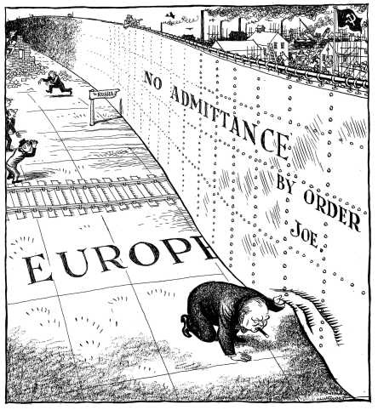
Source 1
A British cartoon commenting on Churchill’s ‘Iron Curtain’ speech, in the Daily Mail, 6th March 1946.
Practice Question 1
Source 1 shows that Churchill was worried about what was happening behind what he termed ‘the Iron Curtain’. How do you know? Explain your answer by using Source 1 and your own knowledge.
(4 marks)

‘The main reason for the development of the Cold War 1945-46 was the dropping of the atomic bombs on Japanese cities.’
How far do you agree with this statement?
Explain your answer.
(16 marks)
(SPaG: 4 marks)

Write an account of how Stalin’s takeover of Eastern Europe affected the development of the Cold War.
(8 marks)

Write an account of how events in China in 1949 became a reason for the worsening of the Cold War.
(8 marks)

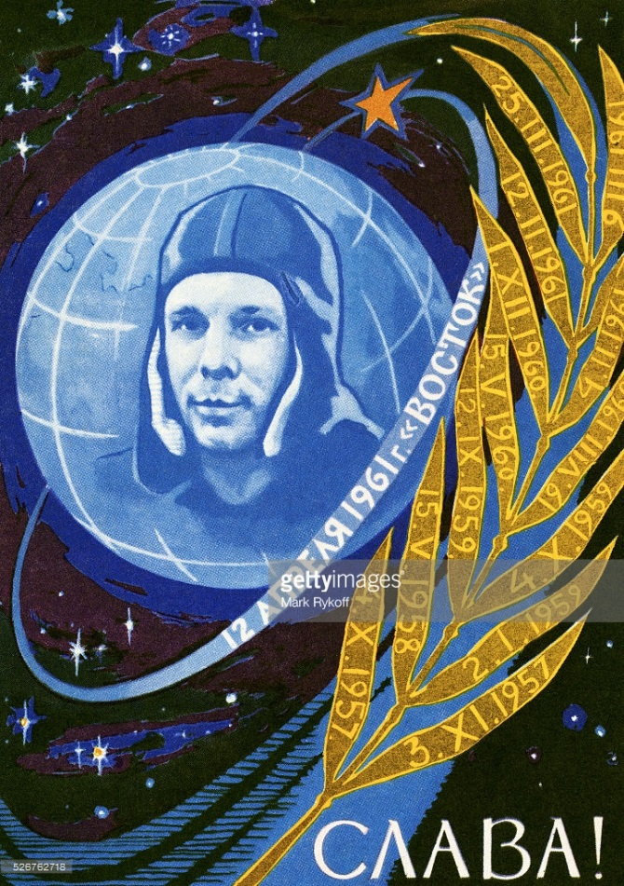
A poster celebrating Yuri Gagarin and the Vostok Space Programme in 1961. The dates on the leaves of the branch are important stages in the Soviet space programme.

Practice Question 5
Study Source 2.
Source 2 supports the USSR. How do you know? Explain your answer by using Source 2 and your contextual knowledge.
(4 marks)

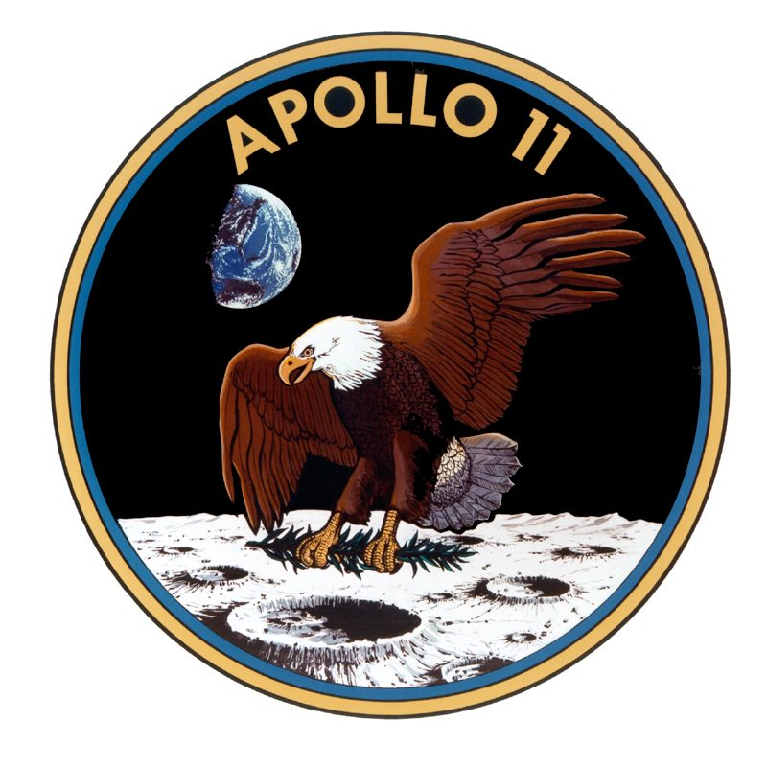
“First I believe that this nation should commit itself to achieving the goal, before this decade is out, of landing a man on the moon and returning him safely to the Earth. No single space project in this period will be more impressive to mankind, or more important in the long-range exploration of space; and none will be so difficult or expensive to accomplish.”
Source 4.
Extracts from a speech by US President John F Kennedy. Kennedy became President in January 1961.

Source 3: The logo of the US Apollo 11 mission.

Practice Question 6
Study Sources 3 and 4.
How useful are these sources to a historian studying American attitudes towards the space race at the beginning of the 1960s?
Explain your answer by using Sources 3 and 4 and your contextual knowledge.
(12 marks)

Write an account of how the events in Hungary in1956 increased tensions in the Cold War.
(8 marks)

‘The main reason for increasing tensions in the Cold War in the mid-1950s was the developing arms race.’
How far do you agree with this statement? Explain your answer.
(16 marks)
(SPaG: 4 marks)

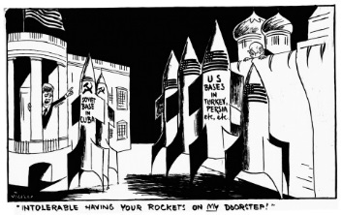

Source 5
A cartoon by Vicky (Victor Weisz) from the London Evening Standard, 24th October 1962.

“(In 1961) we increased our military aid to Cuba. We were sure the Americans would never agree to the existence of Castro’s Cuba. They feared, and we hoped, that a socialist Cuba might become a magnet that would attract other Latin American countries to socialism. We had to find an effective deterrent to American interference in the Caribbean.
The Caribbean crisis was a triumph of Soviet foreign policy and a personal triumph in my own career. Today Cuba exists as an independent socialist country right in front of America. Cuba’s very existence is good propaganda.
We behave with dignity and forced the United States to demobilise and to recognise Cuba.”
Source 6
Khrushchev was forced from power in 1964. This extract comes from his memoirs written in 1971.
Practice Question 9
Study Sources 5 and 6.
How useful are these sources to a historian for understanding the Cuban Missile Crisis?
Explain your answer using both sources and your contextual knowledge.
(12 marks)

Write an account of how the ending of the Cuban Missile Crisis when the Soviet ships turned around effected the reputations of the USA and the USSR.
(10 marks)

‘The main person to benefit in the Cuban Missile Crisis was Castro, not Kennedy or Khrushchev.’
How far do you agree with this statement?
Explain your answer.
(16 marks)
(SPaG: 4 marks)

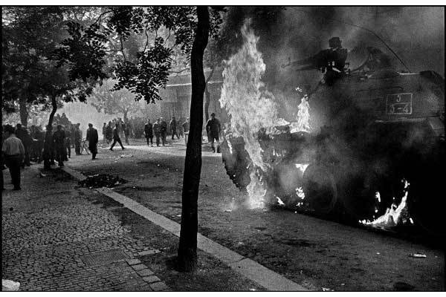
Source 7.
Czechs burning Soviet tanks in Prague, August 1968.
Practice Question 12
Study Source 7.
Source 7 opposes the Soviet Union. How do you know?
Explain your answer by using Source 20 and your contextual knowledge.
(4 marks)

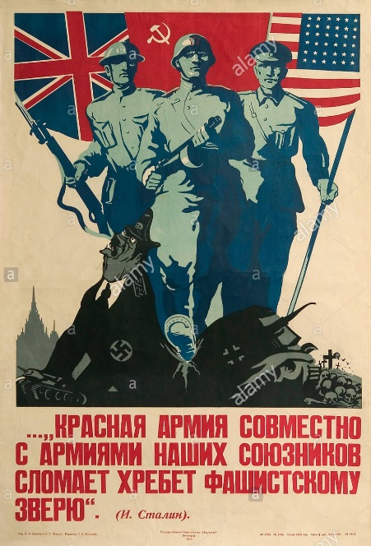
Source 8
A Soviet poster produced in 1944; the caption was a quotation from Stalin and said ‘The Red Army, together with the armies of our allies will break the back of the Fascist beast.’

Practice Question 13
Study Source 8. Source 8 shows the cooperation between the Allies and the Soviet Union during the Second World War. How do you know?
Explain your answer using the Source and your contextual knowledge.
(4 marks)

A British cartoon by E H Shepard for the satirical magazine Punch, published in 1945, entitled ‘Trouble with some of the pieces.’
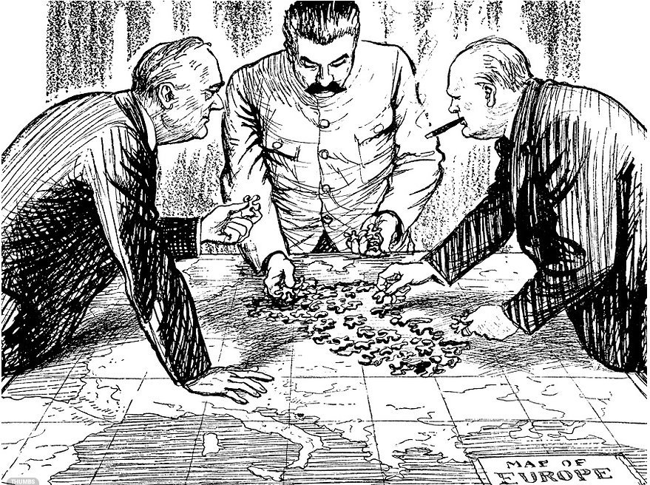

Rumania
Russia 90%
The others 10%
Greece
Great Britain (in accord with USA) 90%
Russia 10%
Yugoslavia 50-50%
Hungary 50-50%
Bulgaria
Russia 75%
The others 25%
Source 10
The ‘percentage agreement’ 9th October
1944, written by Churchill; the actual
Document featured checkmarks
Allegedly made by Stalin as a sign of
Agreement.

Practice Question 14

Look at Sources 9 and 10. How useful are these sources to a historian studying the relationship between the Soviet Union and the Allies at the end of the Second World War? Explain your answer using these sources and your contextual knowledge.
(12 marks)

Source 10: A British cartoon by E H Shepard for the satirical magazine Punch, published in 1945, entitled ‘Trouble with some of the pieces.’

Practice Question 15

“The bombing of Hiroshima destroyed the chance for a good relationship between East and West after the Second World War.”

How far do you agree?
Explain your answer.
(16 marks)
(SPaG:4 marks)

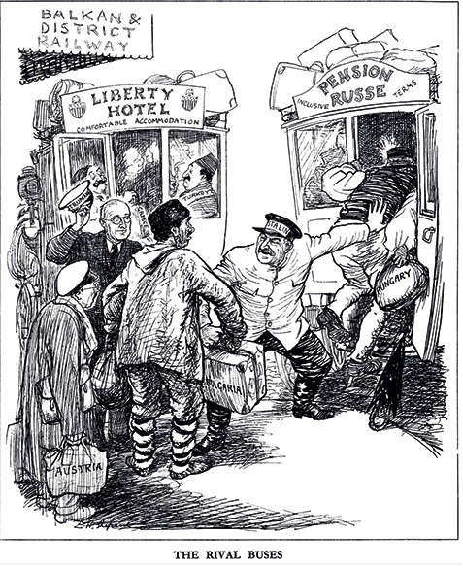
Practice Question 18

‘The main reason for tension between East and West between 1945 and 1949 was the issue of Berlin.’

How far do you agree with this statement? Explain your answer.
(16 marks)
(SPaG: 4 marks)

Practice Question 17

Write an account of the Marshall Plan and the Soviet response increased tensions between the superpowers between 1947 and 1949.

(8 marks)

Source 11

Practice Question 16

Study Source 11. Source 11 is critical of Stalin and the USSR. How do you know?

Explain your answer using Source C and your contextual knowledge.
(4 marks)

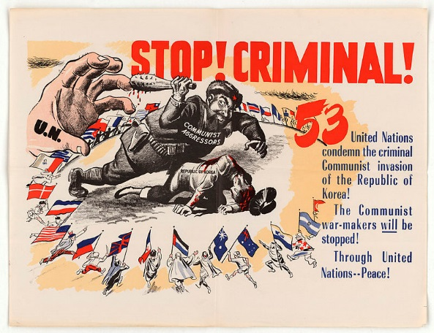
Source 12

Practice Question 19

Study Source 12. Source 12 supports the United Nations intervention in Korea. How do you know?

Explain your answer using Source B and your contextual knowledge.

(4 marks)

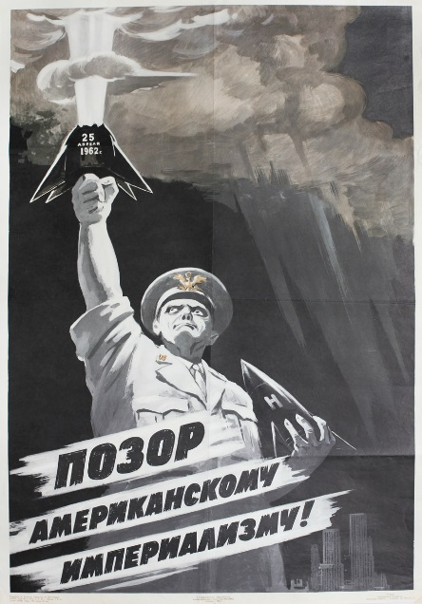
Source 13
A poster published in 1962 by the Russian artist Vadim Volikov; it was a response to a US nuclear test and is called ‘Shame on American Imperialism.’

Practice Question 20
Study Source 13.
Source 13 shows the Americans as encouraging aggression. How do you know?
Explain your answer using Source C and your contextual knowledge.
(4 marks)

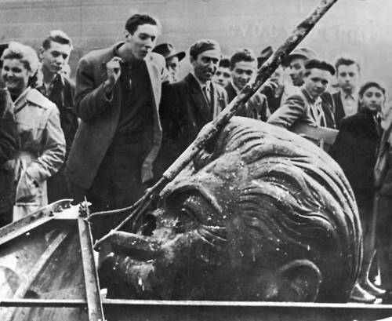
‘The main consequence of superpower rivalry between 1945 and 1965 was the nuclear arms race.’
How far do you agree with statement? Explain your answer.
(16 marks)
(SPaG: 4 marks)

Look at the hell that Rákosi (the Hungarian leader) made of Hungary and you will see an accusation, not of Marxism, not of Communism, but of Stalinism. Hypocrisy without limit; medieval cruelty; slogans devoid of meaning; poverty for all but a tiny handful of leaders who lived in luxury, with mansions on Rόzsadomb, Budapest’s pleasant Hill of Roses, special schools for their children, special well-stocked shops for their wives – even special bathing beaches at Lake Balaton, shut off from the common people by barbed wire

Source 15
Written by Bertrand Russell, a Nobel Prize winning philosopher; he was a founding member of CND and, despite being 89 years old, was arrested during a protest and spent a week in prison.

Practice Question 23
‘The lack of American intervention in Hungary shows a thaw in the Cold War.’
How far do you agree with this statement? Explain your answer.
(16 marks)

Practice Question 22
Study Sources 14 and 15. How useful are these to a historian studying the causes of the Hungarian Uprising?
Explain your answer using Sources 14 and 15 and your contextual knowledge.
(12 marks)

Source 14
A man spits at the head of a demolished statue of Stalin during the 1956 uprising.

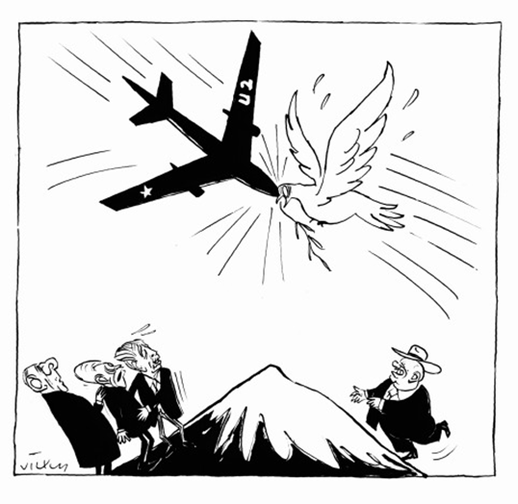
The Department has received the text from Mr Khrushchev’s further remarks about the unarmed plane which is reported to have been shot down in the Soviet Union. It appears that in endeavouring to obtain information now concealed behind the Soviet Union a flight over Soviet territory was probably undertaken by an unarmed civilian U2 plane.
It is certainly no secret that, given the state of the world today, intelligence collection activities are practised by all countries, and post-war history certainly reveals that the Soviet Union has not been lagging behind in this field.
The necessity for such activities as measures for legitimate national defence is enhanced by the excessive secrecy practised by the Soviet Union in contrast to the free world.

Source 17
From a statement issued by the US State Department on 7th May 1960.

Practice Question 24.
Study Sources 16 and 17.
How useful are these to a historian studying the impact of the U2 Crisis?
Explain your answer using Sources 16 and 17 and your contextual knowledge.
(12 marks)

Source 16
A British cartoon from 1962, showing the impact of the U2 crisis on the peace process

Practice Question 25
Write an account of how the shooting down of a U2 spy plane in 1960 became an international crisis.
(8marks)

Source 18
A cartoon by Michael Cummings, published in November 1956 in the British News Chronicle newspaper; Cummings’ targets were usually left-wing, such as trade unions or student protests; the cartoon shows a man representing Hungary lying on the floor, while a soldier with the Soviet emblem on his helmet walks away; UNO stands for United Nations Organisation, another name for the United Nations.

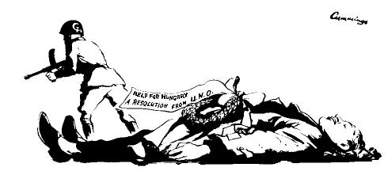
We do not speak of a Hungarian Revolution. We speak of the Hungarian agony. From the moment when the Communist regime in Budapest fired upon an unarmed crown and turned its quarrel with the Hungarian people from a political quarrel which it could not win into an armed revolt which, with Soviet aid, it could not lose, the suppression of the Hungarian resistance was inevitable. The world seemed to feel that it had no choice, short of atomic war, but to sit back and watch, in horror and disgust, the brutal, methodological destruction of an angry people by overwhelming force and conscienceless treachery.
Source 19
Written for Time-Life magazine by the left-wing American journalist Archibald MacLeish, 10th December 1956; MacLeish was briefly given responsibility for promoting the idea of the UN in the final weeks of the Roosevelt presidency; he was investigated by the FBI as a suspected communist but no real evidence was ever found.
Practice Question 26
How useful are Sources 18 and 19 to a historian studying opinions in the West about the Hungarian Uprising? Explain your answer using Sources 18 and 19 and your contextual knowledge.
(12 marks)

Practice Question 27
Write an account of how the city of Berlin was a point of tension between the superpowers between 1960 and 1963.
(8marks)

There are many people in the world who really don’t understand what is the great issue between the free world and the Communist world.
Lass’ sie nach Berlin kommen. Let them come to Berlin…
Freedom is indivisible, and when one man is enslaved, all are not free. When all are free, then we can look forward to that day when this city will be joined as one and this country and this great continent of Europe in a peaceful and hopeful globe…
All – All free men, wherever they may live, are citizens of Berlin.
And, therefore, as a free man I take pride in the words –
‘Ich bin ein Berlinner.’
Source 20
An extract from Kennedy’s speech in West Berlin, 26th June 1963.

Source 21
An American cartoon by Don Wright, published in the Miami Herald in 1961; the figure talking on the wall is Khrushchev.
Practice Question 28
Study Sources 20 and 21. How useful are Sources 20 and 21 to a historian studying the state of superpower relations between the building of the Berlin Wall and Kennedy’s visit to the city?

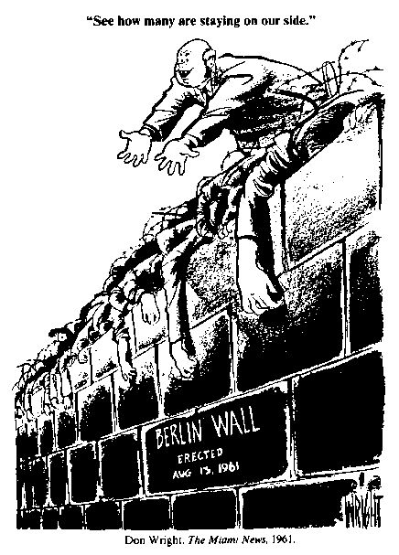
Practice Question 29
Write an account of how Cuba became an ally of the Soviet Union.
(8 marks)

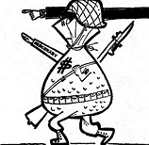
Practice Question 32
Write an account of how the Prague Spring became an international crisis during 1968.
(8 marks)

Practice Question 31
Write an account of how the siting of Soviet missiles in Cuba became an international crisis in 1962.
(8 marks)

Source 22
A cartoon from a Cuban newspaper, published on April 30th 1961; the caption says ‘Technical assistance, Yankee-style.’ And the character’s arm says ‘mercenary’, which is a soldier who fights for anyone who will pay.
Practice Question 30
Study Source 22. Source 22 supports Castro’s government. How do you know?
Explain your answer by using Source 22 and your contextual knowledge.
(4 marks)

Practice Question 34
‘The main reason for détente was the cost of the Cold War.’
How far do you agree with this statement? Explain your answer.
(16 marks)

Practice Question 33
‘The main result of the 1968 Soviet intervention in Czechoslovakia was the damage it did to the reputation of communism.’
How far do you agree with statement? Explain your answer.
(16 marks)

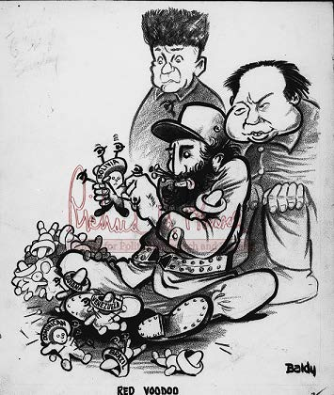
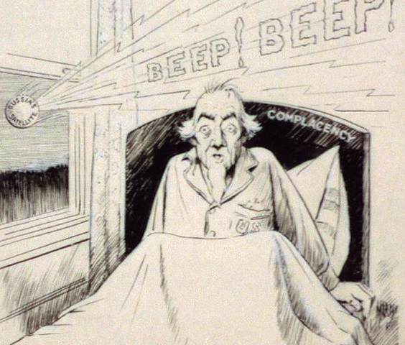
Source A. An American cartoon published in October 1957. It shows the USA being woken by a Russian satellite.

Source B A cartoon called ‘Red Voodoo’ published in an American magazine in January 1959. The leaders of China and the USSR are standing behind Castro. Some people believe that voodoo is a type of magic where pain can be inflicted on victims by ‘hurting’ models of victims.

What is hidden behind the Americans’ hatred of the Cuban Revolution… a small country of only seven million people, economically underdeveloped, without financial or military means to threaten the security or economy of any other country? What explains it is fear. Not fear of the Cuban Revolution but fear of the Latin American Revolution.
Source C From a speech made by Fidel Castro in February 1962.

- Study Source A.

Source A supports the USA taking part in the space race. How do you know?

Explain your answer by using Source A and your contextual knowledge.
(4 marks)

- Study Sources B and C.
How useful are Sources B and C to a historian studying the threat posed by Cuba?
Explain your answer using Sources B and C and your contextual knowledge.
(12 marks)

- Write an account of how the shooting down of a U2 spy plane in 1960 became an international crisis.
(8 marks)

- ‘The main reason for the development of the Cold War in the years 1945 to 1949 was the Truman Doctrine.’

How far do you agree with this statement?

Explain your answer.
(16 marks)
(SPaG: 4 marks)

Key Person: | Country: | Dates: | Key Details. | Key events involved in:
Clement Attlee | British | 1945. | British PM at Potsdam. Labour MP.  He was concerned about the USSR’S expansion into Eastern Europe.  Wanted to make sure Germany was safe from attack. | Potsdam
George Marhsall | American | 1947 onwards. | He was Secretary of State under Truman.  He planned and coordinated the Marshall Plan, winning the Nobel Peace Prize for his efforts in 1953.  In total $14.15 billion dollars was divided between countries who accepted Marshall aid in Europe. | Marshall Plan
Mao Tse-tung | China | 1949 | He emerged as leader of China in 1949 after the communists took power. In 1966 his cultural Revolution cemented his powerful position.  His vision of communism is known as Maoism.  In Feb 1950 signed a Treaty of Friendship with Stalin.  After Stalin's death relationship between USSR and china began to break down. | China fall to Communism in 1949.  Treaty of Friendship 1950
Senator McCarthy | USA | 1954 |  | McCarthyism
Imre Nagy | Hungary | 1956 | Prime minister of Hungary in 1956. He rejected communism and was in favour o of greater freedom and leaving the Warsaw Pact. He was arrested , tried and executed. | Hungarian Uprising.
Fidel Castro | CUBA | 1959- 2016 | Made Cuba communist in a revolution in 1959, and this led to a trade embargo with America. He took over US businesses in Cuba. Allowed the building of Soviet Nuclear Missiles in Cuba. | 1959: Cuba becomes Communist.  1961: Bay of Pigs.  1962: Cuban Missile Crisis.
Gary Powers | USA | 1960 | His spy plane was shot down over USSR. He was sentenced to 10 years in prison. Khrushchev was so angry with the Americans he walked out of the Paris Peace Summit. | SPACE RACE
Yuri Gagarin | USSR | 12 August  1961 | First human in space: Yuri Gagarin. | SPACE RACE
Alexander Dubcek | Czechoslavoakia | 1968 | Became leader of Czechoslovakia in 1968. He introduced wide ranging reforms but said they would remain part of the Warsaw Pact.  He was forced from power in 1969 and expelled from the communist party. He was arrested and taken to a work camp in Russia. | Prague Spring.

