Conflict and Tension between East and West, 1945-1972.

AQA History GCSE

Practice Questions

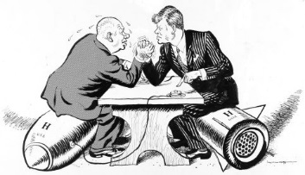

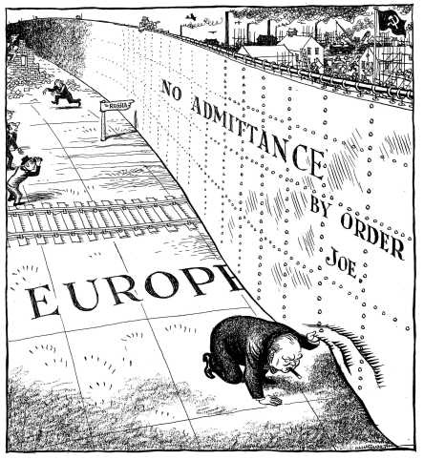
Source 1
A British cartoon commenting on Churchill’s ‘Iron Curtain’ speech, in the Daily Mail, 6th March 1946.
Practice Question 1
Source 1 shows that Churchill was worried about what was happening behind what he termed ‘the Iron Curtain’. How do you know? Explain your answer by using Source 1 and your own knowledge.
(4 marks)

Practice Question 2
‘The main reason for the development of the Cold War 1945-46 was the dropping of the atomic bombs on Japanese cities.’
How far do you agree with this statement?
Explain your answer.
(16 marks)
(SPaG: 4 marks)
Practice Question 3
Write an account of how Stalin’s takeover of Eastern Europe affected the development of the Cold War.
(8 marks)

Practice Question 4
Write an account of how events in China in 1949 became a reason for the worsening of the Cold War.
(8 marks)

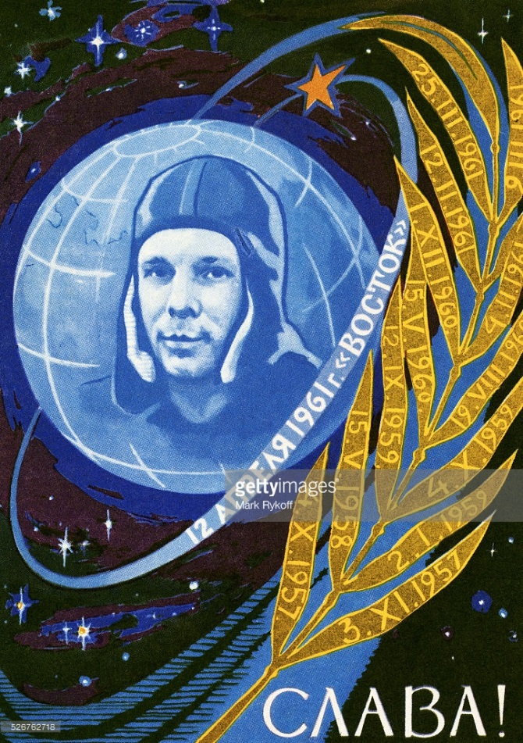
Source 2
A poster celebrating Yuri Gagarin and the Vostok Space Programme in 1961. The dates on the leaves of the branch are important stages in the Soviet space programme.

Practice Question 5
Study Source 2.
Source 2 supports the USSR. How do you know? Explain your answer by using Source 2 and your contextual knowledge.
(4 marks)
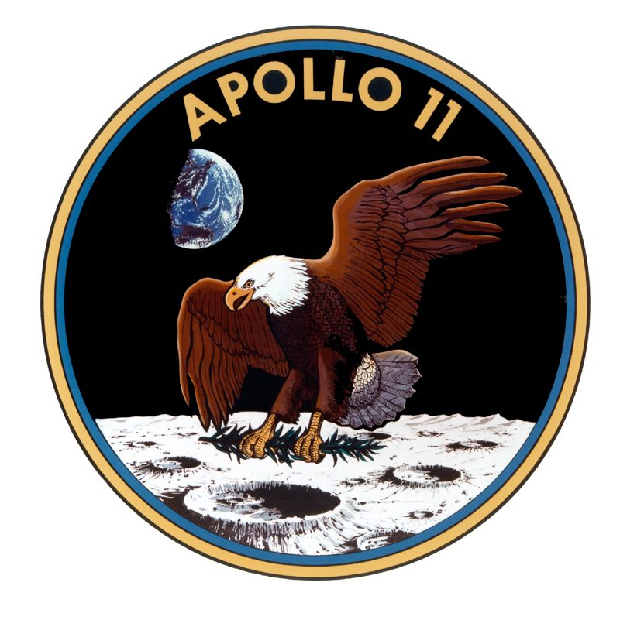
Source 3.
The logo of the US Apollo 11 mission.

“First I believe that this nation should commit itself to achieving the goal, before this decade is out, of landing a man on the moon and returning him safely to the Earth. No single space project in this period will be more impressive to mankind, or more important in the long-range exploration of space; and none will be so difficult or expensive to accomplish.”
Source 4.
Extracts from a speech by US President John F Kennedy. Kennedy became President in January 1961.
Practice Question 6
Study Sources 3 and 4.
How useful are these sources to a historian studying American attitudes towards the space race at the beginning of the 1960s?
Explain your answer by using Sources 3 and 4 and your contextual knowledge.
(12 marks)

Practice Question 7
Write an account of how the events in Hungary in1956 increased tensions in the Cold War.
(8 marks)

Practice Question 8
‘The main reason for increasing tensions in the Cold War in the mid-1950s was the developing arms race.’
How far do you agree with this statement? Explain your answer.
(16 marks)
(SPaG: 4 marks)
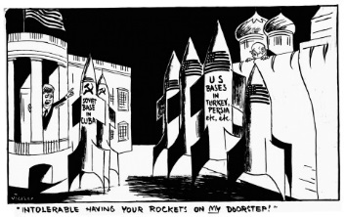
Source 5
A cartoon by Vicky (Victor Weisz) from the London Evening Standard, 24th October 1962.

“(In 1961) we increased our military aid to Cuba. We were sure the Americans would never agree to the existence of Castro’s Cuba. They feared, and we hoped, that a socialist Cuba might become a magnet that would attract other Latin American countries to socialism. We had to find an effective deterrent to American interference in the Caribbean.
The Caribbean crisis was a triumph of Soviet foreign policy and a personal triumph in my own career. Today Cuba exists as an independent socialist country right in front of America. Cuba’s very existence is good propaganda.
We behave with dignity and forced the United States to demobilise and to recognise Cuba.”
Source 6
Khrushchev was forced from power in 1964. This extract comes from his memoirs written in 1971.
Practice Question 9
Study Sources 5 and 6.
How useful are these sources to a historian for understanding the Cuban Missile Crisis?
Explain your answer using both sources and your contextual knowledge.
(12 marks)
Practice Question 10
Write an account of how the ending of the Cuban Missile Crisis when the Soviet ships turned around effected the reputations of the USA and the USSR.
(10 marks)

Practice Question 11
‘The main person to benefit in the Cuban Missile Crisis was Castro, not Kennedy or Khrushchev.’
How far do you agree with this statement?
Explain your answer.
(16 marks)
(SPaG: 4 marks)

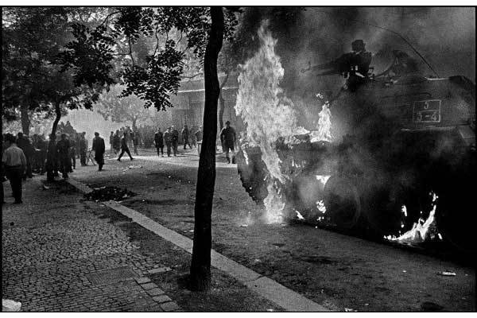
Source 7.
Czechs burning Soviet tanks in Prague, August 1968.
Practice Question 12
Study Source 7.
Source 7 opposes the Soviet Union. How do you know?
Explain your answer by using Source 20 and your contextual knowledge.
(4 marks)

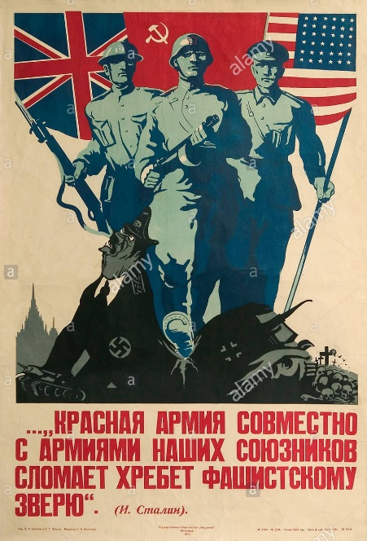
Source 8
A Soviet poster produced in 1944; the caption was a quotation from Stalin and said ‘The Red Army, together with the armies of our allies will break the back of the Fascist beast.’

Practice Question 13
Study Source 8. Source 8 shows the cooperation between the Allies and the Soviet Union during the Second World War. How do you know?
Explain your answer using the Source and your contextual knowledge.
(4 marks)
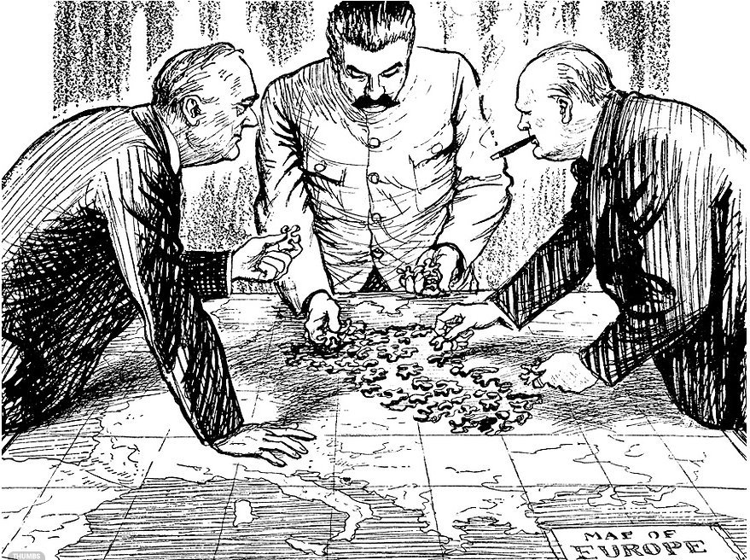
Rumania
Russia 90%
The others 10%
Greece
Great Britain (in accord with USA) 90%
Russia 10%
Yugoslavia 50-50%
Hungary 50-50%
Bulgaria
Source 10
A British cartoon by E H Shepard for the satirical magazine Punch, published in 1945, entitled ‘Trouble with some of the pieces.’

Russia 75% Source 9
The others 25%
Source 9
The ‘percentage agreement’ 9th October
1944, written by Churchill; the actual
document featured checkmarks
allegedly made by Stalin as a sign of
agreement.

Practice Question 14

Look at Sources 9 and 10. How useful are these sources to a historian studying the relationship between the Soviet Union and the Allies at the end of the Second World War? Explain your answer using these sources and your contextual knowledge.
(12 marks)

Practice Question 15

“The bombing of Hiroshima destroyed the chance for a good relationship between East and West after the Second World War.”

How far do you agree?
Explain your answer.
(16 marks)
(SPaG:4 marks)

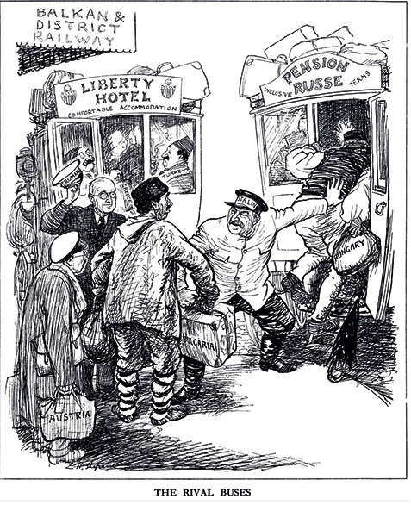

Source 11

Practice Question 16

Study Source 11. Source 11 is critical of Stalin and the USSR. How do you know?

Explain your answer using Source C and your contextual knowledge.
(4 marks)

Practice Question 17

Write an account of the Marshall Plan and the Soviet response increased tensions between the superpowers between 1947 and 1949.

(8 marks)

Practice Question 18

‘The main reason for tension between East and West between 1945 and 1949 was the issue of Berlin.’

How far do you agree with this statement? Explain your answer.
(16 marks)
(SPaG: 4 marks)
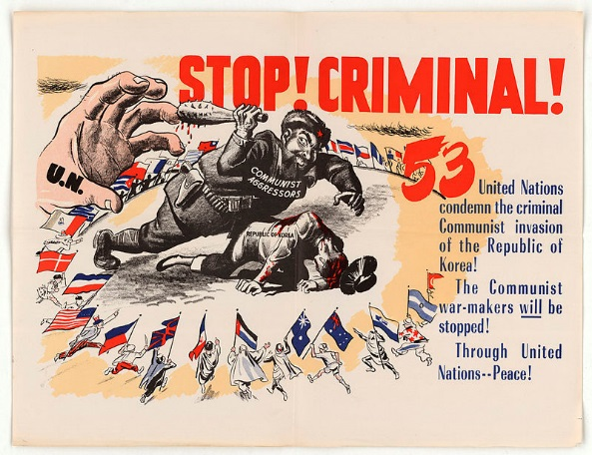

Source 12

Practice Question 19

Study Source 12. Source 12 supports the United Nations intervention in Korea. How do you know?

Explain your answer using Source B and your contextual knowledge.

(4 marks)
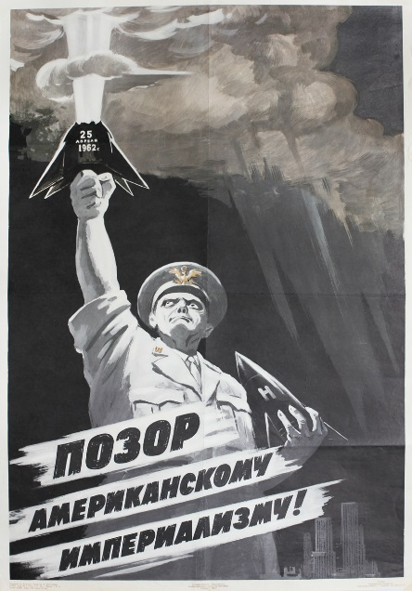
Source 13
A poster published in 1962 by the Russian artist Vadim Volikov; it was a response to a US nuclear test and is called ‘Shame on American Imperialism.’

Practice Question 20
Study Source 13.
Source 13 shows the Americans as encouraging aggression. How do you know?
Explain your answer using Source C and your contextual knowledge.
(4 marks)

Practice Question 21
‘The main consequence of superpower rivalry between 1945 and 1965 was the nuclear arms race.’
How far do you agree with statement? Explain your answer.
(16 marks)
(SPaG: 4 marks)
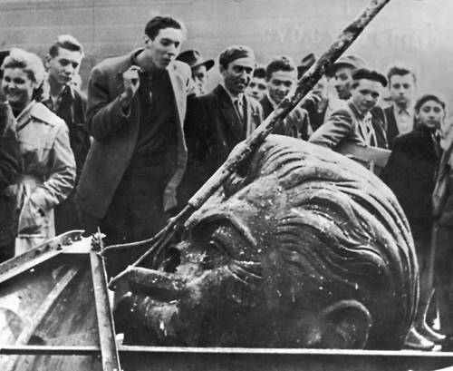

Source 14
A man spits at the head of a demolished statue of Stalin during the 1956 uprising.

Source 15
Look at the hell that Rákosi (the Hungarian leader) made of Hungary and you will see an accusation, not of Marxism, not of Communism, but of Stalinism. Hypocrisy without limit; medieval cruelty; slogans devoid of meaning; poverty for all but a tiny handful of leaders who lived in luxury, with mansions on Rόzsadomb, Budapest’s pleasant Hill of Roses, special schools for their children, special well-stocked shops for their wives – even special bathing beaches at Lake Balaton, shut off from the common people by barbed wire.
Written by Bertrand Russell, a Nobel Prize winning philosopher; he was a founding member of CND and, despite being 89 years old, was arrested during a protest and spent a week in prison.

Practice Question 22
Study Sources 14 and 15. How useful are these to a historian studying the causes of the Hungarian Uprising?
Explain your answer using Sources 14 and 15 and your contextual knowledge.
(12 marks)
Practice Question 23
‘The lack of American intervention in Hungary shows a thaw in the Cold War.’
How far do you agree with this statement? Explain your answer.
(16 marks)
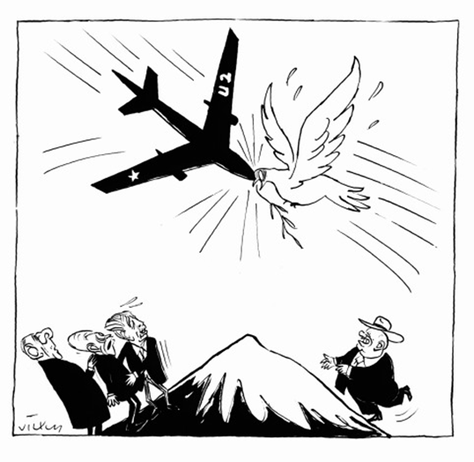
Source 16
A British cartoon from 1962, showing the impact of the U2 crisis on the peace process
The Department has received the text from Mr Khrushchev’s further remarks about the unarmed plane which is reported to have been shot down in the Soviet Union. It appears that in endeavouring to obtain information now concealed behind the Soviet Union a flight over Soviet territory was probably undertaken by an unarmed civilian U2 plane.
It is certainly no secret that, given the state of the world today, intelligence collection activities are practised by all countries, and post-war history certainly reveals that the Soviet Union has not been lagging behind in this field.
The necessity for such activities as measures for legitimate national defence is enhanced by the excessive secrecy practised by the Soviet Union in contrast to the free world.

Source 17
From a statement issued by the US State Department on 7th May 1960.

Practice Question 24.
Study Sources 16 and 17.
How useful are these to a historian studying the impact of the U2 Crisis?
Explain your answer using Sources 16 and 17 and your contextual knowledge.
(12 marks)
Practice Question 25
Write an account of how the shooting down of a U2 spy plane in 1960 became an international crisis.
(8marks)

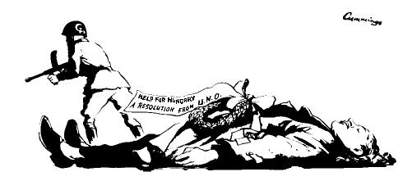
Source 18
A cartoon by Michael Cummings, published in November 1956 in the British News Chronicle newspaper; Cummings’ targets were usually left-wing, such as trade unions or student protests; the cartoon shows a man representing Hungary lying on the floor, while a soldier with the Soviet emblem on his helmet walks away; UNO stands for United Nations Organisation, another name for the United Nations.
We do not speak of a Hungarian Revolution. We speak of the Hungarian agony. From the moment when the Communist regime in Budapest fired upon an unarmed crown and turned its quarrel with the Hungarian people from a political quarrel which it could not win into an armed revolt which, with Soviet aid, it could not lose, the suppression of the Hungarian resistance was inevitable. The world seemed to feel that it had no choice, short of atomic war, but to sit back and watch, in horror and disgust, the brutal, methodological destruction of an angry people by overwhelming force and conscienceless treachery.

Source 19
Written for Time-Life magazine by the left-wing American journalist Archibald MacLeish, 10th December 1956; MacLeish was briefly given responsibility for promoting the idea of the UN in the final weeks of the Roosevelt presidency; he was investigated by the FBI as a suspected communist but no real evidence was ever found.

Practice Question 26
How useful are Sources 18 and 19 to a historian studying opinions in the West about the Hungarian Uprising? Explain your answer using Sources 18 and 19 and your contextual knowledge.
(12 marks)
Practice Question 27
Write an account of how the city of Berlin was a point of tension between the superpowers between 1960 and 1963.
(8marks)
There are many people in the world who really don’t understand what is the great issue between the free world and the Communist world.
Lass’ sie nach Berlin kommen. Let them come to Berlin…
Freedom is indivisible, and when one man is enslaved, all are not free. When all are free, then we can look forward to that day when this city will be joined as one and this country and this great continent of Europe in a peaceful and hopeful globe…
All – All free men, wherever they may live, are citizens of Berlin.
And, therefore, as a free man I take pride in the words –
‘Ich bin ein Berlinner.’
Source 20
An extract from Kennedy’s speech in West Berlin, 26th June 1963.

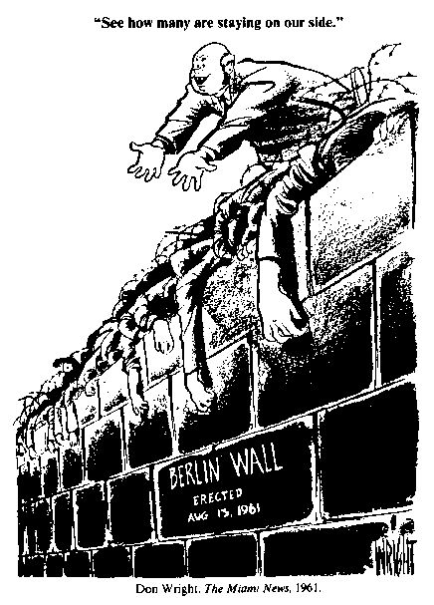
Source 21
An American cartoon by Don Wright, published in the Miami Herald in 1961; the figure talking on the wall is Khrushchev.
Practice Question 28
Study Sources 20 and 21. How useful are Sources 20 and 21 to a historian studying the state of superpower relations between the building of the Berlin Wall and Kennedy’s visit to the city?
Explain your answer using Sources A and C and your own knowledge.
(12 marks)

Practice Question 29
Write an account of how Cuba became an ally of the Soviet Union.
(8 marks)
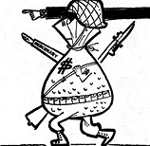
Source 22
A cartoon from a Cuban newspaper, published on April 30th 1961; the caption says ‘Technical assistance, Yankee-style.’ And the character’s arm says ‘mercenary’, which is a soldier who fights for anyone who will pay.
Practice Question 30
Study Source 22. Source 22 supports Castro’s government. How do you know?
Explain your answer by using Source 22 and your contextual knowledge.
(4 marks)

Practice Question 31
Write an account of how the siting of Soviet missiles in Cuba became an international crisis in 1962.
(8 marks)

Practice Question 32
Write an account of how the Prague Spring became an international crisis during 1968.
(8 marks)

Practice Question 33
‘The main result of the 1968 Soviet intervention in Czechoslovakia was the damage it did to the reputation of communism.’
How far do you agree with statement? Explain your answer.
(16 marks)

Practice Question 34
‘The main reason for détente was the cost of the Cold War.’
How far do you agree with this statement? Explain your answer.
(16 marks)

Practice Questions for Paper 1:
Conflict and Tension between East and West 1945-1972
The examination questions on Conflict and Tension will be varied but there will be some questions on sources (A03), a question on your knowledge and analysis of the period using historical concepts (A01 and A02), and an extended writing question (A01 and A02). Below is a selection of these different kinds of questions for you to practice.

Answer all four questions. You are advised to spend 50 minutes on these four questions.

Source A. An American cartoon published in October 1957. It shows the USA being woken by a Russian satellite.
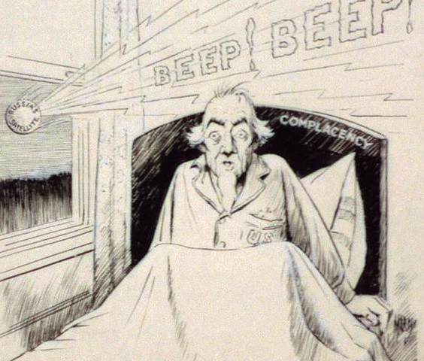

Source B A cartoon called ‘Red Voodoo’ published in an American magazine in January 1959. The leaders of China and the USSR are standing behind Castro. Some people believe that voodoo is a type of magic where pain can be inflicted on victims by ‘hurting’ models of victims.
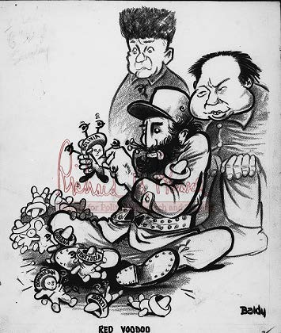

Source C From a speech made by Fidel Castro in February 1962.
What is hidden behind the Americans’ hatred of the Cuban Revolution… a small country of only seven million people, economically underdeveloped, without financial or military means to threaten the security or economy of any other country? What explains it is fear. Not fear of the Cuban Revolution but fear of the Latin American Revolution.

Answer all four questions below.

- Study Source A.

Source A supports the USA taking part in the space race. How do you know?

Explain your answer by using Source A and your contextual knowledge.
(4 marks)

- Study Sources B and C.
How useful are Sources B and C to a historian studying the threat posed by Cuba?
Explain your answer using Sources B and C and your contextual knowledge.
(12 marks)

- Write an account of how the shooting down of a U2 spy plane in 1960 became an international crisis.
(8 marks)

- ‘The main reason for the development of the Cold War in the years 1945 to 1949 was the Truman Doctrine.’

How far do you agree with this statement?

Explain your answer.
(16 marks)
(SPaG: 4 marks)

