PACKAGING DEVELOPMENT

PURPOSE OF PACKAGING:

DIE CUTTING PROCESS:

PACKAGING LOGO’s NEEDED

WILD THINGS LOGO: DRAW BELOW (FONT STYLE)

PRINTING PROCESS:

NET DESIGN: DRAW BELOW

SURFACE GRAPHICS

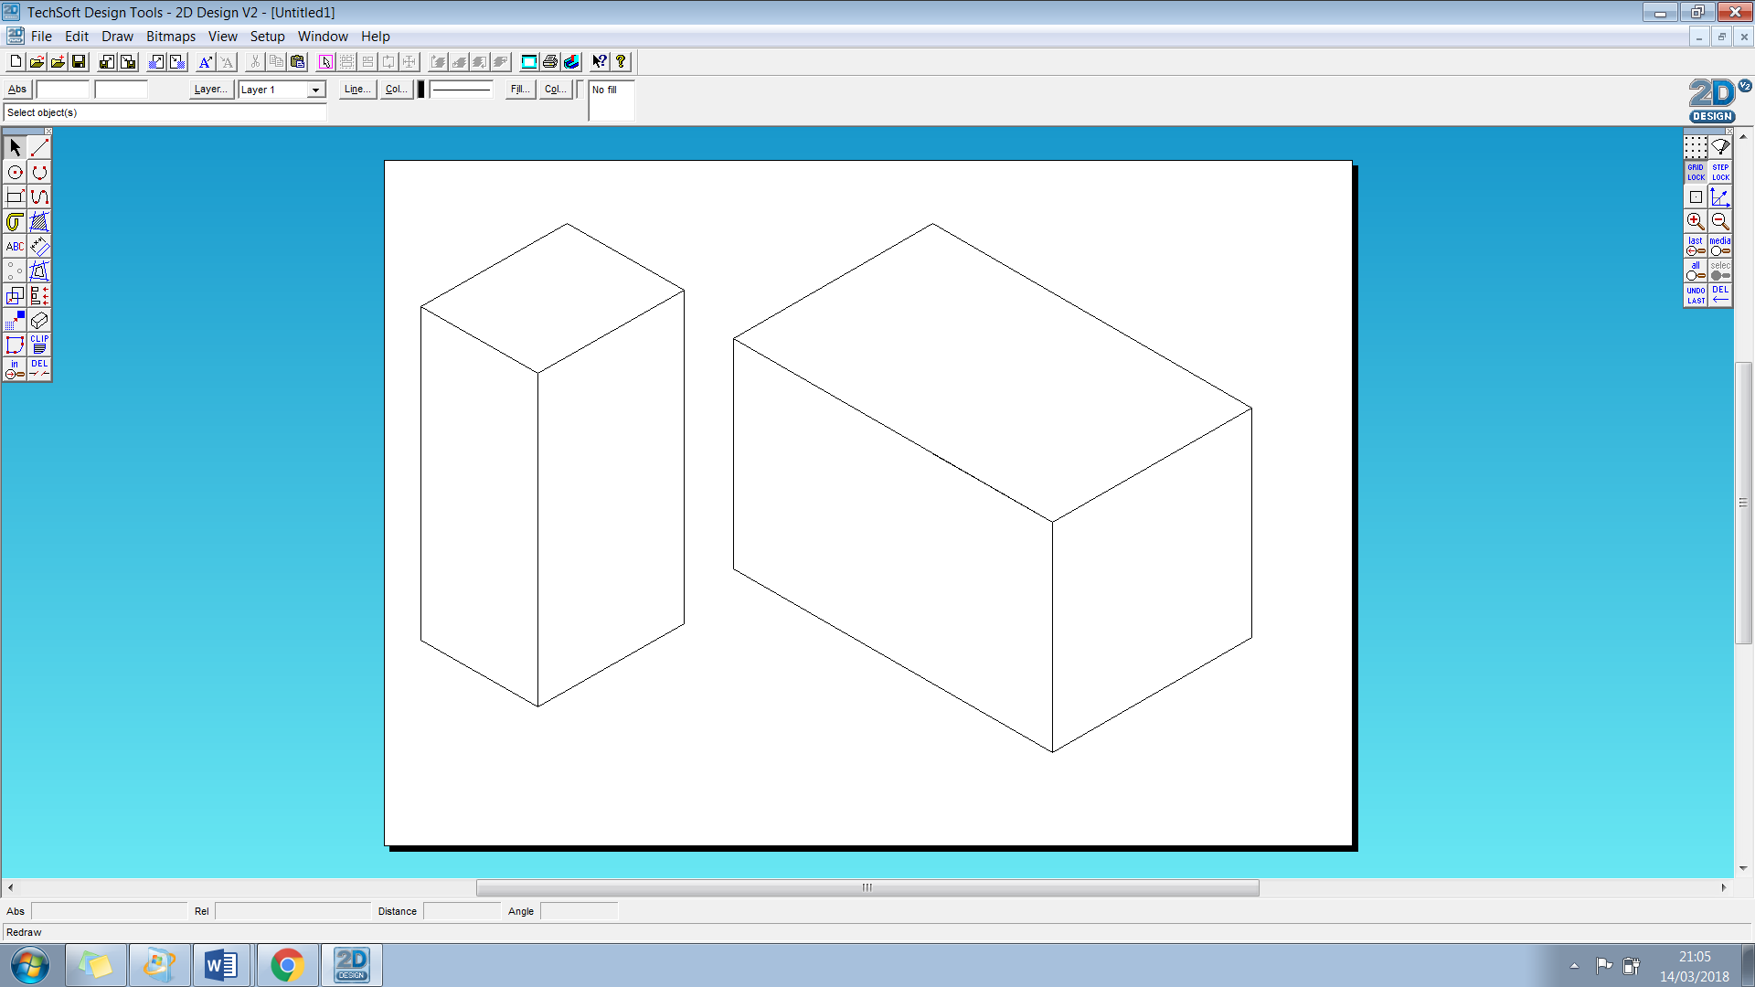

PACKAGING NET DESIGNS- Choose one for your product

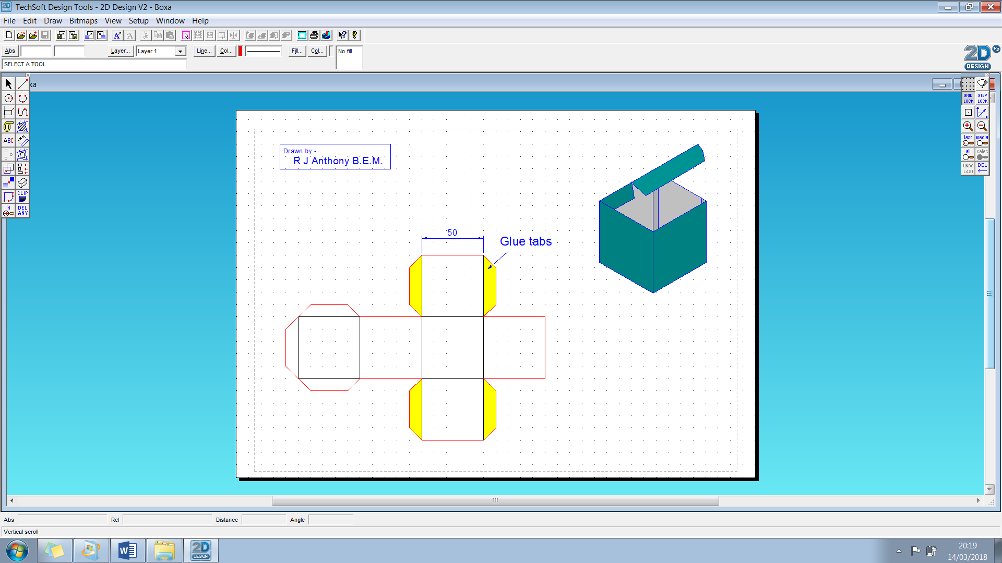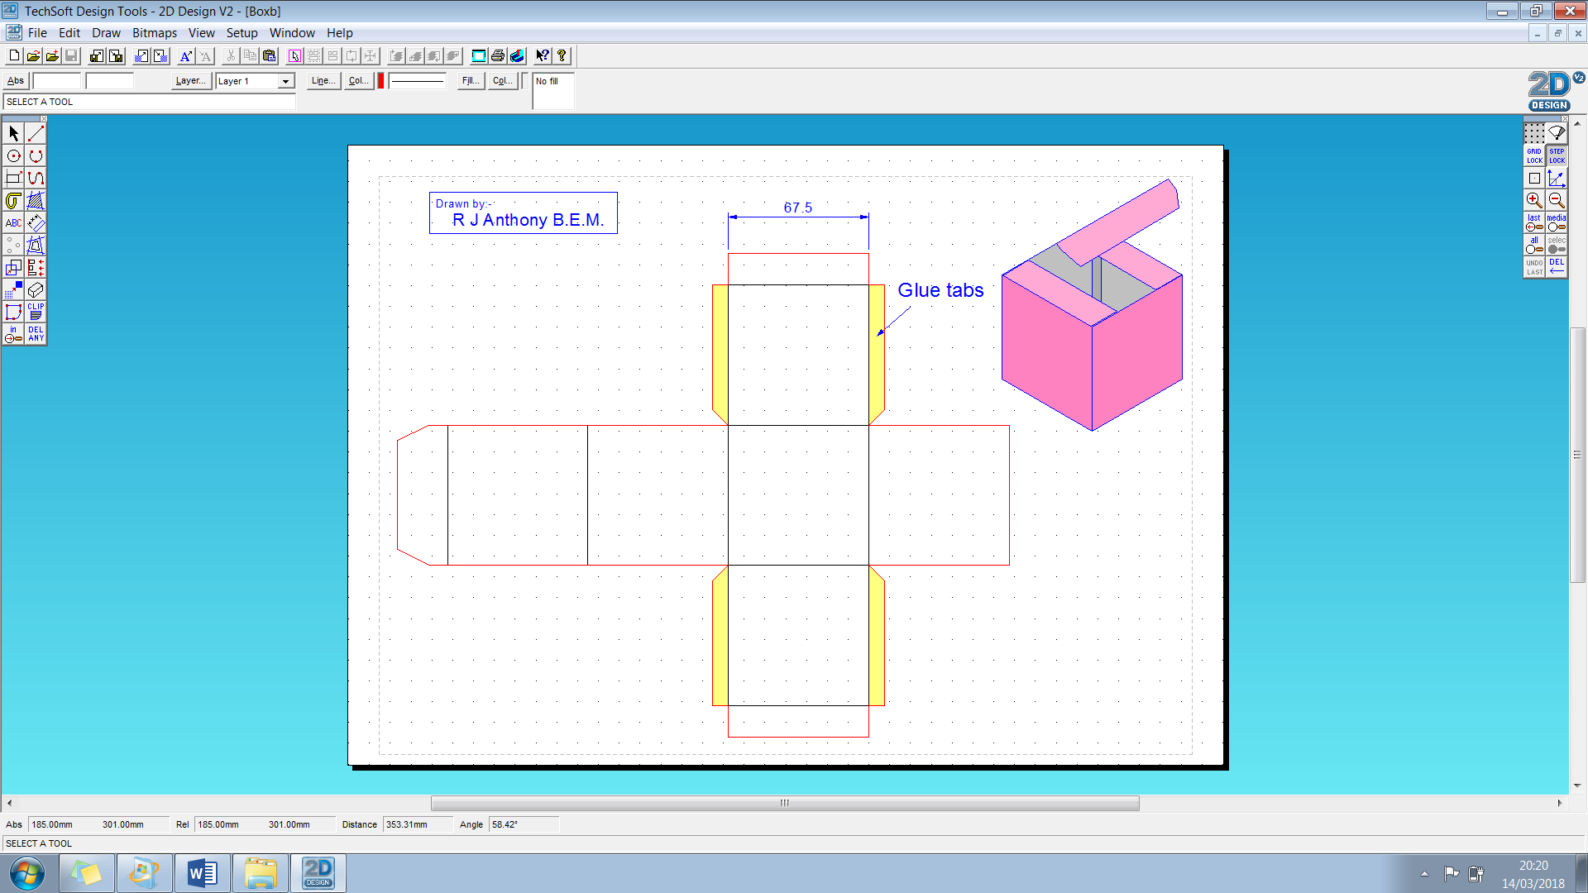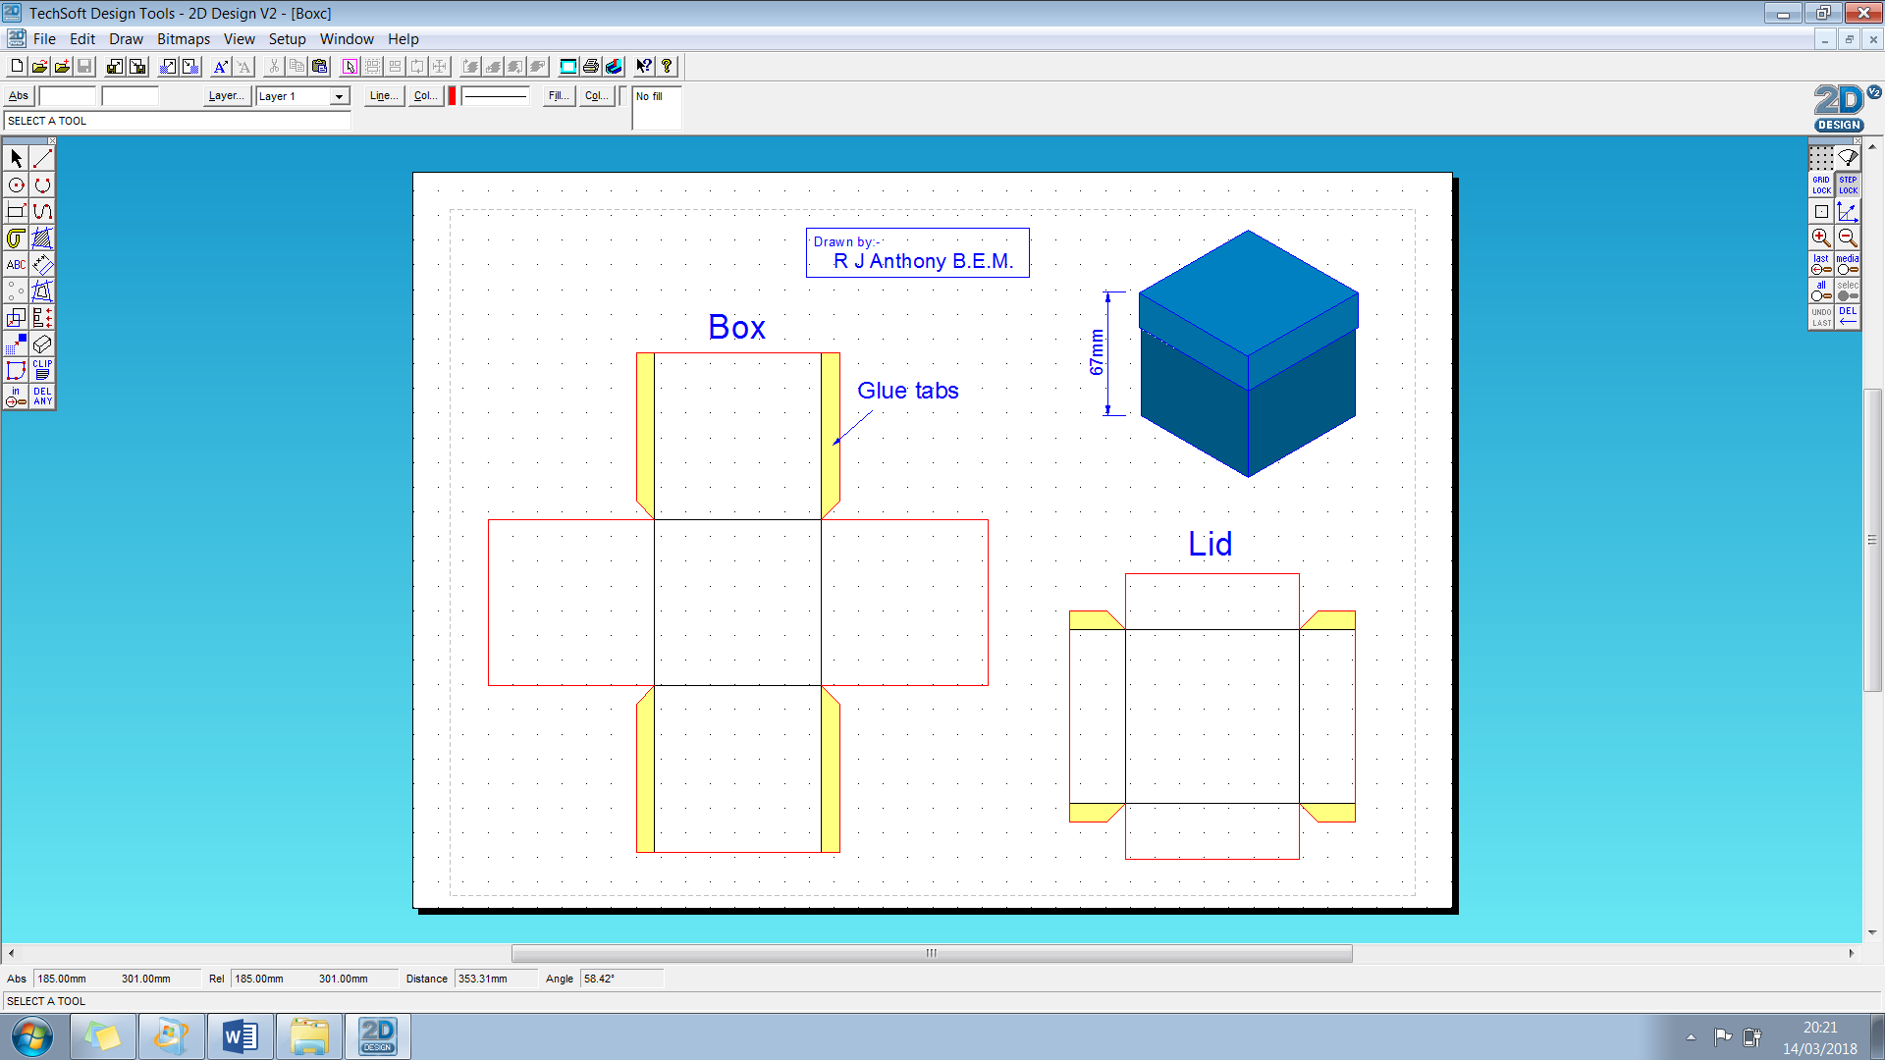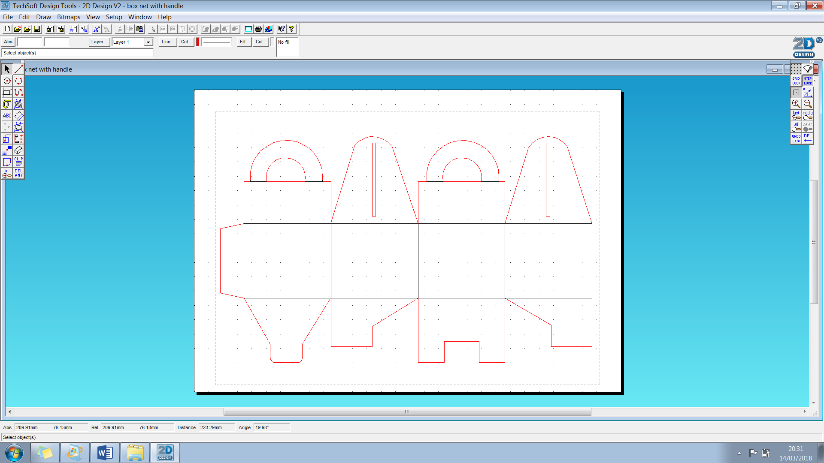

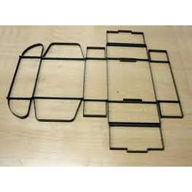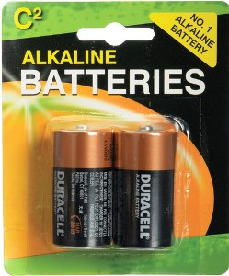OFFSET LITHOGRAPHY DIE CUTTING BLISTER PACKAGING

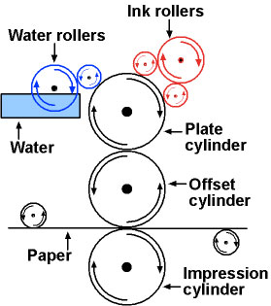

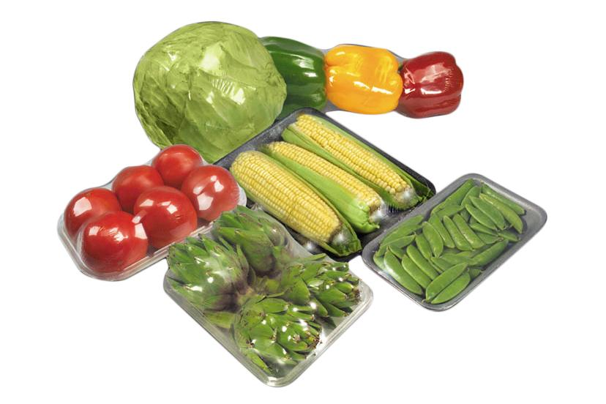

SHRINK WRAP PACKAGING

PACKAGING SYMBOLS

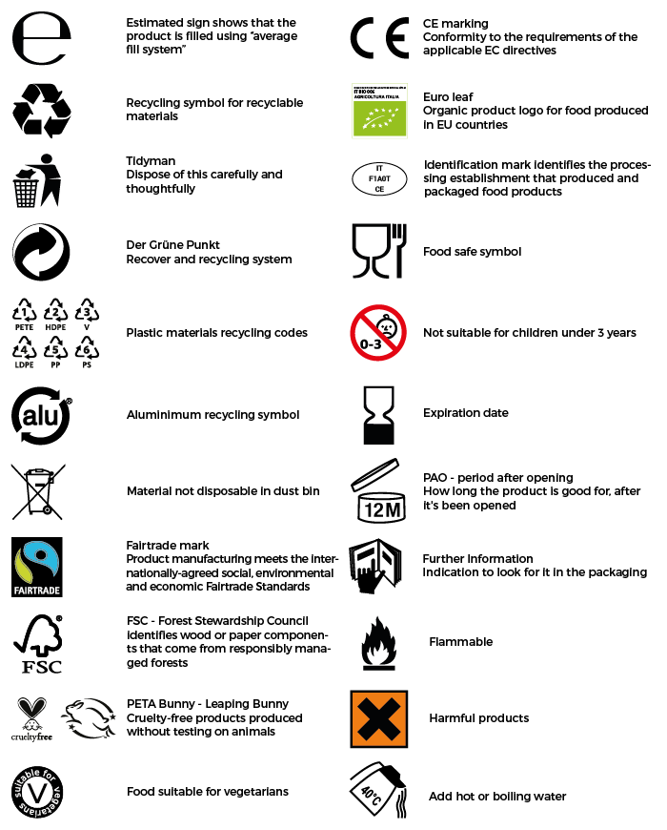

The main purposes of packaging are:

* to **preserve** the product
* to **protect** the product from damage
* to make the product more **attractive** to the consumer
* to make it easier to **transport** the product

