You should have received an email from your English teacher about your English work. It is no longer on 'Teams' or a 'Word' document. It is on a program called SENECA.

To access:

- Press on the link you were sent via email. If you do not have a link, please email your English teacher.

- You need to sign up with a password you can remember. Please use your full birth name. Example: Marie Jones.

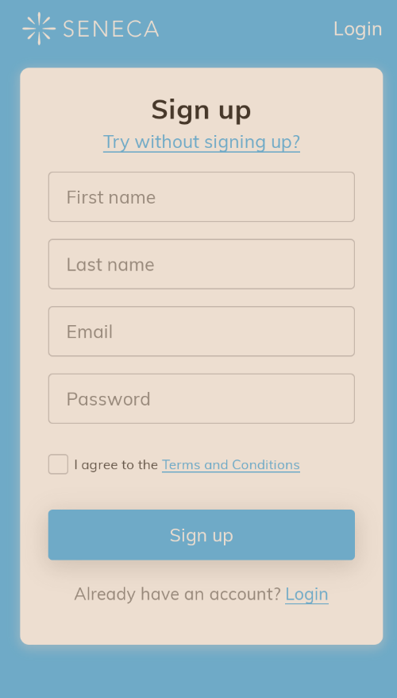

- It will then ask you for your school name. You must type the whole school name and not NUSA.

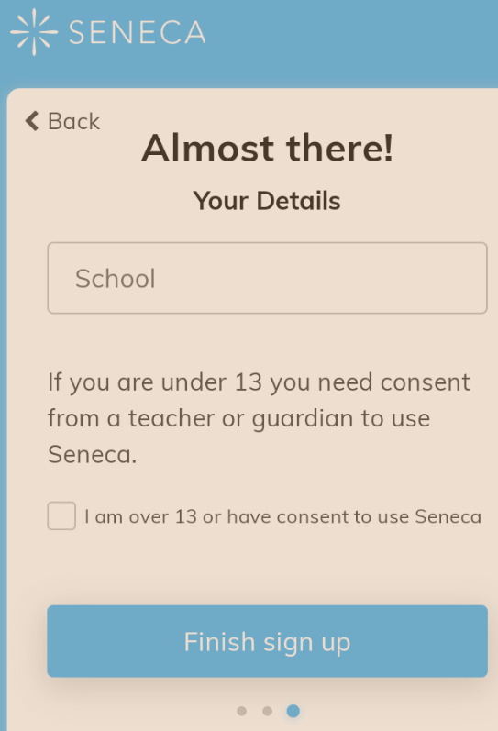
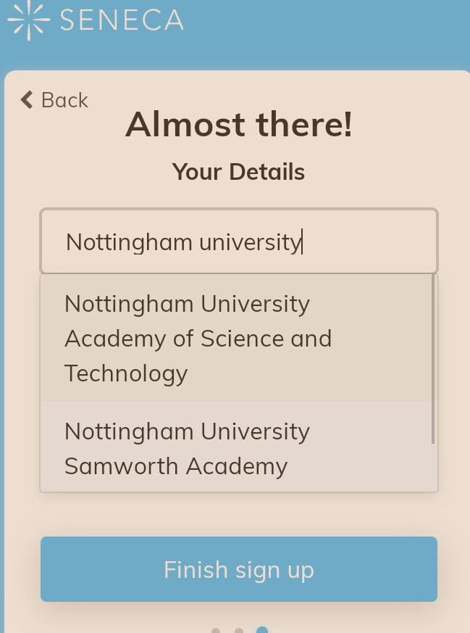

- You will then join your class!
- An assignment will also appear on your account. You will be given a due date for your assignment too.

